**Style Guidelines for Final Year Project ReportsML Ontology solution for Blood Donation System**

**Final Year Project Report**

**Session 2022-2023**

A 4th Year Student

A project submitted in partial fulfilment of the

COMSATS University Degree

of

BSc. (Hons.)BS in Computer Science / Software Engineering (CUI)



Department of Computer Science

COMSATS University Islamabad, Lahore Campus

07 June 2023

# Project Detail

|  |  |  |  |  |  |
| --- | --- | --- | --- | --- | --- |
| Type (Nature of project) | | | [  ] **D**evelopment  [  ] **R**esearch [  ] **R**&**D** | | |
| Area of specialization | | | Web Development | | |
| **Project Group Members** | | | | | |
| Sr.# | Reg. # | Student Name | | Email ID | *Signature |
| (i) | FA19-BSE-112 | Akash Ur Rehman | | [akashurrehman456@gmail.com](mailto:akashurrehman456@gmail.com) |  |
| (ii) | FA19-BSE-033 | Muhammad Abu Hurairah | | [Abuhurairahishtiaq37@gmail.com](mailto:Abuhurairahishtiaq37@gmail.com) |  |
| (iii) | FA19-BSE-098 | Muhammad Salman | | [Salman.ahmed.9373@gmail.com](mailto:Salman.ahmed.9373@gmail.com) |  |

*The candidates confirm that the work submitted is their own and appropriate credit has been given where reference has been made to work of others

# Plagiarism Free Certificate

This is to certify that, I am ________Akash Ur Rehman_ S/D/o ____Saif Ur Rehman___, group leader of FYP under registration no CIIT/__FA19-BSE-112_/LHR at Computer Science Department, COMSATS University Islamabad, Lahore Campus. I declare that my FYP proposal is checked by my supervisor and the similarity index is _8% that is less than 20%, an acceptable limit by HEC. Report is attached herewith as Appendix A.

Date: _____4th January 2023___ Name of Group Leader: _Akash Ur Rehman___ Signature: 

Name of Supervisor: __Miss Sana Rizwan___ Co-Supervisor (if any): ____________________

Designation: ____Assistant Professor Designation: _____________________

Signature: _____________________ Signature: _____________________

Table of Contents

Project Detail 2

Plagiarism Free Certificate 2

1. Chapter 1: Introduction 16

1.1 Introduction 16

1.2 Objectives 17

1.3 Problem Statement 18

1.4 Assumptions and Constraints 19

1.4.1 Assumption 19

1.4.2 Constraints 19

1.5 Project Scope (what and what not to consider) 19

2. Chapter 2: Requirements Analysis 20

2.1 Literature Review / Existing system study 20

2.2 Stakeholder List (Actors) 23

2.3 Requirement Elicitation 26

2.3.1 Functional Requirement 26

FR01- Login 26

FR02- Registration 26

FR03- Make the Request for Blood 27

FR04- Donate Blood 28

FR05- Check eligibility of User for blood donation 28

FR06- View Blood Donation Centers 29

FR07- Generate Appointment Report 29

FR08- Display User Profile 30

FR09- View Blood Requests 30

FR10-Update Personal Information 31

FR11- Delete Personal Information 31

FR12- Get User feedback 31

FR13- Add User information. 32

FR14- Generate Report on bloodstocks. 33

FR15- Update Blood stock 33

FR16- Download Weekly/Monthly Appointment Reports 33

FR17- Manage NGO’s or Blood donation Centers. 34

FR18- Add news. 34

FR19- Manage Advertisement 35

FR20- Handling Blood Requests 35

FR21- Managing User’s Personal Information 35

FR22- Managing Campaigns 36

FR23- Managing Donor List 36

FR24- Manage Sponsors 36

FR25- Manage Financial donations. 37

FR26- Manage Job posts. 37

FR27- Managing frequently asked questions. 38

2.3.2 Non-Functional Requirements 38

NFR01: Performance 38

NFR02- Security 39

NFR03- Maintainability 39

NFR04- Usability 39

NFR05-Reliability 39

2.3.3 Requirement Traceability Matrix 40

2.4 Use Case Description 44

UC01-Login 45

UC02-Register 47

UC03-Make the Request for Blood 49

UC04-Donate Blood 51

UC05- Check eligibility of User for blood donation 53

UC06-View Blood Donation Centers 55

UC07-Generate Appointment Report 57

UC08-Display User Profile 58

UC09-View Blood Request 60

UC10-Update Personal Information 62

UC11-Delete Personal Information / Account 64

UC12-Get User Feedback 66

UC13-Add Blood donor’s Information 68

UC14-Generate report of blood stocks 70

UC15-Update blood stock 71

UC16-Download Appointment Reports 72

UC17- Manage NGO’s or Blood donation centers 73

UC18- Manage News 74

UC19- Manage Advertisement 75

UC20- Handling Blood Request 76

UC21- Managing User’s Personal Information 77

UC22- Managing Campaigns 78

UC23- Managing Donor List 80

UC24- Manage Sponsors 81

UC25- Manage Financial Donations 83

UC26- Manage Job Posts 84

UC27- Manage Frequently Asked Questions 85

2.5 Use Case Diagrams 86

2.5.1 Login 86

2.5.2 Registration 87

2.5.3 Make Request for Blood 88

2.5.4 Donate Blood 89

2.5.5 Check eligibility for blood Donation 90

2.5.6 View Blood donation Centers 91

2.5.7 Generate Appointment Reports 92

2.5.8 Display user Profile 93

2.5.9 View Blood Requests 94

2.5.10 Update Personal Information 95

2.5.11 Delete Personal Information 96

2.5.12 Get User Feedback 97

2.5.13 Add Blood Donor’s Information 98

2.5.14 Generate Blood Stock Report 99

2.5.15 Update Blood Stock 100

2.5.16 Download Appointment Report 101

2.5.17 Manage NGO’s or Blood Donation Centers 102

2.5.18 Manage News 103

2.5.19 Manage Advertisement 104

2.5.20 Update Personal Information 105

2.5.21 Manage User’s Personal Information 106

2.5.22 Manage Campaigns 107

2.5.23 Manage Donor List 108

2.5.24 Manage Sponsors 109

2.5.25 Manage Funds 110

2.5.26 Manage Job Posts 111

2.5.27 Manage Frequently Asked Questions 112

2.6 Software Development Life Cycle Model 113

3. Chapter 3: System Design 114

3.1 Work Breakdown Structure (WBS) 114

3.2 Activity Diagram 115

3.2.1 Login 115

3.2.2 Registration 116

3.2.3 Make the Request for Blood 117

3.2.4 Donate Blood 118

3.2.5 Check Eligibility of User for Blood Donation 119

3.2.6 View Blood Donation Centers 120

3.2.7 Generate Appointment Report 121

3.2.8 Display User Profile 122

3.2.9 View Blood Requests 123

3.2.10 Update Personal Information 124

3.2.11 Delete Personal Information 125

3.2.12 Get User Feedback 126

3.2.13 Add User Information 127

3.2.14 Generate Report on Blood Stocks 128

3.2.15 Update Blood Stock 129

3.2.16 Download Weekly/Monthly Appointment Report 130

3.2.17 Manage NGOs or Blood Donation Centers 131

3.2.18 Add News 132

3.2.19 Manage Job Posts 133

3.2.20 Manage Campaigns 134

3.2.21 Manage Financial Donations 135

3.2.22 Manage Donor List 136

3.2.23 Manage Advertisement 137

3.2.24 Handling Blood Request 138

3.2.25 Managing User’s Personal Information 139

3.2.26 Manage Sponsors 140

3.2.27 Manage Frequently Asked Questions 141

3.3 Sequence Diagram 142

3.3.1 Login 142

3.3.2 Registration 143

3.3.3 Make the Request for Blood 144

3.3.4 Donate Blood 145

3.3.5 Check Eligibility of User for Blood Donation 146

3.3.6 View Blood Donation Centers 147

3.3.7 Generate Appointment Report 148

3.3.8 Display User Profile 149

3.3.9 View Blood Requests 150

3.3.10 Update Personal Information 151

3.3.11 Delete Personal Information 152

3.3.12 Get User Feedback 153

3.3.13 Add User Information 154

3.3.14 Generate Report on Blood Stocks 155

3.3.15 Update Blood Stock 156

3.3.16 Download Weekly/Monthly Appointment Report 157

3.3.17 Manage NGOs or Blood Donation Centers 158

3.3.18 Manage News 159

3.3.19 Manage Advertisement 160

3.3.20 Handling Blood Request 161

3.3.21 Managing User’s Personal Information 162

3.3.22 Managing Campaigns 163

3.3.23 Manage Donor List 164

3.3.24 Manage Sponsors 165

3.3.25 Manage Financial Donations 166

3.3.26 Manage Job Posts 167

3.3.27 Manage Frequently Asked Questions 168

3.3 Software Architecture 169

3.4 Class Diagram 170

3.5 Database Diagram 171

3.6 Collaboration Diagram 172

3.6.1 Login 172

3.6.2 Registration 173

3.6.3 Make the Request for Blood 174

3.6.4 Donate Blood 175

3.6.5 Check Eligibility of User for Blood Donation 176

3.6.6 View Blood Donation Centers 177

3.6.7 Generate Appointment Report 178

3.6.8 Display User Profile 179

3.6.9 View Blood Requests 180

3.6.10 Update Personal Information 181

3.6.11 Delete Personal Information 182

3.6.12 Get User Feedback 183

3.6.13 Add User Information 184

3.6.14 Generate Report on Blood Stocks 185

3.6.15 Update Blood Stock 186

3.6.16 Download Weekly/Monthly Appointment Report 187

3.6.17 Manage NGOs or Blood Donation Centers 188

3.6.18 Add News 189

3.6.19 Manage Advertisement 190

3.6.20 Handling Blood Requests 191

3.6.21 Managing User’s Personal Information 192

3.6.22 Managing Campaigns 193

3.6.23 Managing Donors List 194

3.6.24 Manage Sponsors 195

3.6.25 Manage Financial Donation 196

3.6.26 Manage Job Posts 197

3.6.27 Managing Frequently Asked Questions 198

4. Chapter 4: System Testing 199

4.1 Test Cases 199

Test Case 4.1.1 - Login 199

Test Case 4.1.2 - Register 199

Test Case 4.1.3 – Make Request For Blood 200

Test Case 4.1.4 – Donate Blood 200

Test Case 4.1.5 – Check Eligibility of user for Blood Donation 201

Test Case 4.1.6 – View Blood Donation Centers 202

Test Case 4.1.7 – Generate Appointment Report 202

Test Case 4.1.8 – Display User Profile 203

Test Case 4.1.9 – View Blood Requests 204

Test Case 4.1.10 – Update Personal Information 204

Test Case 4.1.11 – Delete Personal Information 205

Test Case 4.1.12 – Get User Feedback 206

Test Case 4.1.13 – Add Blood donor’s Information 207

Test Case 4.1.1 – Generate Report of Blood Stocks 207

Test Case 4.1.15 – Update Blood Stocks 208

Test Case 4.1.16 – Download Appointment Reports 208

Test Case 4.1.17 – Manage NGO’s or Blood donation centers 209

Test Case 4.1.18 – Manage News 210

Test Case 4.1.19 – Manage Advertisement 210

Test Case 4.1.20 – Handling Blood Requests 211

Test Case 4.1.21 – Managing Users Personal Information 212

Test Case 4.1.22 – Managing Campaigns 212

Test Case 4.1.23- Manage Donor List 213

Test Case 4.1.24 – Manage Sponsors 214

Test Case 4.1.25 – Manage Financial Donations 215

Test Case 4.1.26 – Manage Job Posts 215

Test Case 4.1.27- Managing Frequently Asked Questions 216

4.2 Unit / Integration / Acceptance Testing 217

4.2.1. Unit Testing 217

4.2.2 Integration Testing 217

4.2.3. Acceptance Testing: 217

5. Chapter 5: Conclusion 218

5.1 Problem Faced and Lesson Learned 218

5.1.1 Problem Faced 218

5.1.2 Lesson Learned 219

5.2 Project Summary 219

5.3 Future Work 220

References 220

List of Figures

Figure 1: Login 92

Figure 2: Registration 93

Figure 3: Make Request for Blood 94

Figure 4: Donate Blood 95

Figure 5 Check Eligibility of the User for Blood Donation 96

Figure 6 View Blood Donation Centers 97

Figure 7: Generate Appointment Report Usecase Diagram 98

Figure 8: Display User Profile Usecase Diagram 99

Figure 9: View Blood Requests Usecase Diagram 100

Figure 10: Receive Appointment Booking Notifications Usecase Diagram 101

Figure 11: Update Personal Information Usecase Diagram 102

Figure 12: Delete Personal Information Usecase Diagram 103

Figure 13: Get User Feedback Usecase Diagram 104

Figure 14: Add Blood Donor’s Information Usecase Diagram 105

Figure 15: Generate Blood Stock Report Usecase Diagram 106

Figure 16: Update Blood Stock Usecase Diagram 107

Figure 17: Download Appointment Report Usecase Diagram 108

Figure 18: Manage Blood Donation Center Request Usecase Diagram 109

Figure 19: Manage NGO’s or Blood Donation Centers Usecase Diagram 110

Figure 20: Manage News Usecase Diagram 111

Figure 21: Manage Advertisement Usecase Diagram 112

Figure 22: Manage Enquiries Usecase Diagram 113

Figure 23: Manage User’s Personal Information Usecase Diagram 114

Figure 24: Manage Campaigns Usecase Diagram 115

Figure 25: Manage Donor List Usecase Diagram 116

Figure 26: Manage Donor List Usecase Diagram 117

Figure 27: Manage Sponsors Usecase Diagram 118

Figure 28: Manage Funds Usecase Diagram 119

Figure 29: Manage Job Posts Usecase Diagram 120

Figure 30: Manage Frequently Asked Questions Usecase Diagram 121

Figure 31 Work Breakdown structure 123

Figure 32: Login 124

Figure 33: Registration 125

Figure 34: Make the Request for Blood 126

Figure 35: Donate Blood 127

Figure 36 : Check Eligibility of User for Blood Donation 128

Figure 37 View Blood Donation Centers 129

Figure 38 Generate Appointment Report 130

Figure 39 Display User Profile 131

Figure 40 View Blood Requests 132

Figure 41 Receive Appointment Booking Notification 133

Figure 42 Update Personal Information 134

Figure 43 Delete Personal Information 135

Figure 44 Get User Feedback 136

Figure 45 Add User Information 137

Figure 46 Generate report of Blood Stock 138

Figure 47 Update blood Stock 139

Figure 48 Download weekly Appointment Reports 140

Figure 49 Manage blood donation Center requests 141

Figure 50 Manage NGO or blood Donation Center requests 142

Figure 51 Add News 143

Figure 52 Manage Job Post Activity Diagram 144

Figure 53 Manage Campaign Activity Diagram 145

Figure 54 Manage Financial Donation Activity Diagram 146

Figure 55 Manage Donor List Activity Diagram 147

Figure 56 Manage Advertisement Activity Diagram 148

Figure 57 Handling blood Request Activity Diagram 149

Figure 58 Managing User’s Personal Information 150

Figure 59 Manage Sponsors 151

Figure 60 Manage Frequently Asked Questions 152

Figure 61 Managing Enquiries 153

Figure 62 Manage Advertisement Activity Diagram 154

Figure 63 Registration Sequence Diagram 155

Figure 64 Make the Request for Blood Sequence Diagram 156

Figure 65 Donate Blood Sequence Diagram 157

Figure 66 Check Eligibility of User for Blood Donation 158

Figure 67 View Blood Donation Center’s Sequence Diagram 159

Figure 68 Generate Appointment Report Sequence Diagram 160

Figure 69 Display User Profile Sequence Diagram 161

Figure 70 View Blood Request Sequence Diagram 162

Figure 71 Receive Appointment Booking Notification Sequence Diagram 163

Figure 72 Update Personal Information 164

Figure 73 Delete Personal Information 165

Figure 74 Get User Feedback 166

Figure 75 Add Information of blood Donors 167

Figure 76 Generate Report on Blood Stock 168

Figure 77 Update Blood Stock 169

Figure 78 Download Appointment Reports 170

Figure 79 Manage Blood Donation Center Requests 171

Figure 80 Manage NGO or Blood Donation Center 172

Figure 81 Manage News 173

Figure 82 Manage Advertisement 174

Figure 83 Handling Blood Request 175

Figure 84 Managing Enquiries 176

Figure 85 Managing User’s Personal Information 177

Figure 86 Managing Campaigns 178

Figure 87 Manage Donor List 179

Figure 88 Manage Sponsors 180

Figure 89 Manage Financial Donations 181

Figure 90 Manage Job Posts 182

Figure 91 Manage Frequently Asked Questions 183

Figure 92 Software Architecture Diagram 184

Figure 93 Class Diagram 185

Figure 94 Database Diagram 186

Figure 95 Login Collaboration Diagram 187

Figure 96 Registration Collaboration Diagram 188

Figure 97 Make the request for blood Collaboration Diagram 189

Figure 98 Donate Blood Collaboration Diagram 190

Figure 99 Check Eligibility of User for Blood Donation Collaboration Diagram 191

Figure 100 View Blood Donation Center Collaboration Diagram 192

Figure 101 Generate Appointment Report Collaboration Diagram 193

Figure 102 Display User Profile Collaboration Diagram 194

Figure 103 View Blood Request Collaboration Diagram 195

Figure 104 Receive Appointment Booking Notification Collaboration Diagram 196

Figure 105 Update Personal Information Collaboration Diagram 197

Figure 106 Delete Persona Information Collaboration Diagram 198

Figure 107 Get User Feedback Collaboration Diagram 199

Figure 108 Add User Information Collaboration Diagram 200

Figure 109 Generate Report on Blood Stock Collaboration Diagram 201

Figure 110 Update Blood Stock Collaboration Diagram 202

Figure 111 Download Appointment Reports Collaboration Diagram 203

Figure 112 Manage Blood Donation Center’s Request Collaboration Diagram 204

Figure 113 Manage NGO’s/Blood Donation Center Collaboration Diagram 205

Figure 114 Manage News Collaboration Diagram 206

Figure 115 Manage Advertisement Collaboration Diagram 207

Figure 116 Handling Blood Requests Collaboration Diagram 208

Figure 117 Manage Enquiries Collaboration Diagram 209

Figure 118 Manage Users Personal Information Collaboration Diagram 210

Figure 119 Manage Campaigns Collaboration Diagram 211

Figure 120 Manage Donor List Collaboration Diagram 212

Figure 121 Manage Sponsors Collaboration Diagram 213

Figure 122 Manage Financial Donation Collaboration Diagram 214

Figure 123 Managing Job Posts Collaboration Diagram 215

Figure 124 manage Frequently Asked Questions Collaboration Diagram 216

List of Tables

Table 1:2.2 Stakeholder Register 26

Table 2: FR01-Login 27

Table 3:FR02-Registration 28

Table 4:FR03 Make the Request for Blood 29

Table 5 FR04-Donate Blood 29

Table 6:FR05- Check eligibility of User for blood donation 30

Table 7:FR06- View Blood Donation Centers 30

Table 8:FR07- Generate Appointment Report 30

Table 9: FR08- Display User Profile 31

Table 10:FR09- View Blood Requests 31

Table 11:FR10- Receive Appointment Booking Notifications 32

Table 12:FR11- Update Personal Information 32

Table 13:FR12- Delete Personal Information 33

Table 14:FR13- Get User feedback 33

Table 15:FR14- Add User information 34

Table 16:FR15- Generate Report on bloodstocks 34

Table 17:FR16- Update Blood stock 35

Table 18:FR17- Download Weekly/Monthly Appointment Reports 35

Table 19:FR18- Manage Blood donation Center requests 35

Table 20:FR19- Manage NGO’s or Blood donation Centers 36

Table 21:FR20- Add news 36

Table 22:FR21 – Manage Advertisement 37

Table 23:FR22- Handling Blood Requests 37

Table 24:FR23- Managing Enquiries 37

Table 25:FR24- Managing User’s Personal Information 38

Table 26: FR25- Managing Campaigns 38

Table 27: FR26- Managing Donor List 38

Table 28: FR27- Manage Sponsors 39

Table 29: FR28- Manage Financial donations 39

Table 30:FR29- Manage Job posts 40

Table 31:FR30- Managing frequently asked questions 40

Table 32:NFR01: Performance 41

Table 33: NFR02- Security 41

Table 34:NFR03- Maintainability 41

Table 35:NFR04- Usability 41

Table 36:NFR05-Reliability 41

Table 37:2.3.3 Requirement Traceability Matrix 47

*Table 38:UC01-Login* 49

*Table 39:UC02-Register* 51

*Table 40:UC03-Make the Request for Blood* 53

*Table 41:UC04-Donate Blood* 55

*Table 42:UC05- Check eligibility of User for blood donation* 57

*Table 43:UC06-View Blood Donation Centers* 59

*Table 44:UC07-Generate Appointment Report* 60

*Table 45:UC08-Display User Profile* 61

*Table 46:UC09-View Blood Request* 64

*Table 47:UC10-Receive Appointment Booking Notifications* 65

*Table 48:UC11-Update Personal Information* 67

*Table 49:UC12-Delete Personal Information / Account* 69

*Table 50:UC13-Get User Feedback* 71

*Table 51:UC14-Add Blood donor’s Information* 72

*Table 52:UC15-Generate report of blood stocks* 73

*Table 53:UC16-Update blood stock* 74

*Table 54:UC17-Download Appointment Reports* 75

*Table 55:UC18- Manage Blood donation center request* 76

*Table 56:UC19- Manage NGO’s or Blood donation centers* 77

*Table 57:UC20- Manage News* 78

*Table 58:UC21- Manage Advertisement* 80

*Table 59:UC22- Handling Blood Request* 81

*Table 60:UC23- Managing Enquiries* 82

*Table 61:UC24- Managing User’s Personal Information* 83

*Table 62:UC25- Managing Campaigns* 85

*Table 63:UC26- Managing Donor List* 86

*Table 64:UC27- Manage Sponsor* 88

*Table 65:UC28- Manage Financial Donations* 89

*Table 66:UC29- Manage Job Posts* 90

*Table 67:UC30- Manage Frequently Asked Questions* 91

*Table 68: Test Case 4.1.1 - Login* 217

*Table 69: Test Case 4.1.2 - Register* 217

*Table 70: Test Case 4.1.3 – Make Request For Blood* 218

*Table 71: Test Case 4.1.4 – Donate Blood* 219

*Table 72: Test Case 4.1.5 – Check Eligibility of user for Blood Donation* 219

*Table 73 :Test Case 4.1.6 – View Blood Donation Centers* 220

*Table 74: Test Case 4.1.7 – Generate Appointment Report* 221

*Table 75: Test Case 4.1.8 – Display User Profile* 221

*Table 76: Test Case 4.1.9 – View Blood Requests* 222

*Table 77: Test Case 4.1.10 – Receive Appointment Booking Notifications* 223

*Table 78: Test Case 4.1.11 – Update Personal Information* 223

*Table 79: Test Case 4.1.12 – Delete Personal Information* 224

*Table 80: Test Case 4.1.13 – Get User Feedback* 225

*Table 81: Test Case 4.1.14 – Add Blood donor’s Information* 225

*Table 82: Test Case 4.1.15 – Generate Report of Blood Stocks* 226

*Table 83: Test Case 4.1.16 – Update blood Stocks* 226

*Table 84: Test Case 4.1.17 – Download Appointment Reports* 227

*Table 85: Test Case 4.1.18 – Manage Blood Donation center Request* 227

*Table 86: Test Case 4.1.19 – Manage NGO’s or Blood donation centers* 228

*Table 87: Test Case 4.1.20 – Manage News* 228

*Table 88: Test Case 4.1.21 – Manage Advertisement* 229

*Table 89: Test Case 4.1.22 – Handling Blood Requests* 230

*Table 90: Test Case 4.1.23 – Managing Enquiries* 230

*Table 91: Test Case 4.1.24 – Managing Users Personal Information* 231

*Table 92: Test Case 4.1.25 – Managing Campaigns* 232

*Table 93: Test Case 4.1.26- Manage Donor List* 233

*Table 94: Test Case 4.1.27 – Manage Sponsors* 234

*Table 95: Test Case 4.1.28 – Manage Financial Donations* 234

*Table 96: Test Case 4.1.29 – Manage Job Posts* 235

*Table 97: Test Case 4.1.30- Managing Frequently Asked Questions* 235

Abstract

Our project is about Blood Donation Website. A blood donation is basically a process where an individual can voluntarily donate his/her blood for future transfusions. He/she donates his/her blood to the organizations that require that blood for treatment purposes like Hospitals etc. To solve this real-world problem, we adopt machine learning and ontology learning approaches because it makes the system learn by themselves. Blood donation is a very critical process, and this process can be made simple by using the Machine learning approach. In this proposal, we propose an automated blood donation system to ease the emergency and make the blood donation easy process. As the study on the semantic web is progressing, many domain ontologies are being built. Ontologies are built for a variety of reasons, but the main purpose of building ontologies is to provide a specification of a particular domain in an explicit format. Ontologies serve as a common vocabulary for different people i.e., Stakeholders to communicate about a specific domain, providing a framework for capturing and sharing knowledge. Researchers and developers are building ontologies based on their interests. Ontologies provide us with the help of integrating data from different sources by providing a shared understanding of that domain. There are various languages and tools that are used in making ontologies, we have devised a method of manual merging of the ontologies with the help of SPARQL queries for web platforms.

The main goal of creating this system or web application was to allow users to look for blood in blood banks and obtain blood in any situation. By contacting the donor online or at a personal phone number, patients can obtain the blood. We are adding blood donation Centers to our website and users see the available stock of blood of any blood donation Center and can request to them for the blood. The technology for use for implementing of this system is python that will be used for cleaning and training of dataset. We are using different classification algorithms for the training of dataset such as Logistic regression, gradient boosting, decision tree and KNN. Protégé will be used for making the Ontology, react for the frontend development, mongo DB as a Database and node for backend. This system will help the blood donation Centers to keep the record of the blood and can download the reports of bloodstocks and appointments at any time. People can find all the donors (new or old) according to their blood group and can contact them. Donors can easily check if they are viable for donating the blood or not after entering their blood report values. Laboratories will integrate in our system that can confirm the blood report of the users.

# Chapter 1: Introduction

## Introduction

Accidents and other deadly situations are common in the twenty-first century, particularly in Pakistan. Blood is frequently required in an emergency situation. And a great number of deaths take place as a result of timely blood shortages. There are many blood donor societies in Pakistan, but only a few internet platforms may assist in timely blood arrangements and the preservation of priceless lives. In this fast-moving world, manual systems take a lot of time. We can lessen the stress on NGOs and blood banks by employing information technology in this area, and we can assist in identifying donors who will be qualified for donation based on their medical conditions. Our initiative is primarily focused on giving users the option to donate blood as well as obtain blood in an emergency. For the person going through difficult conditions already, that saves a lot of time and effort. Supervised Learning Models based on different factors will be used to classify individuals as donors or non-donors. Ontology will be used in machine learning since it will raise the quality of the data used to train the datasets. We will use Protégé to create the ontology. Because ontology offers a dynamic knowledge basis, it can improve the accuracy of machine learning algorithms.

Our main Aim is to provide the facility of blood to the needy people, especially in urgent situations. Users may also get in touch with the donor if requirements match. Hospitals, Blood banks, and NGOs can all be added by the website administrator. Additionally, they can browse a list of hospitals, blood banks, NGOs, and donors that can be filtered based on location and blood types. They can also send the user various notifications or messages. The blood donation request can also be seen by the admin. Users can also register to the website. Blood can be requested at any time by any user. Additionally, users can access information about various hospitals and blood banks. Every user can access the blood donation request. The request can either be granted or denied.

The main goals that are to be achieved is that each user should be able to request blood. A notification will be sent to the user if the requested blood type is available at any blood bank or NGO. The Admin dashboard allows us to add new Hospitals or Blood banks to our website. Machine learning will be used to categories the donor. The main objectives are that every user can schedule a blood donation appointment with their preferred blood bank or NGO. Appointment information will be sent to the appropriate blood bank or user after the user confirms the appointment. The top of the website and the user's profile will both display each blood request. When classifying the donor, various algorithms will be taken into consideration. Decision Trees and artificial neural networks are these algorithms.

Ontology and Machine learning concepts will be used to determine whether the individual can donate the blood, as well as the closest organization from which he can receive emergency assistance and schedule an appointment if he wants to donate the blood. Ontology and machine learning concepts will be used to accomplish all of this process. We are utilizing Ontology concept because they have the potential to broaden the scope of both cognitive AI and machine learning. Additionally, training dataset quality can be improved by ontology learning.

## Objectives

* Collect all the persons that are willing to save humans life and are motivated to do something for the humanity under a single roof which can be easily accessible nearby to their places.
* Develop a system where people can easily access where they will find the blood they are required.
* Providing a platform to the person who are willing to donate the blood and contribute in helping the Humanity.
* The donor can make appointment when and where they should have to go to donate their blood for the good of humanity.
* The system will motivate people by providing them with the ease of making appointments for the donations of blood and finding the required blood at the time of emergency circumstances at their nearby places.

## Problem Statement

Accidents and other dangerous circumstances are normal in the twenty-first 100 years, especially in Pakistan. Blood is habitually expected in a crisis circumstance. What's more, an extraordinary number of passing’s happen because of opportune blood deficiencies. There are many blood donor social orders in Pakistan, however a couple of web stages might aid convenient blood game plans and the safeguarding of extremely valuable lives. In this quick world, manual frameworks take a great deal of time. We can diminish the weight on NGOs and blood banks by utilizing data innovation around here, and we can help with distinguishing givers who will be equipped for gift in light of their ailments. Our drive is principally Centered around giving clients the choice to give blood as well as get blood in a crisis. For the individual going through troublesome circumstances as of now, that saves a great deal of time and exertion. Managed Learning Models in view of various variables will be utilized to characterize people as givers or non-contributors. Cosmology will be utilized in machine learning since it will raise the nature of the information used to prepare the datasets. We will utilize Protégé to make the cosmology. Since cosmology offers a unique information premise, it can work on the precision of machine learning calculations.

One of the obligations of blood banks is to track blood type graphs of different blood givers who utilize the office. However, most times, that poor person yet completely integrated into the advanced clinical records, you see that the records get excessively enormous to oversee in light of the fact that they are essentially gotten written down. So regardless of whether ordinary contributors visit such offices, they will in any case have to go through the conventions of blood passing all the blood donation prerequisites. This is time-wasting for both the blood giver and the blood bank and is a significant blood donation challenge in the country.

The accessibility of blood banks is one issue, and the maintenance of currently accessible blood banks is another significant blood donation challenge in the country. The unfortunate maintenance originates from the unfortunate power supply and maintenance culture. This outcomes in the unfortunate utilization of autologous blood units which as a rule should be put away in the blood banks for a more drawn out time frame contingent upon when the giver needs it.

The blood banks are very little in number to match the necessities of voluntary blood donation. The most utilitarian blood banks in the nation are found essentially in College Educating Emergency clinics. Furthermore, the miserable news is that few out of every odd state in the nation has a College Educating Emergency clinic. In any event, for those that have, they are possibly a couple of, implying that the inclusion doesn't arrive at most country networks in the state.

Likewise, a portion of the accessible blood banks don't run on a 24-hour premise. Issues that add to this incorporate; power disappointment and low staffing. The inaccessibility of blood banks is one of the significant blood donation challenges. So, in our system we will resolve all the conflicts related to time and resource management as well.

## Assumptions and Constraints

## Assumption

Assumptions are given below:

* Throughout the project, waterfall methodology will be used
* In the whole process, all team members will be available
* The solution will write using the MERN Stack technologies
* For the Ontology learning, Protégé and SPARQL Query will be used
* Throughout the project, different skills of team members will be enhanced
* For the implementation, REST Architecture will be used
* For the UML Diagrams, Visio tool will be used
* MVC Architecture will be used for Implementation

## Constraints

Constraints are given below:

* Different tasks of the Project must be completed within the deadline
* Throughout the development process, team members must follow defined project scope

## Project Scope (what and what not to consider)

* The user can make a request for the blood at any time.
* All the Requests for blood will be shown to the users of the websites which include Administration, blood donation Centers, and donors.
* All the Blood donation Centers of Lahore city can register them on the Website after providing all the information.
* Admin will approve the request of the blood donation Center for registration.
* Before making the appointment, the eligibility of the donor for the blood donation will be checked through ML ontology
* Users can also update and cancel the appointment and notifications will be sent to the respective donation Center.
* The blood donation Center can generate the report of all the appointments, and add or accept.
* The users can see blood donation appointments and all the donations since the account creation.
* All the blood donors will be displayed on the website with blood type and other information
* In the future, we can add a module in which the blood details of the donor can check through machine learning but it is not in our scope. Also, this system can be built at the National level by adding all Blood donation Centers in the whole country that will provide ease in emergency cases.

**Different tools and technologies will be used to develop the Blood donation website such as**

* Editors such as Visual Studio Code and Protégé
* Languages for web development including HTML, CSS, and JavaScript. Frameworks include NodeJS, ReactJS, Bootstrap, and Material UI.
* For making the Ontology model, Protégé will be used
* For sending the Query to the ontology model, Sparql will be used
* MongoDB to store the Data
* Visio for making different diagrams

# Chapter 2: Requirements Analysis

## Literature Review / Existing system study

**“Haemoglobinopathies in India: estimates of blood requirements and treatment costs for the decade 2017-2026,” [1]**

*“And those who saved the life of one, it shall be as if he had saved the life of all mankind”. The best one among you is one who is beneficial to others. (Prophet Muhammad P.B.U.H).* In this study, it is explore that collecting blood from the donor and making it available for different types of patients (thalassemia patients, cancer patients, etc.) in developing countries is very intense. Number of patients die because a lack of blood supply on time or transfusion with affected blood. Now, Pakistan Health Organizations (PHO) is providing facilities to patients to save their lives in any emergency. Gathering correct data from the person who desires to donate the blood results prevention of hazardous blood that infects the patients.

**“Profiling blood donors in Egypt: A neural network analysis, Expert system with Applications,” [2]**

Blood is needed in emergency as well as routine operations like medical disease (cancer), heart bypass, etc. Different models such as Multi-layer perceptron neural network (MLP) and probabilistic neural network (PNN) models are used for predicting the values. Also, compare the performance of Neutral Networks and traditional techniques like linear discriminant analysis (LDA). World Health Organization (WHO) suggests that blood should be collect by outstanding regular donors through strengthening the blood donation system. This research study fills the different gaps like no communication facility between donor and patient, searching the blood donor by checking their status (Available or Not Available) and blood group type. Profiling the donors is a good and important approach to reach the donors in emergency cases.

**“A Research Paper on Blood Donation Management,” [3]**

Blood shortage has been an ever-serious issue throughout the world. Natural science progresses has raised the blood demand significantly. This issue motivates us to build or grow the system that will help people in an emergency. The drawback of the previously build system was that there was no database storage for registered users like blood donors. In addition, hospitals were not easy to contact the blood donors. The retrieval information process of blood donors is a very hard and tough process and makes it difficult for hospitals to save serious critical lives. The new automated system would provide different facilities (like searching for available donors and user-friendly interfaces) for donors to make themselves available for blood donation. In the new system, all records are stored in manageable databases.

**“A Research Paper on Study of Blood Donation in Pakistan” [4]**

The overall number of blood donation facilities in Pakistan is 183, and 3.5 million units of blood are thought to be collected annually. In Pakistan, voluntary blood donation is currently a very unsatisfactory practice. Only 10.6% of people donate blood voluntarily, with the remaining 88.3% coming from family, friends, or replacement donors, according to data gathered in 2013 from 300 blood banks for the WHO global database on blood safety. The estimated blood collection per 1,000 populations is 16.6, and only 16.6 people donate blood on a regular basis.

**“People fear for Blood Donation, A study on People attitude towards Blood Donation” [5]**

Respondents were questioned to evaluate the cause of either a positive or negative attitude regarding the good results of a blood donation that might later be examined

Positivity might be encouraged and negativity could be reduced. Positive Altruism informed their blood donation philosophy. In 56% of cases, a desire to assist others, along with other favorable family and friend motivation was a source of reinforcement (28%) and (16%) Religious organizations. The unfavorable perception of the Fear of the process and other factors led to the practice of blood donation the idea that blood banks mishandle or sell blood products for financial gains.

**“Relationship between religion and blood transfusion habits” [6]**

Young people make up the bulk of the population of Pakistan. Our investigation revealed that the study group's average age was 21.84 years, falling within the expected range of 20 to 25 years. Given that the majority of participants were Muslims, the current study did not examine the relationship between religion and blood transfusion habits in great detail. The fundamental importance of religion cannot be overstated if we are to develop a targeted campaign for public and donor awareness. The analysis revealed a distorted representation of the provincial population for ethnicity as well. For best results, efforts must be made to include equal representation in a national research or a KAP initiative divided up by area, as well as the adoption of appropriate directed, effective methods.

**“A Research Paper on ontology Learning” [7]**

Zhou released a paper in 2007 that provided a thorough overview of the outstanding problems and difficulties in ontology learning and detailed illustrations of the process of ontology learning. They put up a fictitious framework for the process of ontology learning. The following are the paper's concluding facts: I they recommended improvements for ontology learning systems that excluded users from all levels of ontology learning; (ii) they emphasized the significance of knowledge representation in the ontology learning domain; and (iii) they clarified the necessity of moving from coarse relationship classes to fine relationships. After careful examination, we discovered that this review neglected important logic-based methods that are employed to create axioms.

**“Predicting donor’s likelihood of donating blood given various factors” [8]**

Blood is required for different medical purposes and emergencies, so we have to determine the perfect donors. There are multiple which help us to determine the perfect donors. These factors include the age of donors, weight, and height, the minimum gap between the blood donation is 86 days. The donors should not have had any kind of disease in the past one to two weeks. On this website, only the donors are allowed to donate blood to the users or blood donation Centers that passed the test or have the stated requirements. According to the survey, middle-category people donate a large amount of blood while the highest-educated people donate the least amount of blood. There are also a number of factors available that can be considered in the project to calculate the donor score and the availability of the donor on time.

**“Blood Donor Classification Using Neural Network and Decision Tree Techniques” [9]**

Data is gathered through an online questionnaire to check that donor will able to donate blood or not when required. Different type of data is gather for the machine learning techniques to categorize the donors into liable or not. Artificial neural networks and decision tree techniques are adapted to predict from the series of questions whether each individual is liable for blood donation or not. From the results, it was observe that the accuracy of the ANN technique is greater than a decision tree. Developing the classification model will improve blood acquisition. Through this donor classification model, they also observe whether the donor will donate the blood or not in the future. This information will improve the blood recruiting process of donors for the blood donation Centers.

## Stakeholder List (Actors)

Stakeholders are the group of people, individuals, or organizations who are directly connected, affected, and linked by the blood donation system project. These actors have their goals and desires regarding the implementation of our project.There are different types of stakeholders who are involved in the Blood Donation System project. Our project stakeholders list is given below:

* Users
  + Blood Donors
  + Request Maker
  + Admin
  + Blood Donation Center
* Customers
* Project Team Members
  + Project Supervisor
  + Project Manager
  + Development Team
    - Front-End Developer
    - Back-End Developer
  + Designer
  + Software Tester

|  |  |  |
| --- | --- | --- |
| Name | Role | Responsibilities |
| Mam Sana Rizwan | Project Supervisor | * Determine and validate or verify project scope. * Facilitate alteration requests made by team. * Facilitate impact evaluations of change requests. * Make schedules for deliverables. * Organize and facilitate scheduled change control meetings for team. * Communicate with team leader and team members. * Assign project development activities tasks. * Review all the project documents. * Check performance of team. * Document submission. |
| Akash Ur Rehman | Team Leader | * Measure and verify project development. * Integrate all the activities with each other performed by team. * Validate change requests made by the team members. * Participate in impact evaluations of change requests. * Communicate results of change requests with team. * Facilitate team members requests for changings. * Update project documents upon approval of all changes. * Assign or distribute tasks to team members. * Communicate with the team and project supervisor. * Make all the documentation includes proposal, requirement specification document, project design. * Develop front-end and back-end integration. * Make test cases and execute on software. * Submit all work to project supervisor |
| Muhammad Salman | Member-01 | * Participate in project development life cycle. * Estimate the need for alterations and communicate them to the project supervisor as necessary. * Communicate with team leader. * Make project proposal document according to requirements. * Make requirement specification document. * Create project design. * Develop front-end interface. * Develop back-end implementation. * Make test cases and execute on software. |
| Muhammad Abu Hurairah | Member-02 | * Participate in project development lifecycle. * Communicate with the team leader. * Make project proposal document. * Make requirement specification document. * Create project design. * Develop front-end interface. * Develop back-end implementation. * Make test cases and execute on software. |
|  | Donor | * Donate blood. * Blood analysis (Check eligibility whether donate blood or not). * Make appointment for donation in Blood Donation Center. |
|  | Request Maker | * Post request for required blood. |
|  | Admin | * Manage users include donors and request makers. * Manage Blood Donation Centers. |
|  | Blood Donation Center | * Manage donor’s appointments. * Manage requests. |

Table 1:2.2 Stakeholder Register

## Requirement Elicitation

### Functional Requirement

### FR01- Login

|  |  |
| --- | --- |
| FR01-  01 | The system will allow the Admin, User and blood donation centers to enter the username or email and password in the “Login” Page of the Blood donation interface |
| FR01-  02 | The system will check if the users email and password are valid and available in the database. |
| FR01-  03 | The system will allow the user to enter his/her information by clicking on the “Login” button |
| FR01-  04 | The system will display the home page after the user’s information confirmed. |

Table 2: FR01-Login

### FR02- Registration

|  |  |
| --- | --- |
| FR02-  01 | The system will allow the User and blood donation centers to enter the personal information (Name, Email, Mobile Number etc.) in the “Registration” Page of the Blood donation interface |
| FR02-  02 | The system will check if the email or phone Number are already available in the database of system. |
| FR02-  03 | The system will generate a new record with the unique id. |
| FR02-  04 | The system will allow the user and blood donation center to give their information to the system database by pressing “Register Button”. |
| FR02-  04.1 | If the User checks a “User Registration” option, home page will display to user after the information is confirmed. |
| FR02-  04.2 | If the user checks a “Blood center registration” option, new form will appear so that center can enter further information (License number, Status etc.) |
| FR02-  05 | The system will check if the center license number is already available in the database. |
| FR02-  05 | The system will display the message after the blood donation center presses “Submit” Button |
| FR02-  06 | Admin will verify the information the blood donation center and approve or deny the request of the centers. |

Table 3:FR02-Registration

### FR03- Make the Request for Blood

### 

|  |  |
| --- | --- |
| FR03-  01 | The system will allow the User and blood donation centers to request for the blood. |
| FR03-  02 | The system will display the “Blood request form” on the website interface. |
| FR03-  03 | The system will allow the blood request maker to enter all the blood information (Blood group, no of bags, Address, Phone Number etc.). |
| FR03-  04 | The system will display the confirmation message after the request maker presses “Submit Button”. |
| FR03-  05 | The system will display the blood requests to all users profile on the top of interface of the website. |
| FR03-  06 | The system will allow all users and blood donation to accept or deny the blood request. |

Table 4:FR03 Make the Request for Blood

### FR04- Donate Blood

|  |  |
| --- | --- |
| FR04-  01 | The system will allow the users to donate the blood to any individual by registering to the website. |
| FR04-  02 | The system will display the user “Blood donation form” when the user clicks “Make blood donation” option in the profile. |
| FR04-  03 | The system will allow the user the enter all the valid information such as Email, Phone Number, Blood group, Age, gender etc. |
| FR04-  04 | The system will allow the user to enter the “Next Button” after filling the blood donation form. |

Table 05: FR04-Donate Blood

### FR05- Check eligibility of User for blood donation

|  |  |
| --- | --- |
| FR05-  01 | The system will display the “blood Analysis” form to the user after filling the initial form of blood donation for checking the eligibility of blood donation. |
| FR05-  02 | The system will allow the user to fill the form by providing valid information (Weight, Smoking, Previous donation etc.) |
| FR05-  03 | The system will allow the user to enter the “submit button” after fill out the “Blood Analysis” Form. |
| FR05-  04 | The system will display the confirmation message to the users if they are eligible for blood donation and navigate to “Blood center” page. |
| FR05-  05 | The system will navigate the user to the home page and send message “Not eligible” if they are not fit for blood donation. |

Table 6:FR05- Check eligibility of User for blood donation

### FR06- View Blood Donation Centers

|  |  |
| --- | --- |
| FR06-  01 | The system will display the blood donations to all the users by clicking the “blood donation option”. |
| FR06-  02 | The system will display all the information of the blood donation centers such as Phone Number, Email, and Address etc. to the users. |
| FR06-  03 | The system will display the “book Appointment” Button if the user fills out the “blood donation form”, otherwise this button will not be display. |

Table 7:FR06- View Blood Donation Centers

### FR07- Generate Appointment Report

|  |  |
| --- | --- |
| FR07-  01 | The system will generate the Appointment receipt when user clicks the “Book Appointment” button. |
| FR07-  02 | The user can download the receipt the clicking on the “Download button”. |
| FR07-  02 | The system will display the appointment details in the user profile. |

Table 8:FR07- Generate Appointment Report

### FR08- Display User Profile

|  |  |
| --- | --- |
| FR08-  01 | The system will allow the users and blood donation centers to view their personal information by clicking “View Profile” option. |
| FR08-  02 | The system will display the user and blood donation centers dashboard to the respective user. |
| FR08-  03 | They can view different options in the dashboard such as “My appointment details”, “Previous donation”, “Blood requests”, and “Profile settings”. |

Table 9: FR08- Display User Profile

### FR09- View Blood Requests

### 

|  |  |
| --- | --- |
| FR09-  01 | The system will allow the user and blood donation centers to view all the blood requests shown at the top of the interface/Page. |
| FR09-  02 | The system will display all the details of the blood request maker such as Address, phone Number, blood group, Age, Gender, No of bags etc. |
| FR09-  03 | The system will allow the users and blood donation centers to accept the request. |
| FR09-  03 | The system will send the notification to the request maker if any user or blood donation center accept the request and confirm the blood donation. |

Table 10:FR09- View Blood Requests

### FR10-Update Personal Information

|  |  |
| --- | --- |
| FR10-  01 | The system will allow the users and blood donation centers to update their personal information (Name, Email, Mobile Number etc.) in the “Update Profile” Page of the Blood donation interface. |
| FR10-  02 | The system will check if the new information is valid and in correct format. |
| FR10-  03 | The system will update the record when the users or blood donation centers clicks “update” button. |
| FR10-  04 | The system will send the notification to the admin about the changes and particular user. |

Table 11:FR10- Update Personal Information

### FR11- Delete Personal Information

|  |  |
| --- | --- |
| FR11-  01 | The system will allow the User and blood donation centers to delete their account and personal information from the Blood donation interface |
| FR11-  02 | The system will delete the record of the user and blood donation center from the database when the user clicks “Delete Account” button. |
| FR11-  03 | The system will display confirmation message “Delete Successfully!” in the response of the button clicks. |
| FR11-  04 | The system will send the notifications to the Admin about the users and blood donation centers who delete their accounts. |

Table 12:FR11- Delete Personal Information

### FR12- Get User feedback

|  |  |
| --- | --- |
| FR12-  01 | The system will display feedback window when the user successfully books the appointment or make the blood request. |
| FR12-  02 | The system will allow the users to select from the options, such as “Outstanding service”, “Effective service”, “Acceptable service ”, “Poor service”, and “Very Poor service” |
| FR12-  03 | The system will allow the users to enter the message or review about the blood donation websites or the services that are provided. |
| FR12-  04 | The system will allow the users to submit their feedback by clicking “Submit button”. |
| FR12-  05 | The Website will display the “Thank you” note and navigate the user to the home page of the blood donation interface. |

Table 13:FR12- Get User feedback.

### FR13- Add User information.

|  |  |
| --- | --- |
| FR13-  01 | The system will allow the blood donation centers to add the information of the blood donors to the blood donation website. |
| FR13-  02 | The system will allow the blood donation centers to enter the valid information such as Username, email, Phone number, last donation made, and Blood group etc. |
| FR13-  03 | The system will record the information when the blood donation centers presses “Submit” button. |
| FR13-  04 | The system will send the confirmation message to the blood donation center on saving the information of the user. |
| FR13-  05 | The system will display the newly added information in the different sections of the blood donation center such as previous donors and last donations made. |

Table 14:FR13- Add User information.

### FR14- Generate Report on bloodstocks.

|  |  |
| --- | --- |
| FR14-  01 | The system will allow the blood donation centers to generate the report of the available bloodstocks keeping the record all time. |
| FR14-  02 | The system will allow the blood donation centers to generate report by clicking “Generate report” |
| FR14-  03 | The system will display the report of the bloodstock to the blood donation and can download the report. |

Table 15:FR14- Generate Report on bloodstocks.

### FR15- Update Blood stock

|  |  |
| --- | --- |
| FR15-  01 | The system will allow the blood donation centers to update the bloodstocks that is available in the center. |
| FR15-  02 | The system will allow the blood donation centers to enter blood stock information such as Blood group, No of bags etc. |
| FR15-  03 | The system will allow the centers to update stock information by pressing “Update” button and in response system will update the record of blood stock |
| FR15-  04 | The system will send the confirmation message to the relevant blood donation center on updating the bloodstock. |

Table 16:FR15- Update Blood stock

### FR16- Download Weekly/Monthly Appointment Reports

|  |  |
| --- | --- |
| FR16-  01 | The system will display all the appointments of the users to the relevant blood donation centers. |
| FR16-  02 | The system will allow the blood donation center to download the weekly or Monthly appointment receipts for keeping the record for future. |
| FR16-  04 | The system will download the appointment reports when the blood donation center clicks “download” button. |

Table 17:FR16- Download Weekly/Monthly Appointment Reports

### FR17- Manage NGO’s or Blood donation Centers.

|  |  |
| --- | --- |
| FR17-01 | The system will allow admin to update the database by adding new NGOs or blood donation center where the NGO’s or the organizations have recently collaborated. |
| FR17-02 | The system will provide admin the facility to delete those NGO’s or centers from the blood donation website when the have stopped collaborating with the website. |
| FR17-03 | The system will provide the admin with the facility to update the database that consists of only those NGO’s or blood donation centers in which the collaborated organizations are working and the donor or the person in need of blood can seek help. |

Table 18:FR17- Manage NGO’s or Blood donation Centers.

### FR18- Add news.

|  |  |
| --- | --- |
| FR18-  01 | The system will allow admin to add news by clicking on “Add Announcement” button in the “Manage Announcements” and adding important announcements and terms and conditions for the acceptance of the blood request into the database that will be displayed on the system in the news feed. |
| FR18-  02 | The system will allow admin to delete news feed from the database by clicking on “Manage Announcements” and then clicking on “Delete Icon” to Delete the active announcement. |
| FR18-  03 | The system will allow admin to view news that is currently available on the system by clicking on “Manage Announcements” and then clicking on “View icon” to view the active announcement. |
| FR18-  04 | The system will allow admin to update news by clicking on “Update Icon” in the “Manage Announcements” page and then make changes and update the news by clicking on “Saves Changes” and “Update Button”. |

Table 19:FR18- Add news.

### FR19- Manage Advertisement

|  |  |
| --- | --- |
| FR19- 01 | The system will allow admin to add new advertisement by clicking on “Mange  Advertisement “on the system as soon as some new opportunities arrive such as when a blood bank is in requirement of the staff etc. or someone is in intense need of the blood and that blood is out of stock in all nearby organizations. |
| FR19- 02 | The system will allow admin to update the database by editing the advertisement by clicking on “Editing Advertisement” in the “Mange Advertisement” page as per the requirement i.e. When the organization needs less no. of staff people as compared to their requirement mentioned before in their advertisement |
| FR19- 03 | The system will allow admin to update the database by deleting the advertisement by clicking on “Delete Icon” following the advertisement name in the “Manage Advertisement” page as soon as the requirement is fulfilled. |

Table 20:FR19 – Manage Advertisement

### FR20- Handling Blood Requests

|  |  |
| --- | --- |
| FR20-  01 | The system will allow admin to view request of recipients by clicking on “View Requests” option from the dashboard. |
| FR20-  02 | The system will allow admin to download the list by clicking on the “Download button/Icon”. |

Table 21:FR20- Handling Blood Requests

### FR21- Managing User’s Personal Information

|  |  |
| --- | --- |
| FR21-  01 | The system will allow admin to access all the personal information of the user by clicking on “Manage Users” and then selecting a specific user and then “View Icon” to view his personal information. |
| FR21-  02 | The system will allow admin to hide user’s personal information from other users by clicking on “Hide Users Info”. |

Table 22:FR21- Managing User’s Personal Information

### FR22- Managing Campaigns

|  |  |
| --- | --- |
| FR22-  01 | The system will allow admin too to access all the campaigns information that are currently live on the system by clicking on “Manage Campaigns” from the Dashboard. |
| FR22-  02 | The system will allow admin to update the database by adding new campaigns on the system by clicking on “Add new Icon” in the Manage Campaigns page. |
| FR22-  03 | The system will allow admin to update the database by updating the Campaign by clicking on “Update Campaigns”. |
| FR22-  04 | The system will allow admin to delete Campaigns from the system. |

Table 23: FR22- Managing Campaigns

### FR23- Managing Donor List

|  |  |
| --- | --- |
| FR23-  01 | The system will allow admin to provide the access to view the donor list from the database. |
| FR23-  02 | The system will allow admin to update donor list based on the donors willing and unwilling status into the database. |
| FR23-  03 | The system will allow admin to download donor list from the database. |

Table 24: FR23- Managing Donor List

### FR24- Manage Sponsors

|  |  |
| --- | --- |
| FR24-  01 | The system will allow admin to manage the sponsors from the database by clicking on “Manage Sponsors” from the database |
| FR24-  02 | The admin can edit the sponsors by clicking on “Edit Button” following the details of the sponsors. |
| FR24-  03 | The admin can save the updated details by clicking on “Update and Save” button |
| FR24- 04 | The admin can delete the sponsors by clicking on “Delete Button” following the details of the sponsor |
| FR24- 05 | The admin can add new sponsors by clicking on “Add Button”. |

Table 25: FR24- Manage Sponsors

### FR25- Manage Financial donations.

|  |  |
| --- | --- |
| FR25-  01 | The system will allow admin to manage financial donations by clicking on “Manage funds” page. |
| FR25-  02 | The admin can view the persons who donated to the system. |
| FR25-  03 | The admin can download the list of the fund’s donors by clicking on ‘download’ button. |

Table 26: FR25- Manage Financial donations.

### FR26- Manage Job posts.

|  |  |
| --- | --- |
| FR26-  01 | The system will allow admin to view job posts by clicking on ‘View button’. |
| FR26-  02 | The system will allow admin to add new job post by clicking on ‘Add New Job post’ Button. |
| FR26-  03 | The system will allow admin to delete the job post by clicking on ‘Delete Button’. |
| FR26- 04 | The system will allow admin to edit the job post by clicking on ‘Edit the job post’ following the name of the job post. |

Table 27:FR26- Manage Job posts.

### FR27- Managing frequently asked questions.

|  |  |
| --- | --- |
| FR27-  01 | The system will allow admin to view the frequently asked questions by clicking on ‘Q/A’ button from the dashboard. |
| FR27-  02 | The system will allow admin to update Q/A by clicking on ‘Update button’ following the Q/A. |
| FR27-  03 | The system will allow admin to delete the Q/A by clicking on delete icon following the Q/A. |
| FR27- 04 | The system will allow admin to add new Q/A by clicking on Add New Q/A on the Q/A page. |

Table 29:FR27- Managing frequently asked questions.

### Non-Functional Requirements

### NFR01: Performance

|  |  |
| --- | --- |
| **NFR01-01** | System should run on the client device that should have at least 1 gb of Ram. |
| **NFR01-02** | Average system response time should be greater than 3 seconds. |
| **NFR01-03** | Mean time to failure of the system should not be more than 60 seconds in 24 hours. |
| **NFR01-04** | Average load of starting pages of the system should be less than 3 seconds. |
| **NFR01-05** | User should be able to simultaneously access the system and can also update the database. |
| **NFR01-06** | Average time taken by the system to process a request should be less than or equal to 5 seconds |

Table 32:NFR01: Performance

### NFR02- Security

|  |  |
| --- | --- |
| **NFR02-01** | The system should provide access to only authorized users via the login module. |
| **NFR02-02** | System shouldn’t allow to update the database except the authorized users. |
| **NFR02-03** | The privacy of the users will be maintained and the users personal information will not be set public if the user itself does not agrees to do so. |

Table 33: NFR02- Security

### NFR03- Maintainability

|  |  |
| --- | --- |
| **NFR03-01** | The system should be designed in such a way that it should be easily maintainable. |

Table 34:NFR03- Maintainability

### NFR04- Usability

|  |  |
| --- | --- |
| **NFR04-01** | The system should be attractive and easy to use |
| **NFR04-02** | The system font size should be set in such a way that the appearance of the system will be soothing and attractive. |

Table 35:NFR04- Usability

### NFR05-Reliability

|  |  |
| --- | --- |
| **NFR05-01** | By reducing the mean time to failure, the system will be made reliable to the user. |

Table 36:NFR05-Reliability

|  |  |  |  |  |  |  |  |  |
| --- | --- | --- | --- | --- | --- | --- | --- | --- |
| Requirement Traceability Matrix | | | | | | | | |
| Project Name | | **ML Ontology Solution for Blood Donation System** | | | | | | |
| Project Description | | In blood donation website, we will focus on helping people to book the appointment for the donation to blood donation Center. We are providing the people with a platform where they can donate their blood in normal situations and emergency scenarios. In this project, develop an automated blood donation system that user can donate blood to anyone in emergency situations and make the blood donation easy process. The main objective of this web Application is that patients can achieve the blood by contacting the donor through the chat or personal contact number. | | | | | | |
| ID | Requirement Description | | Business Needs, Goals, Objectives | Project Objectives |  | Product Design | Product Development | Test Case |
| 01 | Login | | Only authorize person (user) can access to the system. | This requirement will allow the User or blood donation Center or admin to access the system by checking if he/she is a valid registered user in the system. |  | UC-01 |  | TC-01 |
| 02 | Register | | User can easily access to the system. | This requirement will allow the User or Blood Donation Center to register himself/herself in the system and get a user account/system profile. |  | UC-02 |  | TC-02 |
| 03 | Make the Request for Blood | | User make and post request easily. | This requirement will allow the User or Blood Donation Center to request for blood by filling the blood request forms. |  | UC-03 |  | TC-03 |
| 04 | Donate Blood | | User can donate blood easily. | This requirement will allow the User to donate blood by filling the donation forms. |  | UC-04 |  | TC-04 |
| 05 | Check Eligibility of User for Blood Donation | | User can take blood analysis for donation. | This requirement will allow the User to check eligibility for blood donation by filling the blood analysis forms. |  | UC-05 |  | TC-05 |
| 06 | View Blood Donation Centers | | System displays registered blood donation Centers. | This requirement will allow the User view the blood donation Center list and make appointments for blood donation. |  | UC-06 |  | TC-06 |
| 07 | Generate Appointment Report | | Users have appointment receipt in any emergency (System Updates). | This requirement will allow the User to generate the appointment receipt. |  | UC-07 |  | TC-07 |
| 08 | Display User Profile | | Users see their provided personal details. | This requirement will allow the User or blood donation Center or admin to view the personal details by clicking on the view profile tab. |  | UC-08 |  | TC-08 |
| 09 | View Blood Requests | | User clearly view posted blood requests at any time. | This requirement will allow the User or blood donation Center to view the blood requests posted by the request maker and make decisions about acceptance or rejection. |  | UC-09 |  | TC-09 |
| 10 | Update Personal Information | | User can change their personal details easily. | This requirement will allow the User or Blood Donation Center to update himself/herself personal information in the system. |  | UC-10 |  | TC-10 |
| 11 | Delete Personal Information | | User can easily unregister from Blood Donation System. | This requirement will allow the User or blood donation Center or admin to delete his/herself account. |  | UC-11 |  | TC-11 |
| 12 | Get User Feedback | | Gather feedback from user. | This requirement will allow the User give the feedback about blood donation website or system. |  | UC-12 |  | TC-12 |
| 13 | Add User information | | Blood Donation Center add/insert information of user by automated system. | This requirement will allow the blood donation Center to add the information of blood donors to the blood donation website. |  | UC-13 |  | TC-13 |
| 14 | Generate Report on bloodstocks | | Make a report of available blood stock in the donation Center. | This requirement will allow blood donation Center to generate the report of available bloodstocks in the Center. |  | UC-14 |  | TC-14 |
| 15 | Update Blood stock | | Blood Donation Center can change blood stock value in the database. | This requirement will allow the blood donation Centers to update the bloodstock by entering new blood information or change the previous information. |  | UC-15 |  | TC-15 |
| 16 | Download Weekly/Monthly Appointment Reports | | Blood Donation Center can download and store file in the Desktop (PC). | This requirement will allow blood donation Centers to download the appointment details of individual of weekly/Monthly reports. |  | UC-16 |  | TC-16 |
| 17 | Manage NGO’s or Blood donation Centers | | Provide facility to admin can handle NGOs and Blood Donation Centers information. | This requirement will allow an admin to manage NGOs or Blood Donation Centers by adding, deleting or modifying the records in the database. |  | UC-17 |  | TC-17 |
| 18 | Add news | | Admin can easily post latest news in website. | This requirement will allow the admin to manage news, important announcements, terms, and conditions for the acceptance of the blood request into the database by adding, deleting, modifying that will be displayed on the system interface in the news feed. |  | UC-18 |  | TC-18 |
| 19 | Manage Advertisement | | Admin/Blood Donation Center can easily post their needs (requirement) in website. | This requirement will allow to manage the advertisement such as adding, deleting or modifying the advertisement when new opportunities arrive or when there is a need for staff in the blood donation Centers. |  | UC-19 |  | TC-19 |
| 20 | Handling Blood Requests | | Admin have right to make decisions about user requests. | This requirement will handle the user’s requests. The admin can view and download the requests of the users depending upon the validity. |  | UC-20 |  | TC-20 |
| 21 | Managing User’s Personal Information | | Admin have right to handles users and users’ information’s. | This requirement will allow the admin to manage user’s personal information. He/she can view the personal information. |  | UC-21 |  | TC-21 |
| 22 | Managing Campaigns | | Displaying campaigns in the website. And user view these campaigns easily. | This requirement will allow the admin to manage the campaigns currently active on the website. He can change, delete and add new campaigns on the system. |  | UC-22 |  | TC-22 |
| 23 | Managing Donor List | | Handle all donors by automated system. | This requirement will allow the admin to view the donor list. He is also providing with the ability to add, edit and delete the donors from the list. He can also download the list as well. |  | UC-23 |  | TC-23 |
| 24 | Manage Sponsors | | Handle sponsor information in the system database. | The purpose of this requirement is to allow the admin can view, edit and add new sponsors for the system growth. |  | UC-24 |  | TC-24 |
| 25 | Manage Financial donations | | Financial Donation also perform in the website. | This requirement will allow the admin can view the persons list who donate financially to the system. |  | UC-25 |  | TC-25 |
| 26 | Manage Job posts | | Latest Job opportunities posts displayed in the website. | This requirement will allow the admin can post the job opportunities available in the organization affiliated to the system. He can also modify and delete the job posts from the system as well. |  | UC-26 |  | TC-26 |
| 27 | Managing frequently asked questions | | Handle frequently asked questions made by the users. | This requirement will allow the admin can post the frequently asked questions and their solutions on the page for the ease of the users. |  | UC-27 |  | TC-27 |

Table 37:2.3.3 Requirement Traceability Matrix

* 1. Use Case Description

|  |  |  |  |
| --- | --- | --- | --- |
| UC01-Login | | | |
| **Priority:** High | | | |
| **Actor(s):** User (Donor or Recipient), Admin, Blood Donation Center | | | |
| **Brief Description:** | | The purpose of this use case is to let the User (only in Online Blood Donation System) or blood donation Center or admin to access the system by checking if he/she is a valid registered user in the system. | |
| **Pre-Conditions:** | | ● The User (only in Online Blood Donation System) or Blood Donation Center or Admin be registered in the system in order to login the system. | |
| **Normal Flow of Events:** | | | **Alternative Flows:** |
| * This use case starts when a registered User (only in Online Blood Donation System) or Blood Donation Center or Admin wants to access his/her user account/system profile. * The User (only in Online Blood Donation System) or Blood Donation Center or Admin opens the system login page. * The User (only in Online Blood Donation System) or Blood Donation Center or Admin fills correctly and completely the text fields, EMAIL ADDRESS or USER NAME and PASSWORD. * The User (only in Online Blood Donation System) or Blood Donation Center or   Admin selects the “Sign in” option.   * Alternative Path: If each text field is not correctly and completely filled then the system reloads the system login page. * Alternative Path: If the User (only in Online Blood Donation System) or Blood Donation Center or Admin is not already registered in the system, he/she can select the “Create New Account” or “Sign Up” option. * Alternative Path: In case the User (only in Online Blood Donation System) or Blood Donation Center or Admin has forgotten his/her PASSWORD, he/she can select the   “Forgot Password?” link open and then the system sends his/her PASSWORD information at his/her Email address.   * The User (only in Online Blood Donation   System) or Blood Donation Center or Admin gains access to the system.   * This use case ends. | | | * If each text field is not correctly and completely filled, then the system reloads the system login page. * If the User (only in Online Blood Donation System) or Blood Donation Center or Admin is not already registered in the system, he/she can select the “Create New Account” “Sign Up” option. * In case the User (only in Online Blood Donation System) or Blood Donation Center or Admin has forgotten his/her   PASSWORD, he/she can select the “Forgot Password?” link open and then the system sends his/her PASSWORD information at his/her Email address. |
| **Exceptions:** | | | |
| If the User (only in Online Blood Donation System) or Blood Donation Center or Admin does not enter his/her correct EMAIL ADDRESS or USER NAME and PASSWORD then he/she will not be given any access to the system. | | | |
| **Post Condition(s):** | | | |
| The User (only in Online Blood Donation System) or Blood Donation Center or Admin has successfully gained access to his/her user account/system profile. | | | |
| **Use case Cross References:** | | | |
| **Extends:** | None | | |
| **Includes:** | None | | |

*Table 38:UC01-Login*

|  |  |  |
| --- | --- | --- |
| UC02-Register | | |
| **Priority:** High | | |
| **Actor(s):** User (Donors or Recipient), Blood Donation Center | | |
| **Brief Description:** | The purpose of this use case is to let the User (only in Online Blood Donation System) or Blood Donation Center to register himself/herself in the system and get a user account/system profile. | |
| **Pre-Conditions:** | * The User (only in Online Blood Donation System) or Blood Donation Center must fill and submit their online registration form in order to get registered in the system. * The User (only in Online Blood Donation System) or Blood Donation Center must not have an existing user account/system profile in the system. | |
| **Normal Flow of Events:** | | **Alternative Flows:** |

|  |  |  |  |
| --- | --- | --- | --- |
| * This use case starts when an User (only in Online Blood Donation System) or Blood Donation Center wants to get registered in the system. * The User (only in Online Blood Donation System) or Blood Donation Center first fills the online registration form according to the categories (Register as a User or Register as a Blood Donation Center) by correctly and completely filling each text field (In case of Register as a User (FIRST   NAME, LAST NAME, EMAIL ADDRESS, MOBILE NUMBER,  PASSWORD, and RETYPE PASSWORD, etc) In case of Register as a Blood Donation Center (CENTER NAME, LOCATION, CITY, EMAIL, CONTACT NUMBER, TIMING, STATUS, CATEGORY, LICENSE NUMBER,  PASSWORD, etc) in the registration form.   * Alternative Path: If each text field is not correctly and completely filled then the system reloads the online registration form page. * The User (only in Online Blood Donation System) or Blood Donation Center submits the online registration form. * The system confirms by asking the User (only in Online Blood Donation System) or   Blood Donation Center, “Are you sure you want to get registered with this information?”.   * The User (only in Online Blood Donation System) or Blood Donation Center confirms by selecting the “Yes” option. * Alternative Path: The User (only in Online   Blood Donation System) or Blood Donation Center cancels registration by selecting “Cancel” option.   * The User (only in Online Blood Donation System) or Blood Donation Center gets registered in the database. * The system assigns a unique ID to the registered User (only in Online Blood Donation System) or Blood Donation   Center.   * This use case ends. | | ●  ● | If each text field is not correctly and completely filled then the system reloads the online registration form page.  The User (only in Online Blood Donation System) or Blood Donation Center cancels registration by selecting the “Cancel” option. |
| **Exceptions:** | | |  |
| * The User (only in Online Blood Donation System) or Blood Donation Center cannot get registered in the system without submitting an online registration form. * The User (only in Online Blood Donation System) or Blood Donation Center cannot get registered in the database twice. | | | |
| **Post Condition(s):** | | | |
| The User (only in Online Blood Donation System) or Blood Donation Center has been registered in the system**.** | | | |
| **Use case Cross References:** | | | |
| **Extends:** | None | | |
| **Includes:** | None | | |

*Table 39:UC02-Register*

|  |  |  |
| --- | --- | --- |
| UC03-Make the Request for Blood | | |
| **Priority:** High | | |
| **Actor(s):** User (Donor or Recipient) and Blood Donation Center | | |
| **Brief Description:** | The purpose of this use case is to let the User (only in Online Blood Donation System) or Blood Donation Center to request for blood by filling the blood request forms. | |
| **Pre-Conditions:** | * The User or Blood Donation Center must be logged in into the system. * The User or Blood Donation Center must select the “Blood Request” option from the navigation bar. | |
| **Normal Flow of Events:** | | **Alternative Flows:** |

|  |  |  |
| --- | --- | --- |
| * This use case starts when an User (only in Online Blood Donation System) or Blood Donation Center wants to post a request for blood in any situation. * The User (only in Online Blood Donation System) or Blood Donation Center first fills the online blood request form by correctly and completely filling each text field (Included NAME, EMAIL ADDRESS, MOBILE NUMBER, GENDER, BLOOD GROUP, MESSAGE DESCRIPTION and NO OF BAGS, etc). * Alternative Path: If each text field is not correctly and completely filled then the system reloads the online blood request form page. * The User (only in Online Blood Donation System) or Blood Donation Center submits the online blood request form. * The system confirms by asking the User (only in Online Blood Donation System) or Blood Donation Center “Are you sure you want to post a blood request with this information?”. * The User (only in Online Blood Donation System) or Blood Donation Center confirms by selecting the “Yes” option. * Alternative Path: The User (only in Online Blood Donation System) or Blood Donation Center cancels blood request by selecting the “Cancel” option. * The User (only in Online Blood Donation System) moves to the my requests page. ● This use case ends. | | * If each text field is not correctly and completely filled then the system reloads the online blood request form page. * The User (only in Online Blood Donation System) or Blood Donation Center cancels blood requests by selecting the   “Cancel” option. |
| **Exceptions:** | | |
| ● The User (only in Online Blood Donation System) or Blood Donation Center cannot post a blood request without submitting an online blood request form. | | |
| **Post Condition(s):** | | |
| The User (only in Online Blood Donation System) has been moved to the “my requests” page**.** | | |
| **Use case Cross References:** | | |
| **Extends:** | None | |
| **Includes:** | None | |

*Table 40:UC03-Make the Request for Blood*

|  |  |  |  |
| --- | --- | --- | --- |
| UC04-Donate Blood | | | |
| **Priority:** High | | | |
| **Actor(s):** User (Donor or Recipient) | | | |
| **Brief Description:** | | The purpose of this use case is to let the User (only in Online Blood Donation System) to donate blood by filling the donation forms. | |
| **Pre-Conditions:** | | * The User must be logged in into the system. * The User must select the “Donate Blood” option from the navigation bar. | |
| **Normal Flow of Events:** | | | **Alternative Flows:** |
| * This use case starts when an User (only in Online Blood Donation System) wants to donate blood. * The User (only in Online Blood Donation System) first fills or validate (verify) the online blood donation form by correctly and completely filling each text field (Included FIRST NAME, LAST NAME, EMAIL ADDRESS, MOBILE NUMBER,   GENDER, BLOOD GROUP, and AGE, etc).   * Alternative Path: If each text field is not correctly and completely filled then the system reloads the online blood donation form page. * The User (only in Online Blood Donation System) submits the online blood donation form. * The system confirms by asking the User (only in Online Blood Donation System)   “Are you sure you want to donate blood with this information?”.   * The User (only in Online Blood Donation   System) confirms by selecting the “Yes” option.   * Alternative Path: The User (only in Online Blood Donation System) cancels blood donation by selecting the “Cancel” option. * The User (only in Online Blood Donation System) moves to the next page. * This use case ends. | | | * If each text field is not correctly and completely filled then the system reloads the online blood donation form page. * The User (only in Online Blood Donation System) cancels blood donation by selecting the “Cancel” option. |
| **Exceptions:** | | | |
| ● The User (only in Online Blood Donation System) cannot donate blood without submitting an online blood donation form. | | | |
| **Post Condition(s):** | | | |
| The User (only in Online Blood Donation System) has been moved to the check blood eligibility page in the system**.** | | | |
| **Use case Cross References:** | | | |
| **Extends:** | None | | |
| **Includes:** | None | | |

*Table 41:UC04-Donate Blood*

|  |  |  |
| --- | --- | --- |
| UC05- Check eligibility of User for blood donation | | |
| **Priority:** High | | |
| **Actor(s):** User (Donor or Recipient) | | |
| **Brief Description:** | The purpose of this use case is to let the User (only in Online Blood Donation System) to check eligibility for blood donation by filling the blood analysis forms. | |
| **Pre-Conditions:** | * The User must be logged in into the system. * The User must fill the initial form of blood donation for checking the eligibility of blood donation. | |
| **Normal Flow of Events:** | | **Alternative Flows:** |

|  |  |  |
| --- | --- | --- |
| * This use case starts when an User (only in Online Blood Donation System) wants to check whether they are eligible for blood donation or not. * The User (only in Online Blood Donation System) first fills or validate (verify) the online blood donation form by correctly and completely filling each text field.   (Included DISEASE, SMOKING, DONATION HISTORY, WEIGHT,  GENDER, and AGE, etc).   * Alternative Path: If each text field is not correctly and filled then the system reloads the online blood analysis form page. * The User (only in Online Blood Donation System) submits the online blood analysis form. * The system confirms by asking the User.   (Only in Online Blood Donation System)  “Are you sure you want to check blood with this information?”.   * The User (only in Online Blood Donation   System) confirms by selecting the “Yes” option.   * The User gets a confirmation message from the system whether they are eligible for blood donation or not. * Alternative Path: The User (only in Online Blood Donation System) cancels blood analysis by selecting the “Cancel” option. * The User (only in Online Blood Donation System) navigates to the next page (Blood Donation Center List). * This use case ends. | | * If each text field is not correctly and completely filled, then the system reloads the online blood analysis form page. * The User (only in Online Blood Donation System) cancels blood analysis by selecting the “Cancel” option. |
| **Exceptions:** | | |
| ● The User (only in Online Blood Donation System) cannot get blood analysis without submitting an online blood analysis form. | | |
| **Post Condition(s):** | | |
| The User (only in Online Blood Donation System) has received confirmation messages about blood analysis and moved to the check blood donation list page in the system**.** | | |
| **Use case Cross References:** | | |
| **Extends:** | None | |
| **Includes:** | None | |

*Table 42:UC05- Check eligibility of User for blood donation*

|  |  |  |  |
| --- | --- | --- | --- |
| UC06-View Blood Donation Centers | | | |
| **Priority:** High | | | |
| **Actor(s):** User (Donors or Recipient) | | | |
| **Brief Description:** | | The purpose of this use case is to let the Online User (only in Online Blood Donation System) view the blood donation center list and make appointments for blood donation. | |
| **Pre-Conditions:** | | * The user must be logged in into the system. * The user must fill the blood donation form before making appointments. | |
| **Normal Flow of Events:** | | | **Alternative Flows:** |
| * This use case starts when a registered User (only in Online Blood Donation System) wants to view blood donation center lists and make appointments. * The User (only in Online Blood Donation System) opens the blood donation center lists page. * The User (only in Online Blood Donation System) views the blood donation centers (fields included NAME, ADDRESS, EMAIL ADDRESS, LOCATION, and CONTACT NUMBER, etc). * The User (only in Online Blood Donation System) makes an appointment to either accept or deny. * The system confirms by asking the User (only in Online Blood Donation System) “Are you sure you want to confirm the appointment?”. * The User (only in Online Blood Donation System) confirms by selecting the   “Confirm” option.   * Alternative Path: The User (only in Online Blood Donation System) cancels the appointment by clicking on the “Cancel” option. * The system will send the notification to the   blood donation center if any user confirms the appointment.   * This use case ends. | | | ● The User (only in Online Blood Donation System) or Blood Donation Center cancels the acceptance requests by clicking on the “Cancel” option. |
| **Exceptions:** | | | |
| None | | | |
| **Post Condition(s):** | | | |
| The User (only in Online Blood Donation System) or Blood Donation Center or Admin has successfully viewed blood donation requests and made appointments about blood donation. | | | |
| **Use case Cross References:** | | | |
| **Extends:** | None | | |
| **Includes:** | None | | |

*Table 43:UC06-View Blood Donation Centers*

|  |  |  |  |
| --- | --- | --- | --- |
| UC07-Generate Appointment Report | | | |
| **Priority:** Medium | | | |
| **Actor(s):** User (Donors or Recipient) | | | |
| **Brief Description:** | | The purpose of this use case is to let the User (only in Online Blood Donation System) generate the appointment receipt. | |
| **Pre-Conditions:** | | ● The user must be logged in into the system.  ● The user must book the appointment.. | |
| **Normal Flow of Events:** | | | **Alternative Flows:** |
| * This use case starts when a registered User (only in Online Blood Donation System) wants to generate an appointment receipt. * The User (only in Online Blood Donation System) opens my appointment page. * The User (only in Online Blood Donation System) gets the appointment receipt. * The User (only in Online Blood Donation System) downloads an appointment receipt by clicking on the “Download” button. * The User (only in Online Blood Donation System) downloads generated appointments on the computer. * Alternative Path: The User (only in Online Blood Donation System) cancels the appointment receipt by clicking on the   “Cancel” option.   * The User moves to the Home Page after the cancel or download option. * This use case ends. | | | ● The User (only in Online Blood Donation System) or Blood Donation Center cancels the appointment receipt by clicking on the “Cancel” option. |
| **Exceptions:** | | | |
| None | | | |
| **Post Condition(s):** | | | |
| The User (only in Online Blood Donation System) or Blood Donation Center or Admin has successfully generated and downloaded appointments. | | | |
| **Use case Cross References:** | | | |
| **Extends:** | None | | |
| **Includes:** | None | | |

*Table 44:UC07-Generate Appointment Report*

|  |  |  |  |
| --- | --- | --- | --- |
| UC08-Display User Profile | | | |
| **Priority:** Medium | | | |
| **Actor(s):** User (Donors or Recipient), Admin, Blood Donation Center | | | |
| **Brief Description:** | | The purpose of this use case is to let the Online User (only in Online Blood Donation System) or blood donation center or admin to view the personal details by clicking on the view profile tab. | |
| **Pre-Conditions:** | | ● The user, admin or blood donation center must be logged in into the system. | |
| **Normal Flow of Events:** | | | **Alternative Flows:** |
| * This use case starts when a registered User (only in Online Blood Donation System) or Blood Donation Center or Admin wants to view personal details. * The User (only in Online Blood Donation System) or Blood Donation Center or Admin opens the system profile page. * The User (only in Online Blood Donation System) or Blood Donation Center or Admin view the text fields, EMAIL ADDRESS or USERNAME and   PASSWORD.   * The User (only in Online Blood Donation System) or Blood Donation Center or Admin gains access to view the personal details in the system. * This use case ends. | | |  |
| **Exceptions:** | | | |
| None | | | |
| **Post Condition(s):** | | | |
| The User (only in Online Blood Donation System) or Blood Donation Center or Admin has successfully viewed his/her user account/system profile. | | | |
| **Use case Cross References:** | | | |
| **Extends:** | None | | |
| **Includes:** | None | | |

*Table 45:UC08-Display User Profile*

|  |  |  |  |
| --- | --- | --- | --- |
| UC09-View Blood Request | | | |
| **Priority:** Medium | | | |
| **Actor(s):** User (Donors or Recipient) and Blood Donation Center | | | |
| **Brief Description:** | | The purpose of this use case is to let the Online User (only in Online Blood Donation System) or blood donation center to view the blood requests posted by the request maker and make decisions about acceptance or rejection. | |
| **Pre-Conditions:** | | ● The user or blood donation center must be logged in into the system. | |
| **Normal Flow of Events:** | | | **Alternative Flows:** |
| * This use case starts when a registered User (only in Online Blood Donation System) or Blood Donation Center or Admin wants to view blood requests and make decisions about them. * The User (only in Online Blood Donation System) or Blood Donation Center opens the blood requests page. * The User (only in Online Blood Donation System) or Blood Donation Center view the request maker request posts (fields included NAME, ADDRESS, EMAIL ADDRESS, BLOOD GROUP, AGE, GENDER, NO OF BLOOD BAGS, and CONTACT NUMBER, etc). * The User (only in Online Blood Donation System) or Blood Donation Center either accept the request or deny the request. * The system confirms by asking the User (only in Online Blood Donation System) or   Blood Donation Center, “Are you sure you want to accept the request?”.   * The User (only in Online Blood Donation System) or Blood Donation Center confirms by selecting the “Confirm” option. * Alternative Path: The User (only in Online   Blood Donation System) or Blood Donation Center cancels the acceptance requests by clicking on “Cancel” option.   * The system will send the notification to the request maker if any user or blood donation center accepts the request and confirms the blood donation. * This use case ends. | | | ● The User (only in Online Blood Donation System) or Blood Donation Center cancels the acceptance requests by clicking on the “Cancel” option. |
| **Exceptions:** | | | |
| None | | | |
| **Post Condition(s):** | | | |
| The User (only in Online Blood Donation System) or Blood Donation Center or Admin has successfully viewed blood donation requests and made decisions (Accept or Deny). | | | |
| **Use case Cross References:** | | | |
| **Extends:** | None | | |
| **Includes:** | None | | |

*Table 46:UC09-View Blood Request*

|  |  |  |
| --- | --- | --- |
| UC10-Update Personal Information | | |
| **Priority:** High | | |
| **Actor(s):** User (Donors or Recipient), Blood Donation Center | | |
| **Brief Description:** | The purpose of this use case is to let the Online User (only in Online Blood Donation System) or Blood Donation Center to update himself/herself personal information in the system. | |
| **Pre-Conditions:** | * The user and blood donation center must be logged in into the system. * The User (only in Online Blood Donation System) or Blood Donation Center must fill and submit their online updating form in order to get updated in the system. | |
| **Normal Flow of Events:** | | **Alternative Flows:** |

|  |  |  |  |
| --- | --- | --- | --- |
| * This use case starts when an User (only in Online Blood Donation System) or Blood Donation Center wants to update personal information in the system. * The User or Blood Donation Center clicks on the update profile option. * The User (only in Online Blood Donation System) or Blood Donation Center first fills the online updating form according to the categories (Register as a User or Register as a Blood Donation Center) by correctly and completely filling each text field (In case of Register as a User (FIRST   NAME, LAST NAME, EMAIL ADDRESS, MOBILE NUMBER,  PASSWORD, and RETYPE PASSWORD, etc) In case of Register as a Blood Donation Center (CENTER NAME, LOCATION, CITY, EMAIL, CONTACT NUMBER, TIMING, STATUS, CATEGORY, LICENSE NUMBER,  PASSWORD, etc) in the updating form.   * Alternative Path: If each text field is not correctly and filled then the system reloads the online updating form page. * The User (only in Online Blood Donation System) or Blood Donation Center submits the update form. * The system confirms by asking the User (only in Online Blood Donation System) or Blood Donation Center, “Are you sure you want to update with this information?”. * The User (only in Online Blood Donation System) or Blood Donation Center confirms by selecting the “Yes” option. * Alternative Path: The User (only in Online Blood Donation System) or Blood Donation Center cancels update by selecting “Cancel” option. * The User (only in Online Blood Donation System) or Blood Donation Center updated personal information in the database. * The system sends notification to the admin about changes in personal information. * This use case ends. | | ●  ● | If each text field is not correctly and filled, then the system reloads the online updating form page.  The User (only in Online Blood Donation System) or Blood Donation Center cancels update by selecting the “Cancel” option. |
| **Exceptions:** | | |  |
| ● The User (only in Online Blood Donation System) or Blood Donation Center or Admin cannot get updated personal information in the system without submitting an online updating form. | | | |
| **Post Condition(s):** | | | |
| The User (only in Online Blood Donation System) or Blood Donation Center or Admin has updated personal information in the system**.** | | | |
| **Use case Cross References:** | | | |
| **Extends:** | None | | |
| **Includes:** | None | | |

*Table 48:UC10-Update Personal Information*

|  |  |  |
| --- | --- | --- |
| UC11-Delete Personal Information / Account | | |
| **Priority:** Medium | | |
| **Actor(s):** User (Donors or Recipient), Blood Donation Center | | |
| **Brief Description:** | The purpose of this use case is to let the Online User (only in Online Blood Donation System) or blood donation center or admin to delete his/herself account. | |
| **Pre-Conditions:** | ● The User and Blood Donation Center must be logged in the system. | |
| **Normal Flow of Events:** | | **Alternative Flows:** |

|  |  |  |
| --- | --- | --- |
| * This use case starts when a registered User (only in Online Blood Donation System) or Blood Donation Center or Admin wants to delete his/her user account/system profile. * The User (only in Online Blood Donation System) or Blood Donation Center or Admin opens the personal information details page. * The User (only in Online Blood Donation System) or Blood Donation Center selects the “Delete Account” option. * The system confirms by asking the User (only in Online Blood Donation System) or   Blood Donation Center, “Are you sure you want to delete the account?”.   * The User (only in Online Blood Donation System) or Blood Donation Center confirms by selecting the “Yes” option. * Alternative Path: The User (only in Online Blood Donation System) or Blood Donation Center cancels delete account by selecting “Cancel” option. * The User (only in Online Blood Donation System) or Blood Donation Center deleted personal information or accounts in the database. * The system sends notification to the admin about deletion of personal information or account. * The User (only in Online Blood Donation System) or Blood Donation Center or Admin moves to the home page. * This use case ends. | | ● The User (only in Online Blood Donation System) or Blood Donation Center cancels delete account by selecting “Cancel” option. |
| **Exceptions:** | | |
| None | | |
| **Post Condition(s):** | | |
| The User (only in Online Blood Donation System) or Blood Donation Center has successfully deleted his/her user account/system profile. | | |
| **Use case Cross References:** | | |
| **Extends:** | None | |
| **Includes:** | None | |

*Table 49:UC11-Delete Personal Information / Account*

|  |  |  |  |
| --- | --- | --- | --- |
| UC12-Get User Feedback | | | |
| **Priority:** Medium | | | |
| **Actor(s):** User (Donors or Recipient) | | | |
| **Brief Description:** | | The purpose of this use case is to let the Online User (only in Online Blood Donation System) give the feedback about blood donation website or system. | |
| **Pre-Conditions:** | | ● The User must be logged in into the system. | |
| **Normal Flow of Events:** | | | **Alternative Flows:** |
| * This use case starts when a User (only in Online Blood Donation System) or Blood Donation Center wants to give feedback about the system. * The User (only in Online Blood Donation System) or Blood Donation Center first fills the online feedback form by completely filling each text field (MESSAGE DESCRIPTION, REVIEWS ABOUT SERVICES, EMAIL). * Alternative Path: If each text field is not correctly and filled then the system reloads the online feedback form page. * The User (only in Online Blood Donation System) submits the feedback form. * The system confirms by asking the User (only in Online Blood Donation System) or   Blood Donation Center, “Are you sure you want to give feedback with this information?”.   * The User (only in Online Blood Donation   System) confirms by selecting the “Yes” option.   * Alternative Path: The User (only in Online Blood Donation System) or Blood Donation Center cancels feedback by selecting “Cancel” option. * The User (only in Online Blood Donation System) gets a “Thank You” message after giving the feedback. * The User (only in Online Blood Donation System) moves to the home page. * This use case ends. | | | * If each text field is not correctly and filled, then the system reloads the online feedback form page. * The User (only in Online Blood Donation System) or Blood Donation Center cancels registration by selecting the   “Cancel” option. |
| **Exceptions:** | | | |
| ● The User (only in Online Blood Donation System) or Blood Donation Center or Admin cannot give feedback in the system without submitting an online feedback form. | | | |
| **Post Condition(s):** | | | |
| The User (only in Online Blood Donation System) or Blood Donation Center or Admin has been given feedback about the system**.** | | | |
| **Use case Cross References:** | | | |
| **Extends:** | None | | |
| **Includes:** | None | | |

*Table 50:UC12-Get User Feedback*

|  |  |  |
| --- | --- | --- |
| UC13-Add Blood donor’s Information | | |
| **Priority: Medium** | | |
| **Actor(s):** Blood donation center | | |
| **Brief**  **Description:** | The purpose of this use case is to allow the blood donation center to add the information of blood donors to the blood donation website. | |
| **Pre-condition(s):** | * The blood donation centers have assessed the system by entering their valid credentials and entering the information of the blood donors. | |
| **Normal Flow of Events:** | | **Alternative Flows:** |
| 1. This use case starts when the Blood donation centers click on the button for adding the blood donor’s information. 2. The Blood donation center first fills in the different text fields for NAME, AGE, ADDRESS, BLOOD GROUP, and CONTACT NUMBER. 3. Blood donation center submit the information by clicking the “Submit Information” Button. 4. Alternative Path: If text fields are not filled with data in the correct format the system will reload the page and highlight the text fields or send the notification where data was entered in the incorrect format. 5. The system confirms by asking the blood donation center, “Are you sure to submit the information?” 6. The center confirms by selecting the “Yes” option. 7. Alternative Path: The blood donation center selects “No” option and cancels information submission. 8. This use case ends. | | 1. If text fields are not filled with data in the correct format the system will reload the page and highlight the text fields or send the notification where data was entered in the incorrect format. 2. The blood donation center selects “No” option and cancels information submission. |
| **Exceptions:** | | |
| None | | |
| **Post-condition(s):** | | |
| The blood donation center has successfully added the information of the blood donors. | | |
| **Use Case Cross References** | | |
| **Extends:** | None | |
| **Includes:** | None | |

*Table 51:UC13-Add Blood donor’s Information*

|  |  |  |
| --- | --- | --- |
| UC14-Generate report of blood stocks | | |
| **Priority: Medium** | | |
| **Actor(s):** Blood donation center | | |
| **Brief**  **Description:** | The purpose of this use case is to allow blood donation center to generate the report of available bloodstocks in the center. | |
| **Pre-condition(s):** | * The blood donation centers has assess the blood donation center’s interface by entering their credentials. | |
| **Normal Flow of Events:** | | **Alternative Flows:** |
| 1. This use case starts when the Blood Donation Center clicks on the Available blood stock option. 2. The Blood Donation Center selects “the Generate Report” Option from the “Blood Stock” page. 3. The system confirms by asking the Blood Donation center, “Your blood stock report is generated?” 4. The Blood donation center confirms by selecting the “Yes” option. 5. Alternative Path: The Blood Donation Center selects the “No” option and cancels the stock report. 6. The Blood Donation center confirms the “Yes” option. 7. The blood donation center can view and download the bloodstock report by clicking the “download” button. 8. This use case ends. | | 1. The Blood Donation Center select the “No” option and cancels the stock report. |
| **Exceptions:** | | |
| None | | |
| **Post-condition(s):** | | |
| The blood donation center has successfully generated the report of available bloodstocks of the blood donors. | | |
| **Use Case Cross References** | | |
| **Extends:** | None | |
| **Includes:** | None | |

*Table 52:UC14-Generate report of blood stocks*

|  |  |  |
| --- | --- | --- |
| UC15-Update blood stock | | |
| **Priority: High** | | |
| **Actor(s):** Blood donation center | | |
| **Brief**  **Description:** | The purpose of this use case is to allow the blood donation centers to update the bloodstock by entering new blood information or change the earlier information. | |
| **Pre-condition(s):** | * The blood donation centers has assessed the system by entering their credentials for making the changes to the system database. | |
| **Normal Flow of Events:** | | **Alternative Flows:** |
| 1. This use case starts when the Blood Donation Center wants to update the bloodstock. 2. The Blood Donation Center opens the bloodstock page by selecting the “Blood Stock” option. 3. The Blood Donation Center selects the update choice from the “Bloodstock” page. 4. The Blood Donation center updates the stock by entering the valid information in the text fields. 5. Alternative Path: If given text fields are not filled with information in the correct format the system will reload the form and highlight the text fields where information was entered in the incorrect format. 6. The system confirms by asking, “Are you sure to add/Update this information.” 7. The Blood Donation Center confirms by selecting the “Yes” option. 8. Alternative Path: The Blood Donation Center selects “No” option and cancels information submission. 9. This use case ends. | | 1. Alternative Path: If given text fields are not filled with information in the correct format the system will reload the form and highlight the text fields where information was entered in the incorrect format. 2. The Blood Donation Center selects “No” option and cancels information submission. |
| **Exceptions:** | | |
| None | | |
| **Post-condition(s):** | | |
| The blood donation center has successfully update bloodstocks. | | |
| **Use Case Cross References** | | |
| **Extends:** | None | |
| **Includes:** | None | |

*Table 53:UC15-Update blood stock*

|  |  |  |
| --- | --- | --- |
| UC16-Download Appointment Reports | | |
| **Priority: Medium** | | |
| **Actor(s):** Blood donation center | | |
| **Brief**  **Description:** | The purpose of this use case is to allow blood donation centers to download the appointment details of individual of weekly/Monthly reports. | |
| **Pre-condition(s):** | * The blood donation centers have assessed the system by entering their valid credentials. | |
| **Normal Flow of Events:** | | **Alternative Flows:** |
| 1. This use case starts when the Blood Donation Center clicks on the “Appointment” option. 2. The Blood Donation Center selects the “Generate Appointments Reports” Option from the “Appointment” page. 3. The system confirms by asking the Blood Donation center, “Your Appointment report is generated?” 4. The Blood donation center confirms by selecting the “Yes” option. 5. Alternative Path: The Blood Donation Center selects the “No” option and cancels the Appointment reports. 6. The Blood Donation center confirms the “Yes” option. 7. The blood donation center can view and download the Appointment report by clicking the “download” button. 8. This use case ends. | | 1. The Blood Donation Center selects the “No” option and cancels the stock report. |
| **Exceptions:** | | |
| None | | |
| **Post-condition(s):** | | |
| The blood donation center has successfully download the appointment reports of individual blood donor or weekly and Monthly reports. | | |
| **Use Case Cross References** | | |
| **Extends:** | None | |
| **Includes:** | None | |

*Table 54:UC16-Download Appointment Reports*

|  |  |  |
| --- | --- | --- |
| UC17- Manage NGO’s or Blood donation centers | | |
| **Priority: Medium** | | |
| **Actor(s):** Admin | | |
| **Brief**  **Description:** | The purpose of this use case is to allow an admin to manage NGOs or Blood Donation Centers by adding, removing, or modifying the records in the database. | |
| **Pre-condition(s):** | * The user must register as an admin to the blood donation system. * For removing or modifying the blood donation center, there must be at least one record in the database. | |
| **Normal Flow of Events:** | | **Alternative Flows:** |
| 1. This use case starts when the admin of the blood donation website wants to manage the NGOs or blood donation centers by adding, changing, or deleting the record in the system database. 2. The admin views all the records of the NGOs or blood donation centers by selecting the choice of “Manage NGOs or Blood Donation centers” in the admin dashboard. 3. The admin selects the “Add a new Record”, “Delete an existing record”, or “Modify the existing Record” option on the “Manage NGOs or Blood Donation Centers” page. 4. The system confirms by asking, “Are you sure to perform this action”. 5. The admin confirms by selecting the “Yes” option. 6. Alternative Path: The Admin selects the “No” option and cancels the changes. 7. The system adds a new record, or removes or modifies an existing record from the system database at the request of the admin. 8. This use case ends. | | 1. The admin selects the “No” option and cancels the changes. |
| **Exceptions:** | | |
| Admin of the system cannot add or delete the records if there is no records in the system database. | | |
| **Post-condition(s):** | | |
| The admin of the system has successfully removed, modifying, add the new record to the system database. | | |
| **Use Case Cross References** | | |
| **Extends:** | None | |
| **Includes:** | None | |

*Table 56:UC17- Manage NGO’s or Blood donation centers*

|  |  |  |
| --- | --- | --- |
| UC18- Manage News | | |
| **Priority: Medium** | | |
| **Actor(s):** Admin | | |
| **Brief**  **Description:** | The purpose of this use case is to allow the admin to manage news, important announcements, terms, and conditions for the acceptance of the blood request into the database by adding, removing, modifying that will be displayed on the system interface in the news feed. | |
| **Pre-condition(s):** | * The admin has assessed the system by providing the valid information. | |
| **Normal Flow of Events:** | | **Alternative Flows:** |
| 1. This use case starts when Admin clicks the “Manage Announcement” option in the dashboard. 2. The admin can add the news, remove news, or update the news or announcements by selecting the option in the “Manage Announcement” page. 3. Admin submits information. 4. Alternative Path: If all text fields are not filled with data in the correct format the system will highlight the text fields where data was entered in the incorrect format or send an error message. 5. The system confirms by asking the admin, “Are you sure to add this information or announcement?” 6. The admin confirms by selecting the “Yes” option. 7. Alternative Path: The Admin selects the “No” option and cancels the announcement submission. 8. This use case ends. | | 1. If all text fields are not filled with data in correct format the system will highlight the text fields where data was entered in incorrect format or send error message. 2. The admin selects the “No” option and cancels the announcement submission. |
| **Exceptions:** | | |
| None | | |
| **Post-condition(s):** | | |
| The blood donation center has successfully managed the news in the system database. | | |
| **Use Case Cross References** | | |
| **Extends:** | None | |
| **Includes:** | None | |

*Table 57:UC18- Manage News*

|  |  |  |
| --- | --- | --- |
| UC19- Manage Advertisement | | |
| **Priority: Medium** | | |
| **Actor(s):** Admin | | |
| **Brief**  **Description:** | The purpose of this use case is to manage the advertisement such as adding, removing or modifying the advertisement when new opportunities arrive or when there is a need for staff in the blood donation centers. | |
| **Pre-condition(s):** | * The admin has assessed the system by entering their credentials. | |
| **Normal Flow of Events:** | | **Alternative Flows:** |
| 1. This use case starts when Admin clicks the “Manage Advertisement” option in the dashboard. 2. The admin can add the advertisement about the blood donation center or staff needed, delete news, or update the news or announcements by selecting the option in the “Manage Advertisement” page. 3. Admin submits information. 4. Alternative Path: If all text fields are not filled with data in the correct format the system will highlight the text fields where data was entered in the incorrect format or send an error message. 5. The system confirms by asking the admin, “Are you sure to add this information or advertisement?” 6. The admin confirms by selecting the “Yes” option. 7. Alternative Path: The Admin selects the “No” option and cancels the advertisement submission. 8. This use case ends. | | 1. If all text fields are not filled with data in the correct format the system will highlight the text fields where data was entered in the incorrect format or send an error message. 2. The Admin selects the “No” option and cancels the advertisement submission. |
| **Exceptions:** | | |
| None | | |
| **Post-condition(s):** | | |
| The blood donation center has successfully managed the advertisement such as adding, changing or deleting. | | |
| **Use Case Cross References** | | |
| **Extends:** | None | |
| **Includes:** | None | |

*Table 58:UC19- Manage Advertisement*

|  |  |  |
| --- | --- | --- |
| UC20- Handling Blood Request | | |
| **Priority: Medium** | | |
| **Actor(s):** Admin, User/Recipient | | |
| **Brief**  **Description:** | The purpose of this use case is that admin and user can view the blood requests. All the users can accept the blood request, but admin can view and download the blood requests only | |
| **Pre-condition(s):** | * The admin has assessed the system by entering their credentials. | |
| **Normal Flow of Events:** | | **Alternative Flows:** |
| 1. This use case starts when the admin opens the request page. 2. The request can be of two types, The user can send request for the donation of the blood, The user sends request for the blood query i.e. He needs the blood in case of any emergency circumstances. 3. The user can view the request for the donation of the blood by checking the validity report if it is according to the requirements by clicking on “Accept Request”. 4. The system prompts the user by showing a dialog box that states. 5. “Are you sure you want to accept the request”. 6. The user selects the option according to his choice. 7. In case of blood Query, the user or blood Center can accept the request by checking the validity of the patient’s report. 8. This use case ends. | |  |
| **Exceptions:** | | |
| * The admin can’t accept or reject the request if no requests are selected. * The admin can only view the query if and only if it is sent by the user | | |
| **Post-condition(s):** | | |
| The user has successfully received the notification of approval or rejection of the request. | | |
| **Use Case Cross References** | | |
| **Extends:** | None | |
| **Includes:** | None | |

*Table 59:UC20- Handling Blood Request*

|  |  |  |
| --- | --- | --- |
| UC21- Managing User’s Personal Information | | |
| **Priority: high** | | |
| **Actor(s):**  Admin, Users | | |
| **Brief**  **Description:** | The admin can manage the user’s personal Information. He/she can view the personal information of the user based on his request. | |
| **Pre-condition(s):** | The admin must be logged in into the system.  The user must have sent request to update his/her personal information. | |
| **Normal Flow of Events:** | | **Alternative Flows:** |
| 1. This use case starts when the admin accesses the user information by opening “Manage Users” and the “Update Request” page. 2. Then the admin clicks on the “Update Requests” page to see the users who have sent request to update their personal information. 3. The admin can edit their personal information or set it to public or private according to user requirements. 4. The admin can save the changes and update them on the database by clicking on “Update and Save button”. 5. The system then prompts admin “Are you sure you want to update the user information.” 6. The admin the selects “Yes” from the dialog box to save and update the changes. 7. This use case ends. | | The admin can select “No” for making no use Information changes to the system. |
| **Exceptions:** | | |
| The admin can manage user personal information if the request is sent by the user. | | |
| **Post-condition(s):** | | |
| A small alert is sent to the admin “Your changes are done successfully”. | | |
| **Use Case Cross References** | | |
| **Extends:** | None | |
| **Includes:** | None | |

*Table 61:UC21- Managing User’s Personal Information*

|  |  |  |
| --- | --- | --- |
| UC22- Managing Campaigns | | |
| **Priority: Medium** | | |
| **Actor(s):** Admin | | |
| **Brief**  **Description:** | The admin can manage the campaigns currently active on the website. He can change, delete, and add new campaigns on the system | |
| **Pre-condition(s):** | The admin must be logged in into the system.  . | |
| **Normal Flow of Events:** | | **Alternative Flows:** |
| 1. This use case starts when the admin opens the campaign page. 2. Then admin can open the campaigns page by clicking on “Manage Campaigns” button from the dashboard. 3. The admin can view all the active campaigns in the “Manage Campaigns”. 4. The admin can edit the active campaigns by clicking on “Edit Campaigns” button. 5. The campaigns details will be displayed on the screen. 6. The admin can modify the campaign and can update it by clicking on “Update and Save” button. 7. The system prompts admin “Are you sure you want to Update this campaign”. 8. The admin confirms it according to his choice and the actions are performed accordingly. 9. The admin can delete the campaign by clicking on “Delete Campaign” icon following the campaign. 10. The system prompts admin “Are you sure you want to delete this campaign”. 11. The admin confirms it according to his choice and the actions are performed accordingly. 12. The admin can add new campaigns by clicking on the “Add Campaign Icon” on the screen. 13. The admin creates a new campaign and can post it by clicking on “Add Campaign” button. 14. The system prompts the admin “Are you sure you want to add this campaign”. 15. The admin confirms it, and the actions are performed accordingly.   Alternative Path:   1. The admin can select “Cancel” for making no changes to the campaigns. 2. This use case ends. | | Alternative Path:  The admin can select “Cancel” for making no changes to the campaigns. |
| **Exceptions:** | | |
| The detailed page of Campaign screen will only appear if and only if the admin clicks on Edit button.  The admin can only modify the campaigns if the changes are required.  The prompts will only appear if the admins take an action against the page. | | |
| **Post-condition(s):** | | |
| An alert is sent to the admin “The action is performed successfully”. | | |
| **Use Case Cross References** | | |
| **Extends:** | None | |
| **Includes:** | None | |

*Table 62:UC22- Managing Campaigns*

|  |  |  |
| --- | --- | --- |
| UC23- Managing Donor List | | |
| **Priority: High** | | |
| **Actor(s):** Admin, Donors | | |
| **Brief**  **Description:** | The admin can view the donor list. He is also provided the ability to add, edit the donor list as well. He can also download the list. | |
| **Pre-condition(s):** | The admin must be logged in into the system.  The user must be logged in into the system | |
| **Normal Flow of Events:** | | **Alternative Flows:** |
| 1. This use case starts when the admin enters the “Manage Donors” page from the dashboard. 2. When the admin Enters the “Manage Donors” page. He can view the list of available donors. 3. The admin can also view the willing and unwilling status of the donor. 4. The admin can remove the donor from the list by clicking on “Remove Donor” Icon following the name of donor (In the case if he/she is unwilling). 5. The system prompts the admin “Are you sure you want to remove this Donor”. 6. The admin chooses one suitable option, and the actions are performed accordingly. 7. Alternative path: 8. The admin can select “No” for making no changes to the donors list. 9. The admin can download the donors list by clicking on the “Download” button. 10. The system prompts admin to provide the path to save the file being downloaded. 11. The admin downloads the file. 12. This use case ends. | | The admin can select No for making no changes to the donor list. |
| **Exceptions:** | | |
| * The admin can only delete the donor if there is donor present in the database. * The admin can only remove the donor when he is unwilling to donate the blood. * The admin can only download the donor list if there is at least one donor present | | |
| **Post-condition(s):** | | |
| * The admin is provided with an alert message “User successfully removed”. * The admin provided with a message if the download is completed. | | |
| **Use Case Cross References** | | |
| **Extends:** | None | |
| **Includes:** | None | |

*Table 63:UC23- Managing Donor List*

|  |  |  |
| --- | --- | --- |
| UC24- Manage Sponsors | | |
| **Priority: Medium** | | |
| **Actor(s):** Admin, Sponsors | | |
| **Brief**  **Description:** | The admin can view, edit, and add new sponsors for the system growth. | |
| **Pre-condition(s):** | * The admin must be logged into the system. * The sponsors must be logged in into the system. | |
| **Normal Flow of Events:** | | **Alternative Flows:** |
| 1. This use case starts when the admin opens the sponsors page. 2. The admin enters the sponsors page by clicking on “Manage Sponsors” button. 3. The admin can view the sponsors while within this page. 4. The admin can edit the sponsors by clicking on “Edit Button” following the details of the sponsors. 5. The admin can save the updated details by clicking on “Update and Save” button. 6. The system prompts the admin “Are you sure you want to perform this action?”. 7. The admin chooses one suitable option, and the actions are performed accordingly. 8. The admin can delete the sponsors by clicking on “Delete Button” following the details of the sponsor. 9. The system prompts the admin “Are you sure you want to remove this Sponsor”. 10. The admin chooses one suitable option, and the actions are performed accordingly. 11. Alternative paths: The admin can select “No” for making no sponsor changes to the website. 12. The admin can add new sponsors by clicking on “Add Button”. 13. This use case ends. | | The admin can select “No” for making no sponsor changes to the system. |
| **Exceptions:** | | |
| * The admin can only delete sponsors if there is at least one sponsor present. * The admin can only update sponsor information if there is at least one sponsor present. | | |
| **Post-condition(s):** | | |
| * The Alert is generated for the admins in case of success and failures of the action performed. | | |
| **Use Case Cross References** | | |
| **Extends:** | None | |
| **Includes:** | None | |

*Table 64:UC24- Manage Sponsor*

|  |  |  |
| --- | --- | --- |
| UC25- Manage Financial Donations | | |
| **Priority: high** | | |
| **Actor(s):** Admin, Donors | | |
| **Brief**  **Description:** | The admin can view the persons list who donated financially to the system. | |
| **Pre-condition(s):** | * The admin must be logged in into the system. * The donor must be logged in into the system. | |
| **Normal Flow of Events:** | | **Alternative Flows:** |
| 1. This use case begins when the admin opens the Funds page. 2. The admin can open the funds page by clicking on the “Funds” icon. 3. The admin can view the persons who donated to the system. 4. The admin can download the list of the fund’s donors. 5. The system prompts for where to store the list to be downloaded. 6. The admin specifies the path, and the list is stored. 7. This use case ends. | |  |
| **Exceptions:** | | |
| The admin can only download the list if there is at least one fund donor present. | | |
| **Post-condition(s):** | | |
| An alert is generated when the list is successfully downloaded. | | |
| **Use Case Cross References** | | |
| **Extends:** | None | |
| **Includes:** | None | |

*Table 65:UC25- Manage Financial Donations*

|  |  |  |
| --- | --- | --- |
| UC26- Manage Job Posts | | |
| **Priority:** Medium | | |
| **Actor(s): Admin, organizations** | | |
| **Brief**  **Description:** | The admin can post the job opportunities available in the organization affiliated to the system. He can also modify and delete the job posts from the system as well. | |
| **Pre-condition(s):** | * The organizations must be affiliated with the system. * The admin must be logged in into the system. | |
| **Normal Flow of Events:** | | **Alternative Flows:** |
| 1. This use case starts when the admin opens the “Job Posts” page. 2. The admin can view the posted jobs on the system within the job posts page. 3. The admin can modify the jobs by clicking on “modify Icon” next to the job post. 4. The admin can modify the job by clicking on “Update and Save button”. 5. The system prompts the admin “Are you sure you want to make changes to the job post”. 6. The admin chooses from the choice and the actions are performed accordingly. 7. The admin can delete the job and save it by clicking on “Delete button”. 8. The system prompts the admin “Are you sure you want to delete the job post”. 9. Alternative Paths: The admin can select “No” for making no job posts changes to the website. 10. The admin chooses from the choice and the actions are performed accordingly. 11. This use case Ends. | | The admin can select “No” for making no job posts changes to the website. |
| **Exceptions:** | | |
| * The admin can only update the job post if there is at least one job present. * The admin can only delete the job post if it is selected. | | |
| **Post-condition(s):** | | |
| . The admin is notified by alerts on the success of his actions. | | |
| **Use Case Cross References** | | |
| **Extends:** | None | |
| **Includes:** | None | |

*Table 66:UC26- Manage Job Posts*

|  |  |  |
| --- | --- | --- |
| UC27- Manage Frequently Asked Questions | | |
| **Priority: Medium** | | |
| **Actor(s):** Admin | | |
| **Brief**  **Description:** | The admin can post the frequently asked questions and their solutions on the page for the ease of the users. | |
| **Pre-condition(s):** | The admin must be logged in into the system. | |
| **Normal Flow of Events:** | | **Alternative Flows:** |
| 1. This use case starts when the admin enters the Q/A page. 2. The admin can view the available question answers currently live on the system. 3. The admin can edit the available Q/A by clicking on ‘Edit Icon’ in front of Q/A. 4. The admin can Edit the Q/A and save it by clicking on “Edit button”. 5. The system prompts the admin “Are you sure you want to Edit the Q/A”. 6. The admin chooses from the choice and the actions are performed accordingly. 7. The admin can add new Q/A by clicking on the “Add button” on the Q/A page. 8. The system prompts the admin “Are you sure you want to add the Q/A”. 9. The admin chooses from the choice and the actions are performed accordingly. | | The admin can select no for making no changes to the system. |
| **Exceptions:** | | |
| * The admin can only update the Q/A if there is at least one job present. * The admin can only delete the Q/A if it is selected. | | |
| **Post-condition(s):** | | |
| Alert message is sent to the admin according to the actions he performed. | | |
| **Use Case Cross References** | | |
| **Extends:** | None | |
| **Includes:** | None | |

*Table 67:UC27- Manage Frequently Asked Questions*

## Use Case Diagrams

### Login



Figure 1: Login

### Registration



Figure 2: Registration

### Make Request for Blood



Figure 3: Make Request for Blood

### Donate Blood



Figure 4: Donate Blood

### Check eligibility for blood Donation.



Figure 5 Check Eligibility of the User for Blood Donation

### View Blood donation Center’s



Figure 6 View Blood Donation Center’s

### Generate Appointment Reports



Figure 7: Generate Appointment Report Use case Diagram.

### Display user Profile



Figure 8: Display User Profile Use Case Diagram

### View Blood Requests



Figure 9: View Blood Requests Use Case Diagram

### Update Personal Information



Figure 10: Update Personal Information Use case Diagram.

### Delete Personal Information



Figure 11: Delete Personal Information Use case Diagram.

### Get User Feedback



Figure 12: Get User Feedback Use case Diagram.

### Add Blood Donor’s Information



Figure 13: Add Blood Donor’s Information Use case Diagram.

### Generate Blood Stock Report



Figure 14: Generate Blood Stock Report Use case Diagram.

### Update Blood Stock



Figure 15: Update Blood Stock Use Case Diagram

### Download Appointment Report



Figure 16: Download Appointment Report Use case Diagram.

### Manage NGO’s or Blood Donation Centers



Figure 17: Manage NGO’s or Blood Donation Center’s Usecase Diagram

### Manage News



Figure 19: Manage News Use case Diagram.

### Manage Advertisement



Figure 20: Manage Advertisement Use case Diagram.

### Update Personal Information

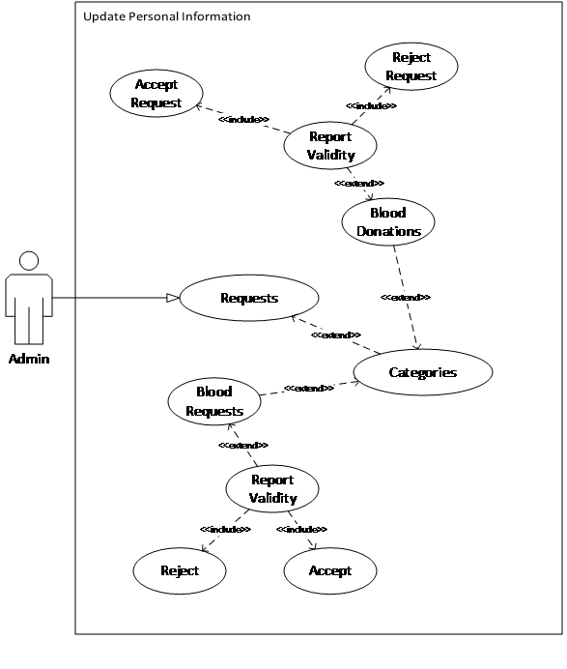

Figure 20: Manage Enquiries Use case Diagram.

### Manage User’s Personal Information



Figure 21: Manage Campaigns Use case Diagram.

### Manage Campaigns



Figure 22: Manage Donor List Use case Diagram.

### Manage Donor List



Figure 23: Manage Donor List Use case Diagram.

### Manage Sponsors



Figure 24: Manage Sponsors Use case Diagram.

### Manage Funds



Figure 25: Manage Funds Use case Diagram.

### Manage Job Posts



Figure 26: Manage Job Posts Use case Diagram.

### Manage Frequently Asked Questions



Figure 27: Manage Frequently Asked Questions Use case Diagram.

## Software Development Life Cycle Model

We used agile and prototyping methodologies for our blood donation system. By using the agile model create a system with a continuous iterative and incremental process. Develop our system through divided modules into small chunks. In our system user panel have a blood request module, develop small modules from the blood request module like post blood request, view request makers, search request makers, etc. Similarly, for other modules like making blood donations, checking the eligibility of users for blood donation, make an appointment in available blood donation Center’s. Then test every module and improve at each iteration.

Through the prototyping model, create a clear picture of the modules of our system that help in the development phases. By using prototyping, we can easily find the missing functionalities in the modules and what functionalities performed in the future development phases.

**We choose the Agile methodology for the project because:**

* It is fast and effective development.
* Through this methodology divided big problems into smaller chunks and sprints.
* The maximum number of requirements is clear and understood.
* Testing is performed continuously on each iteration in each development phase.
* Continuously improves features and product quality.
* Make the project visible at any time.
* Reduce errors and bugs due to finding mistakes in the early stages.

# Chapter 3: System Design

## Work Breakdown Structure (WBS)



Figure 28 Work Breakdown structure

## Activity Diagram

### Login

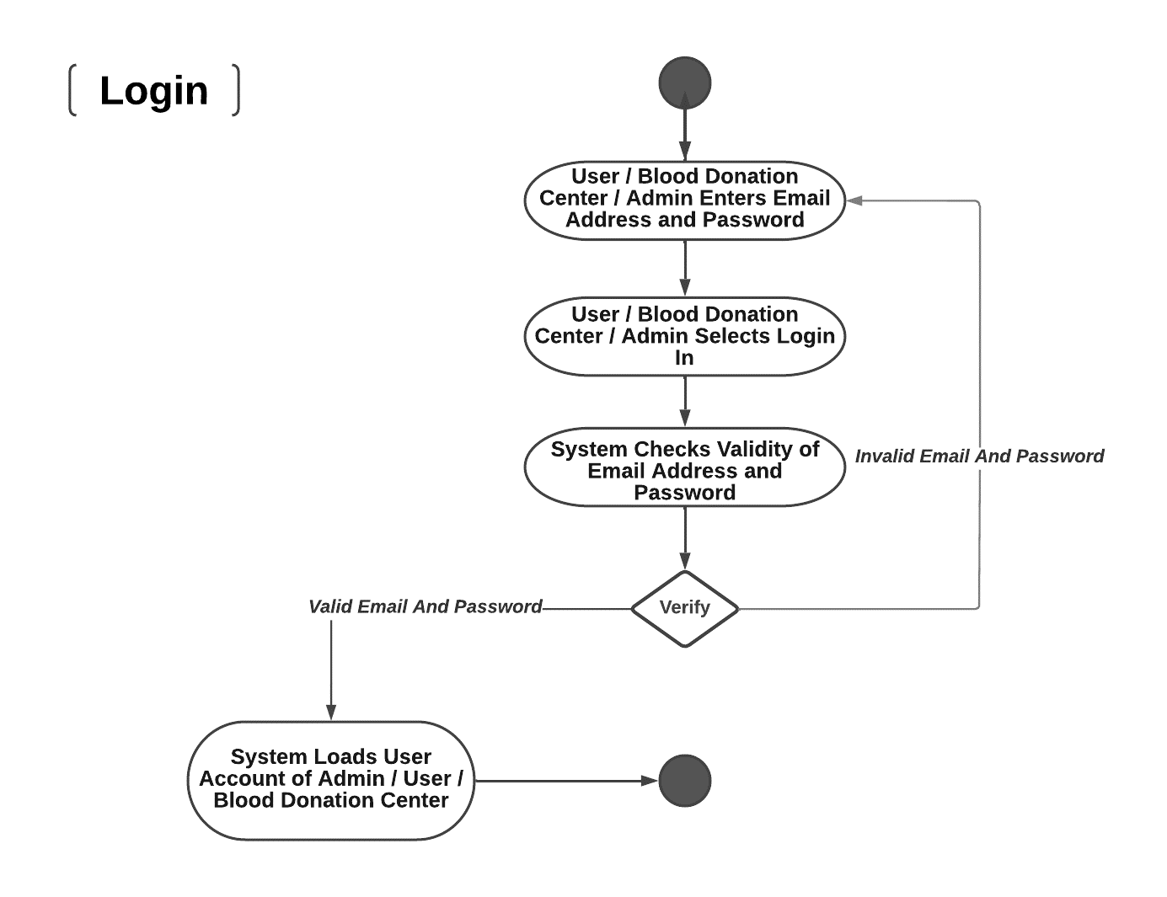

Figure 32: Login

### Registration

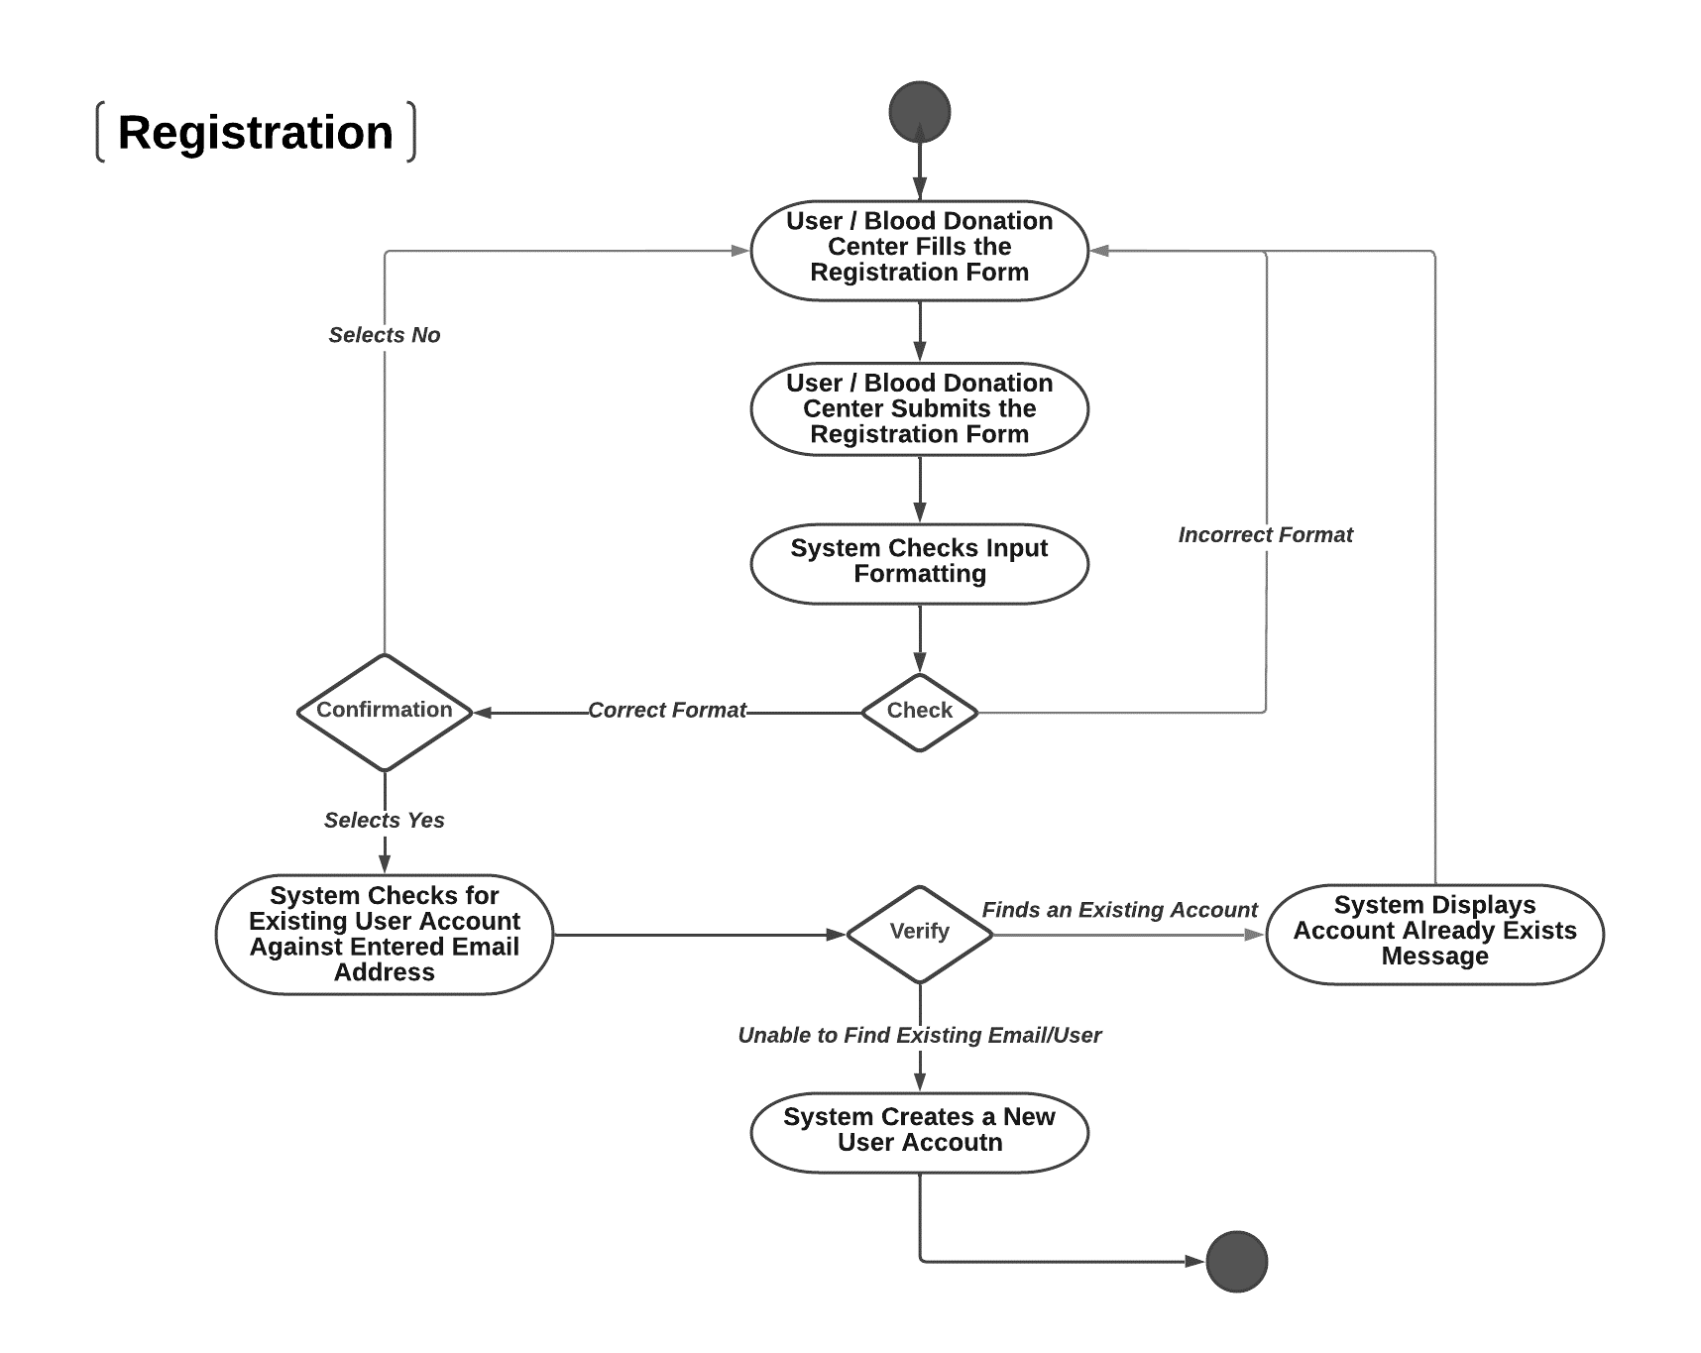

Figure 33: Registration

### Make the Request for Blood

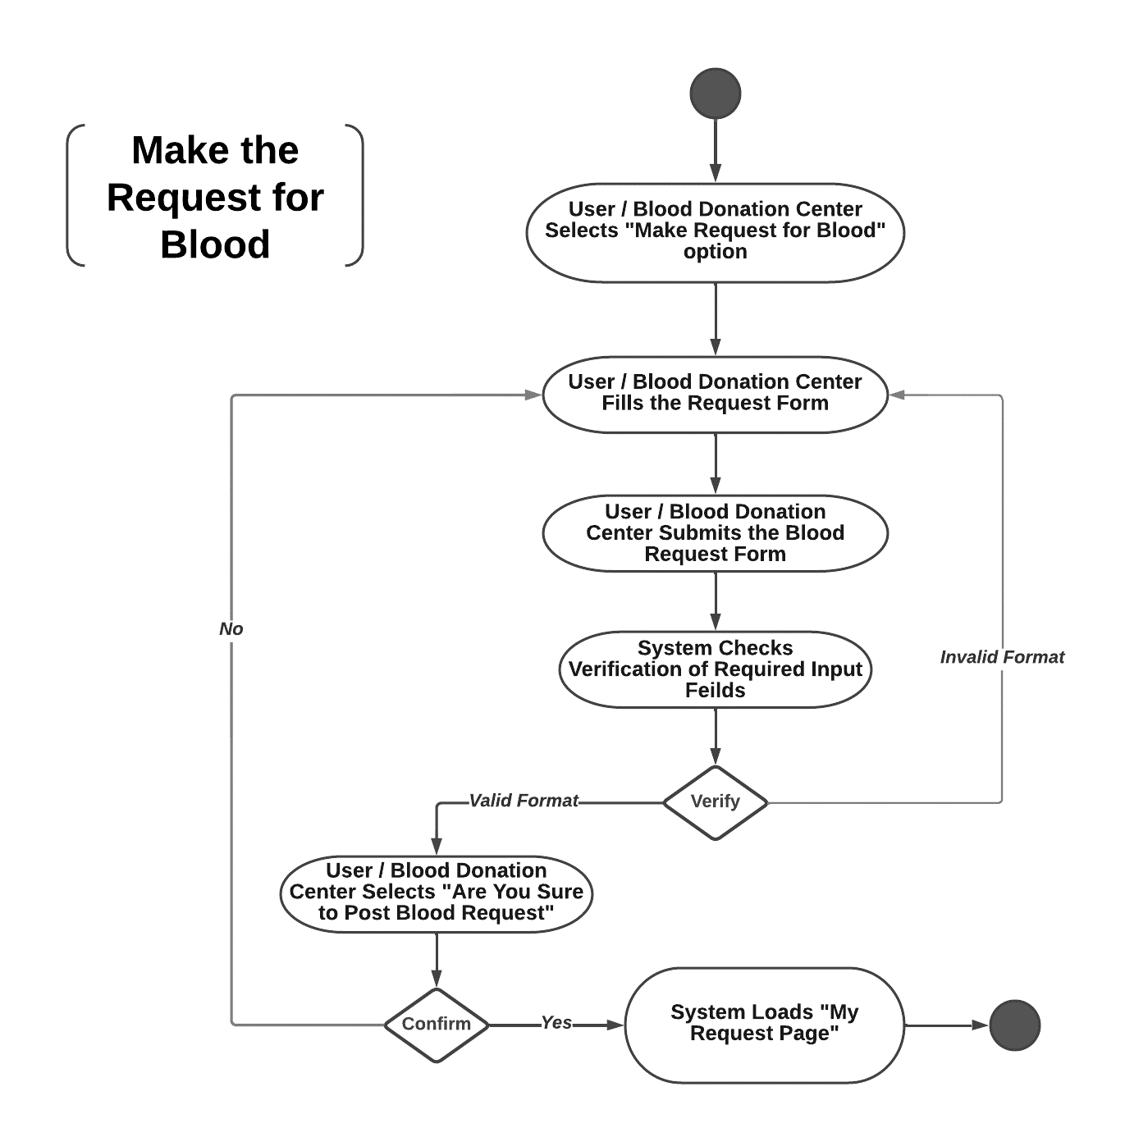

Figure 34: Make the Request for Blood

### Donate Blood

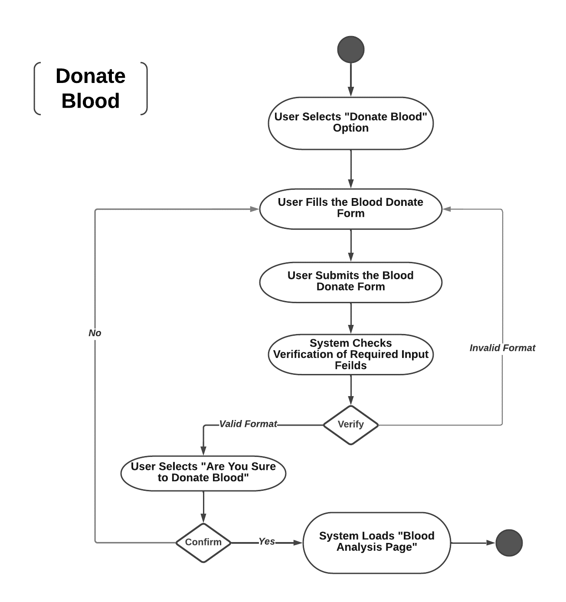

Figure 35: Donate Blood

### Check Eligibility of User for Blood Donation

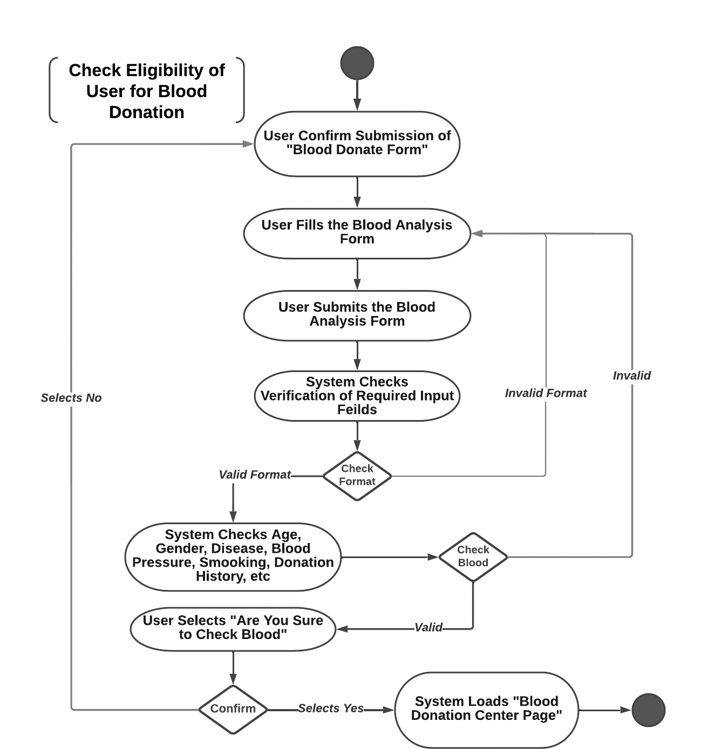

Figure 36 : Check Eligibility of User for Blood Donation

### View Blood Donation Center’s

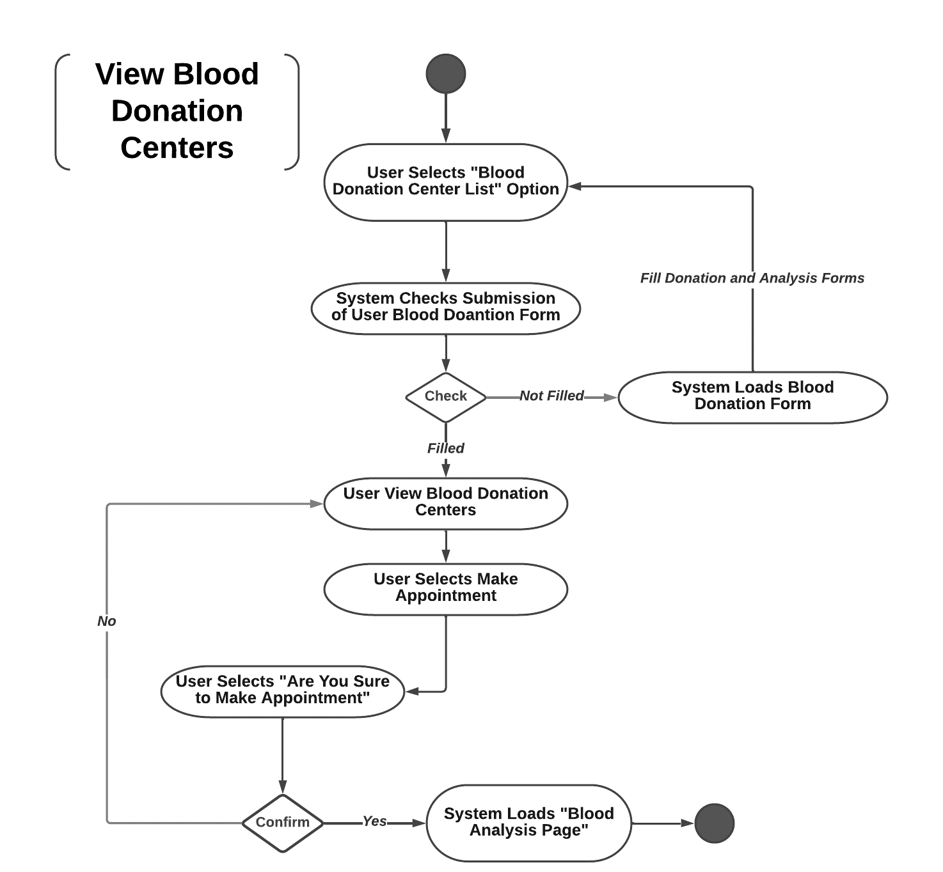

Figure 37 View Blood Donation Center’s

### Generate Appointment Report

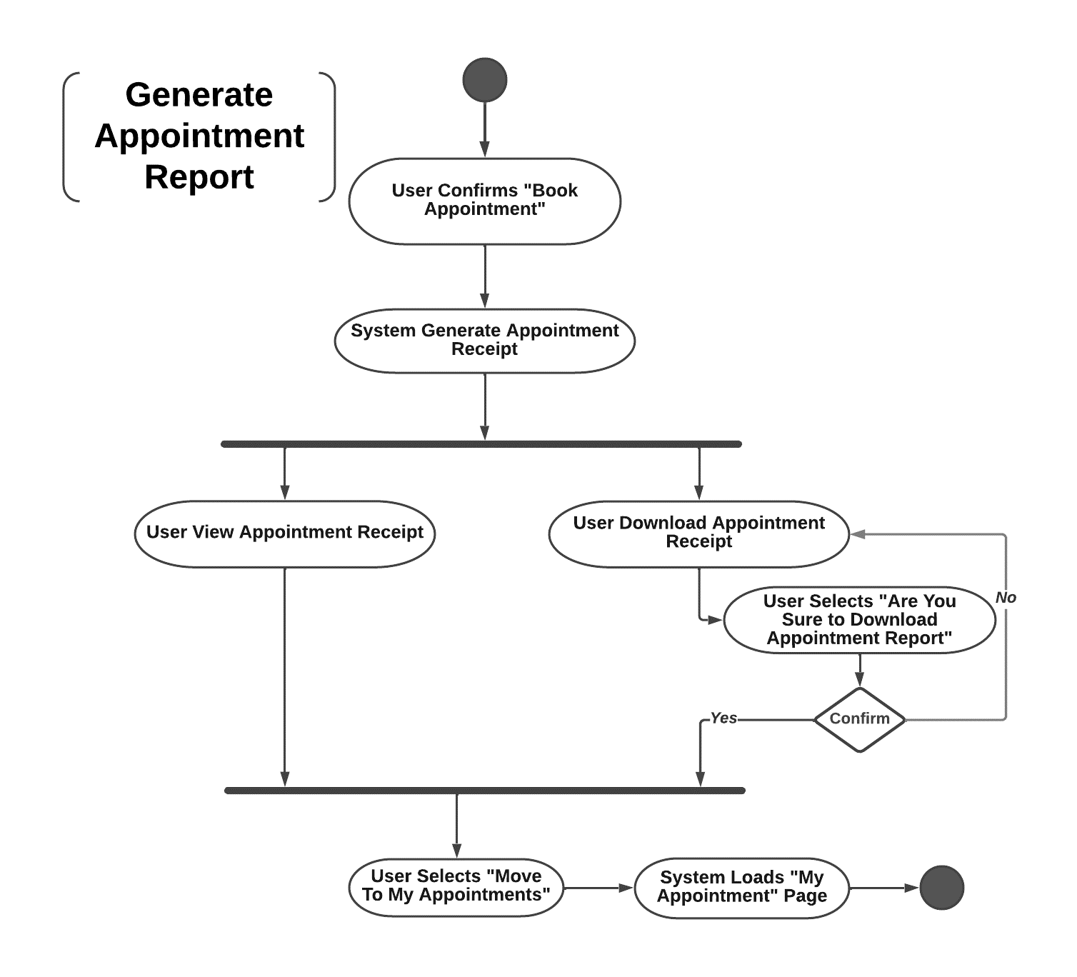

Figure 38 Generate Appointment Report

### Display User Profile

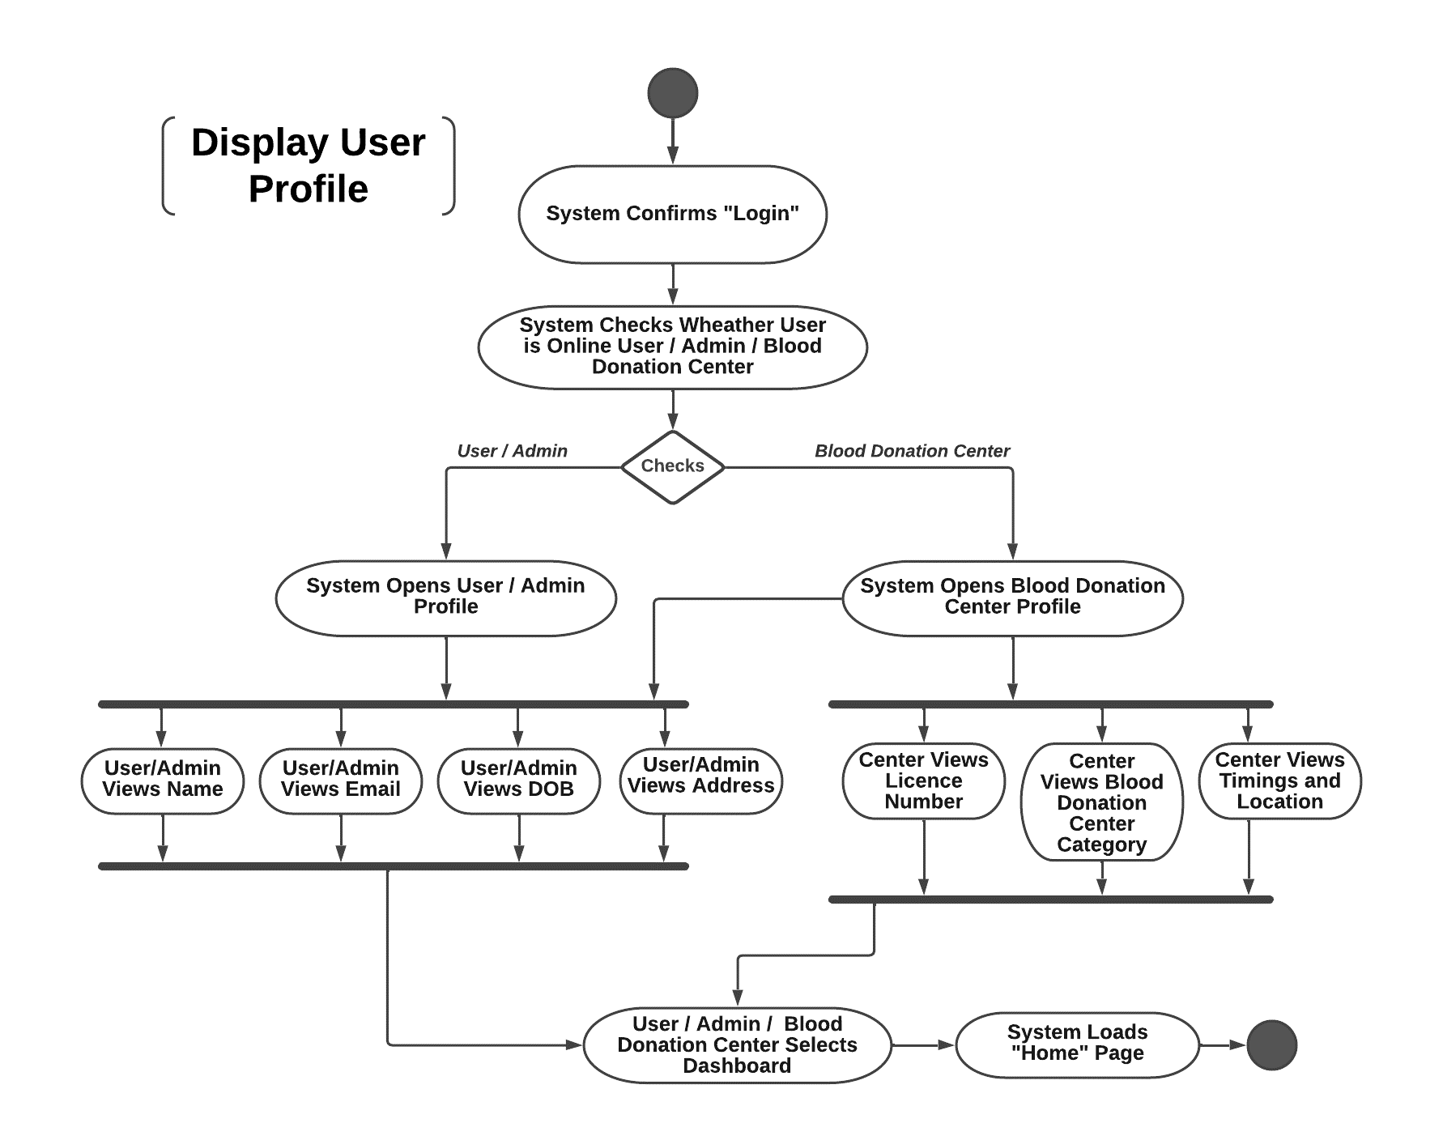

Figure 39 Display User Profile

### View Blood Requests

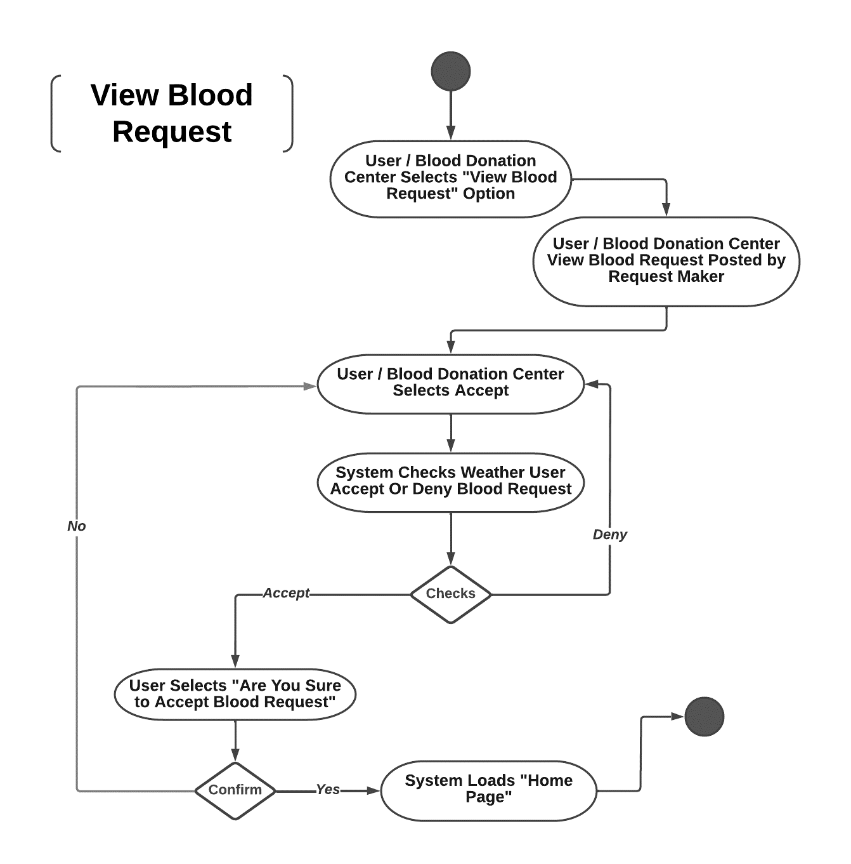

Figure 40 View Blood Requests

### Update Personal Information



Figure 42 Update Personal Information

### Delete Personal Information



Figure 43 Delete Personal Information

### Get User Feedback



Figure 44 Get User Feedback

### Add User Information



Figure 45 Add User Information

### Generate Report on Blood Stocks



Figure 46 Generate report of Blood Stock

### Update Blood Stock



Figure 47 Update blood Stock

### Download Weekly/Monthly Appointment Report



Figure 48 Download weekly Appointment Reports

### Manage NGOs or Blood Donation Center’s



Figure 50 Manage NGO or blood Donation Center requests.

### Add News



Figure 51 Add News

### Manage Job Posts

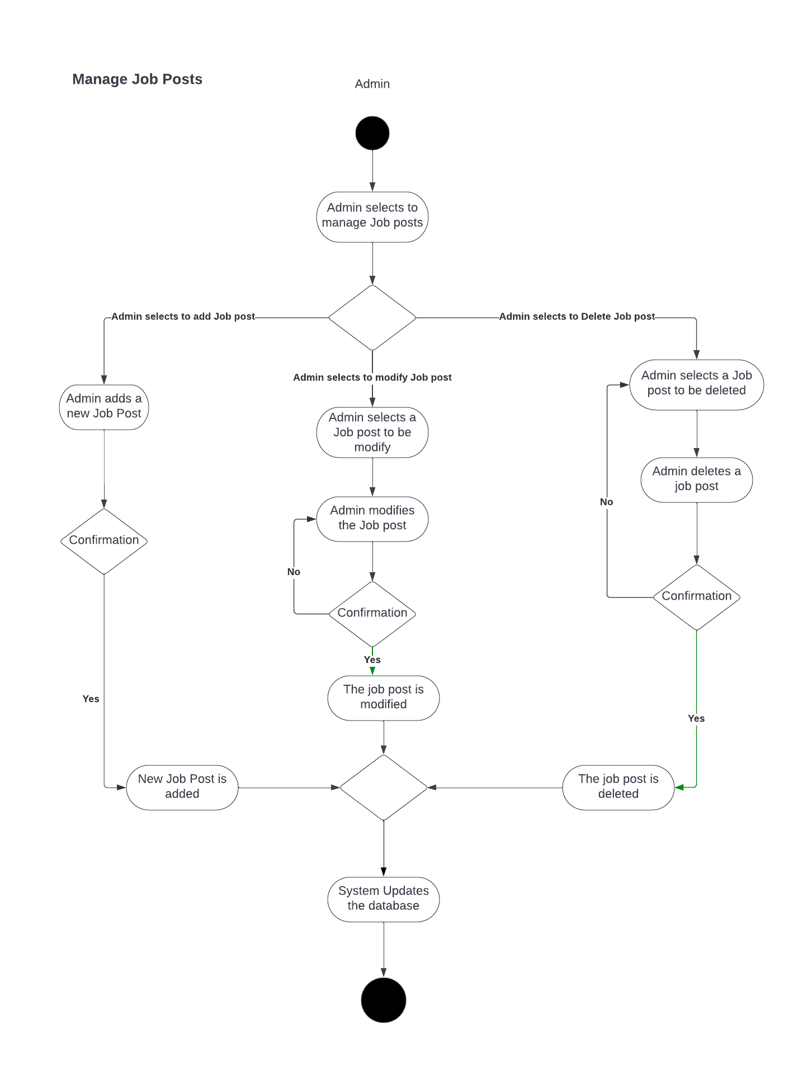

Figure 52 Manage Job Post Activity Diagram

* + 1. Manage Campaigns

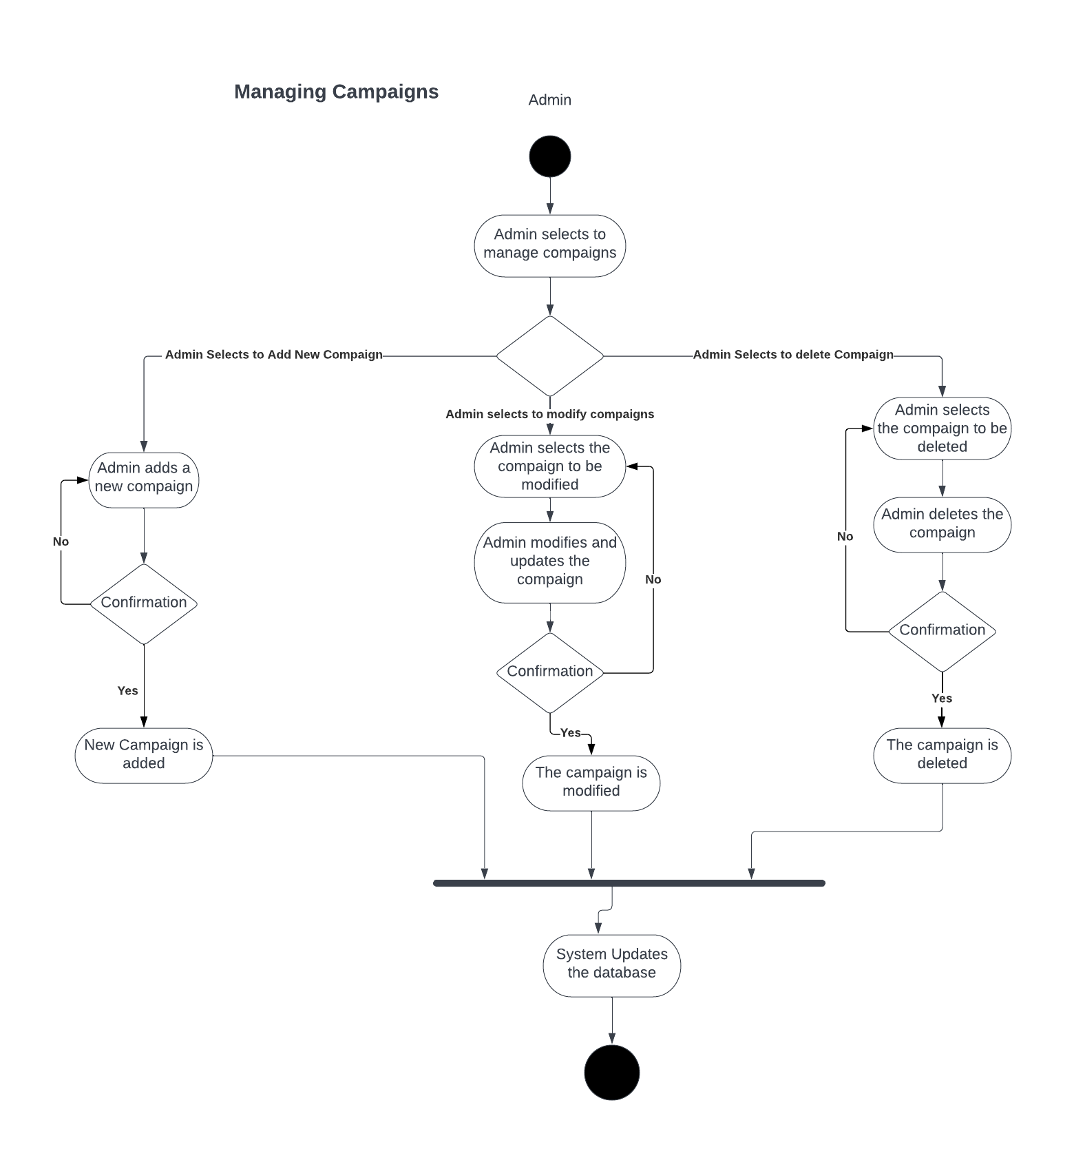

Figure 53 Manage Campaign Activity Diagram

### Manage Financial Donations

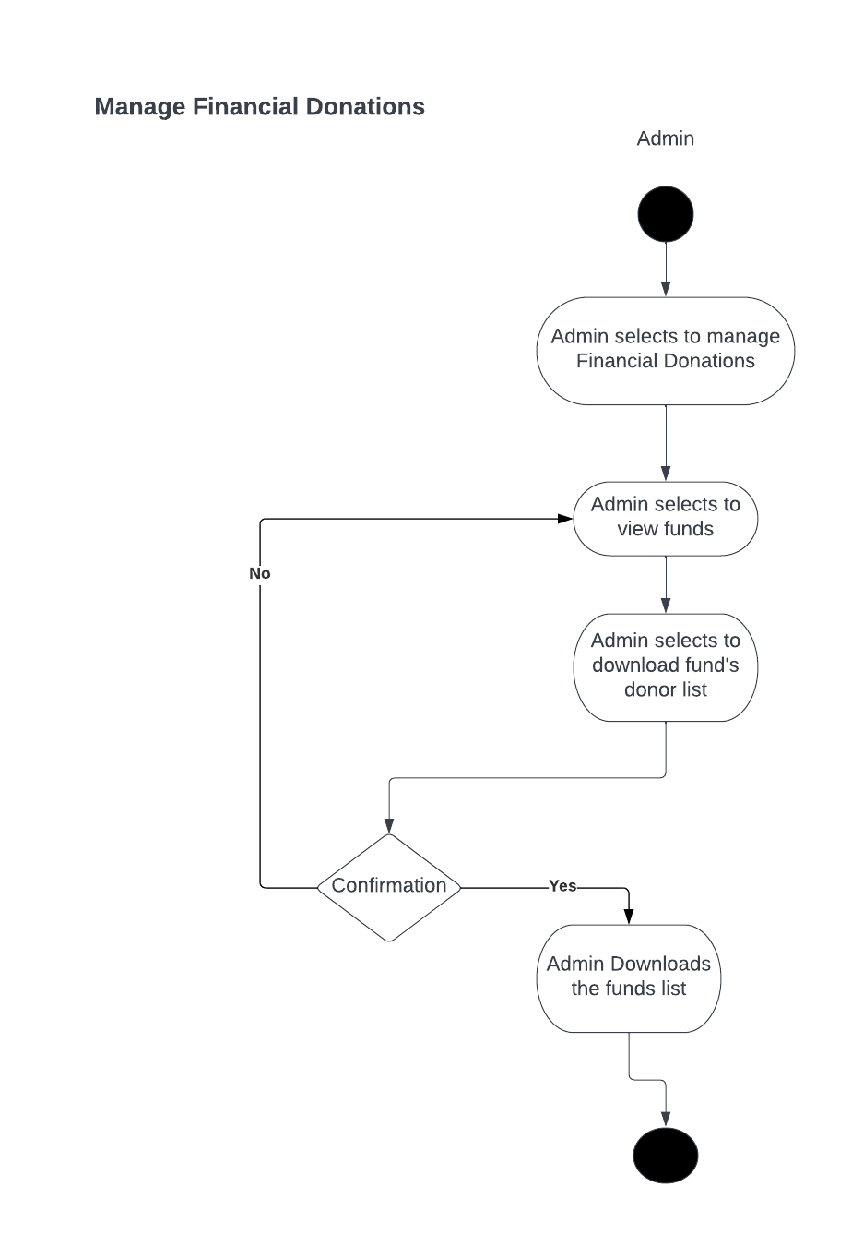

Figure 54 Manage Financial Donation Activity Diagram

### Manage Donor List

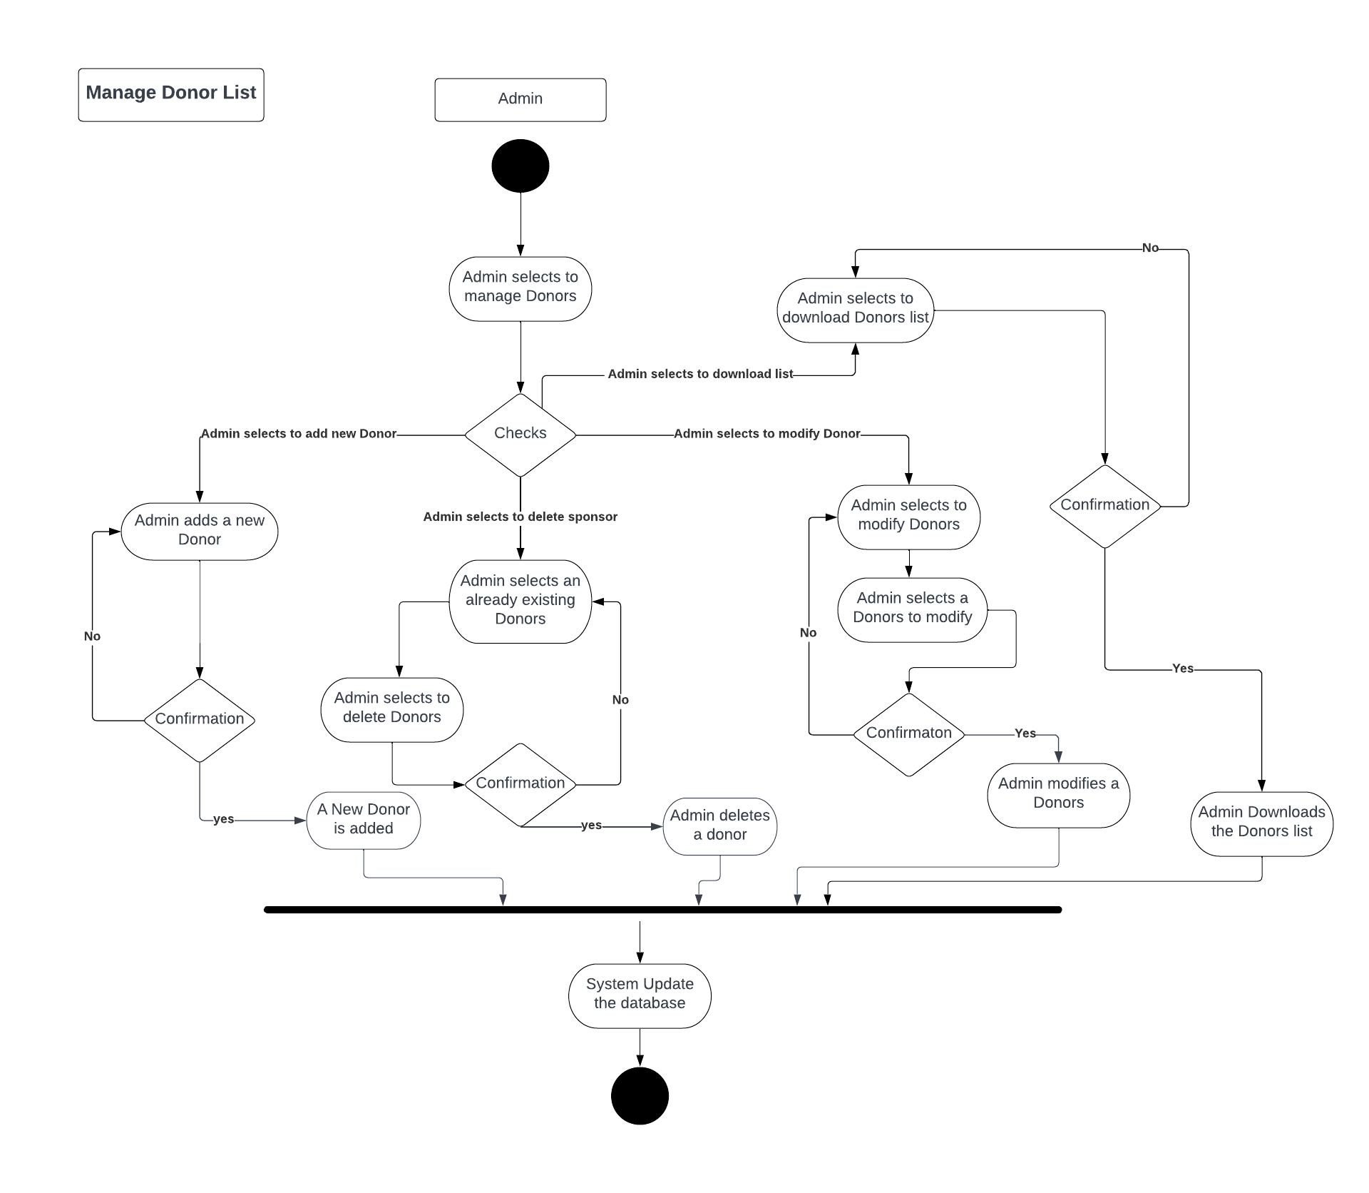

Figure 55 Manage Donor List Activity Diagram

3.2.23 Manage Advertisement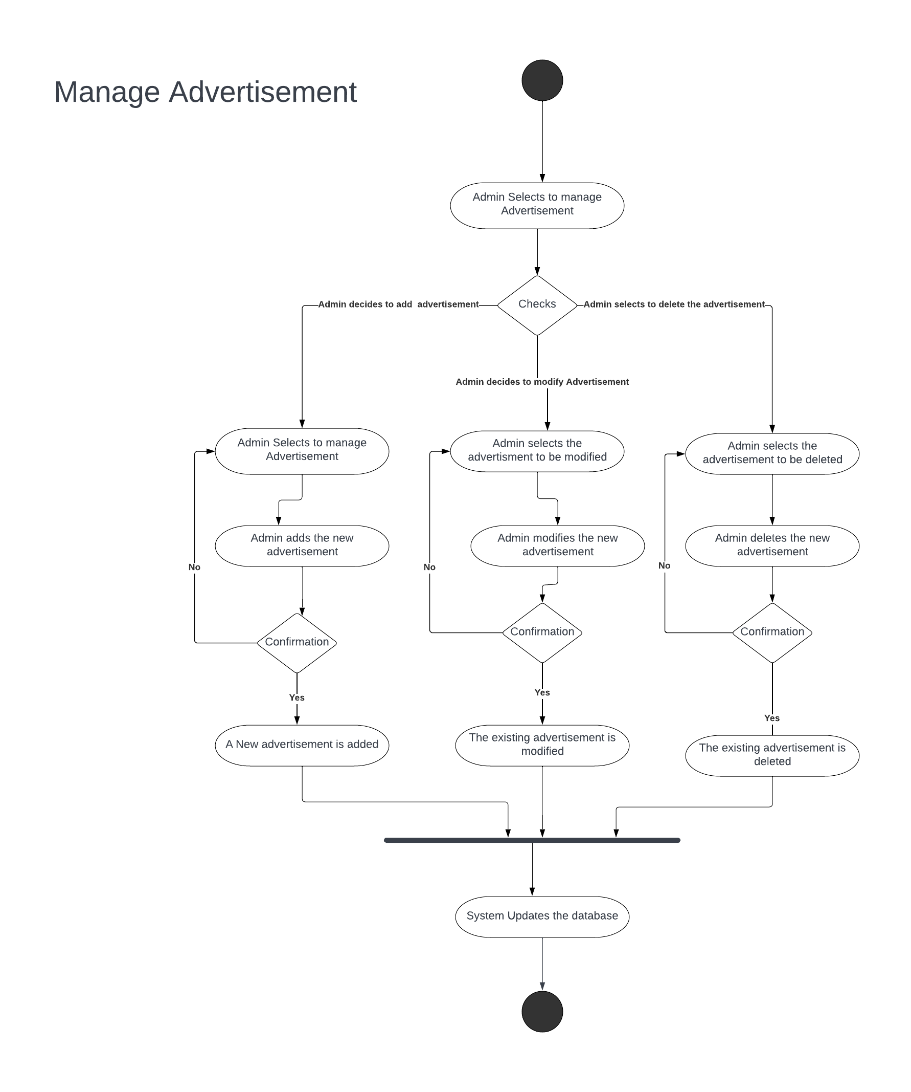

Figure 56 Manage Advertisement Activity Diagram

3.2.24 Handling Blood Request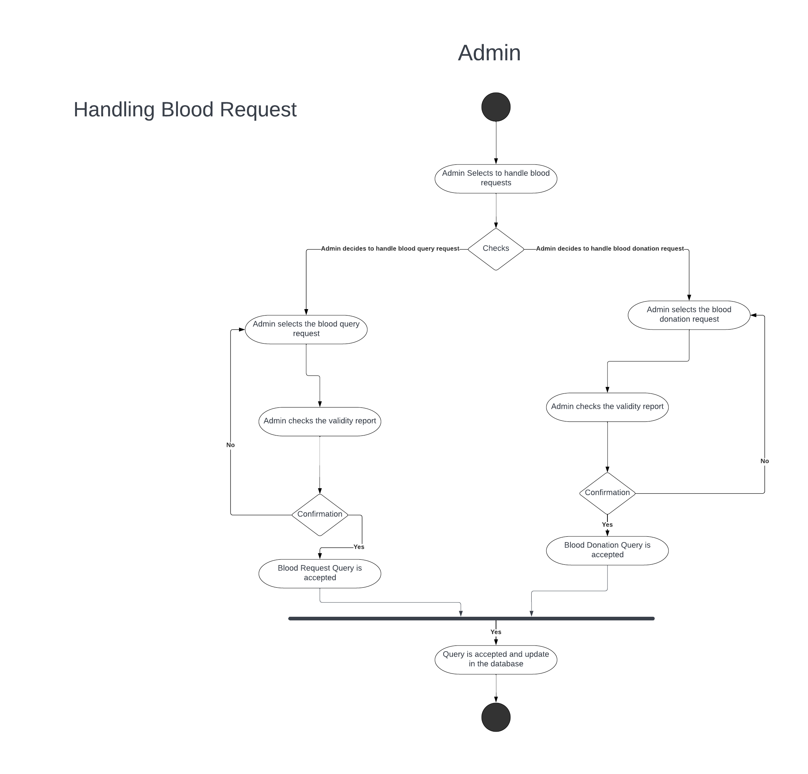

Figure 57 Handling blood Request Activity Diagram

3.2.25 Managing User’s Personal Information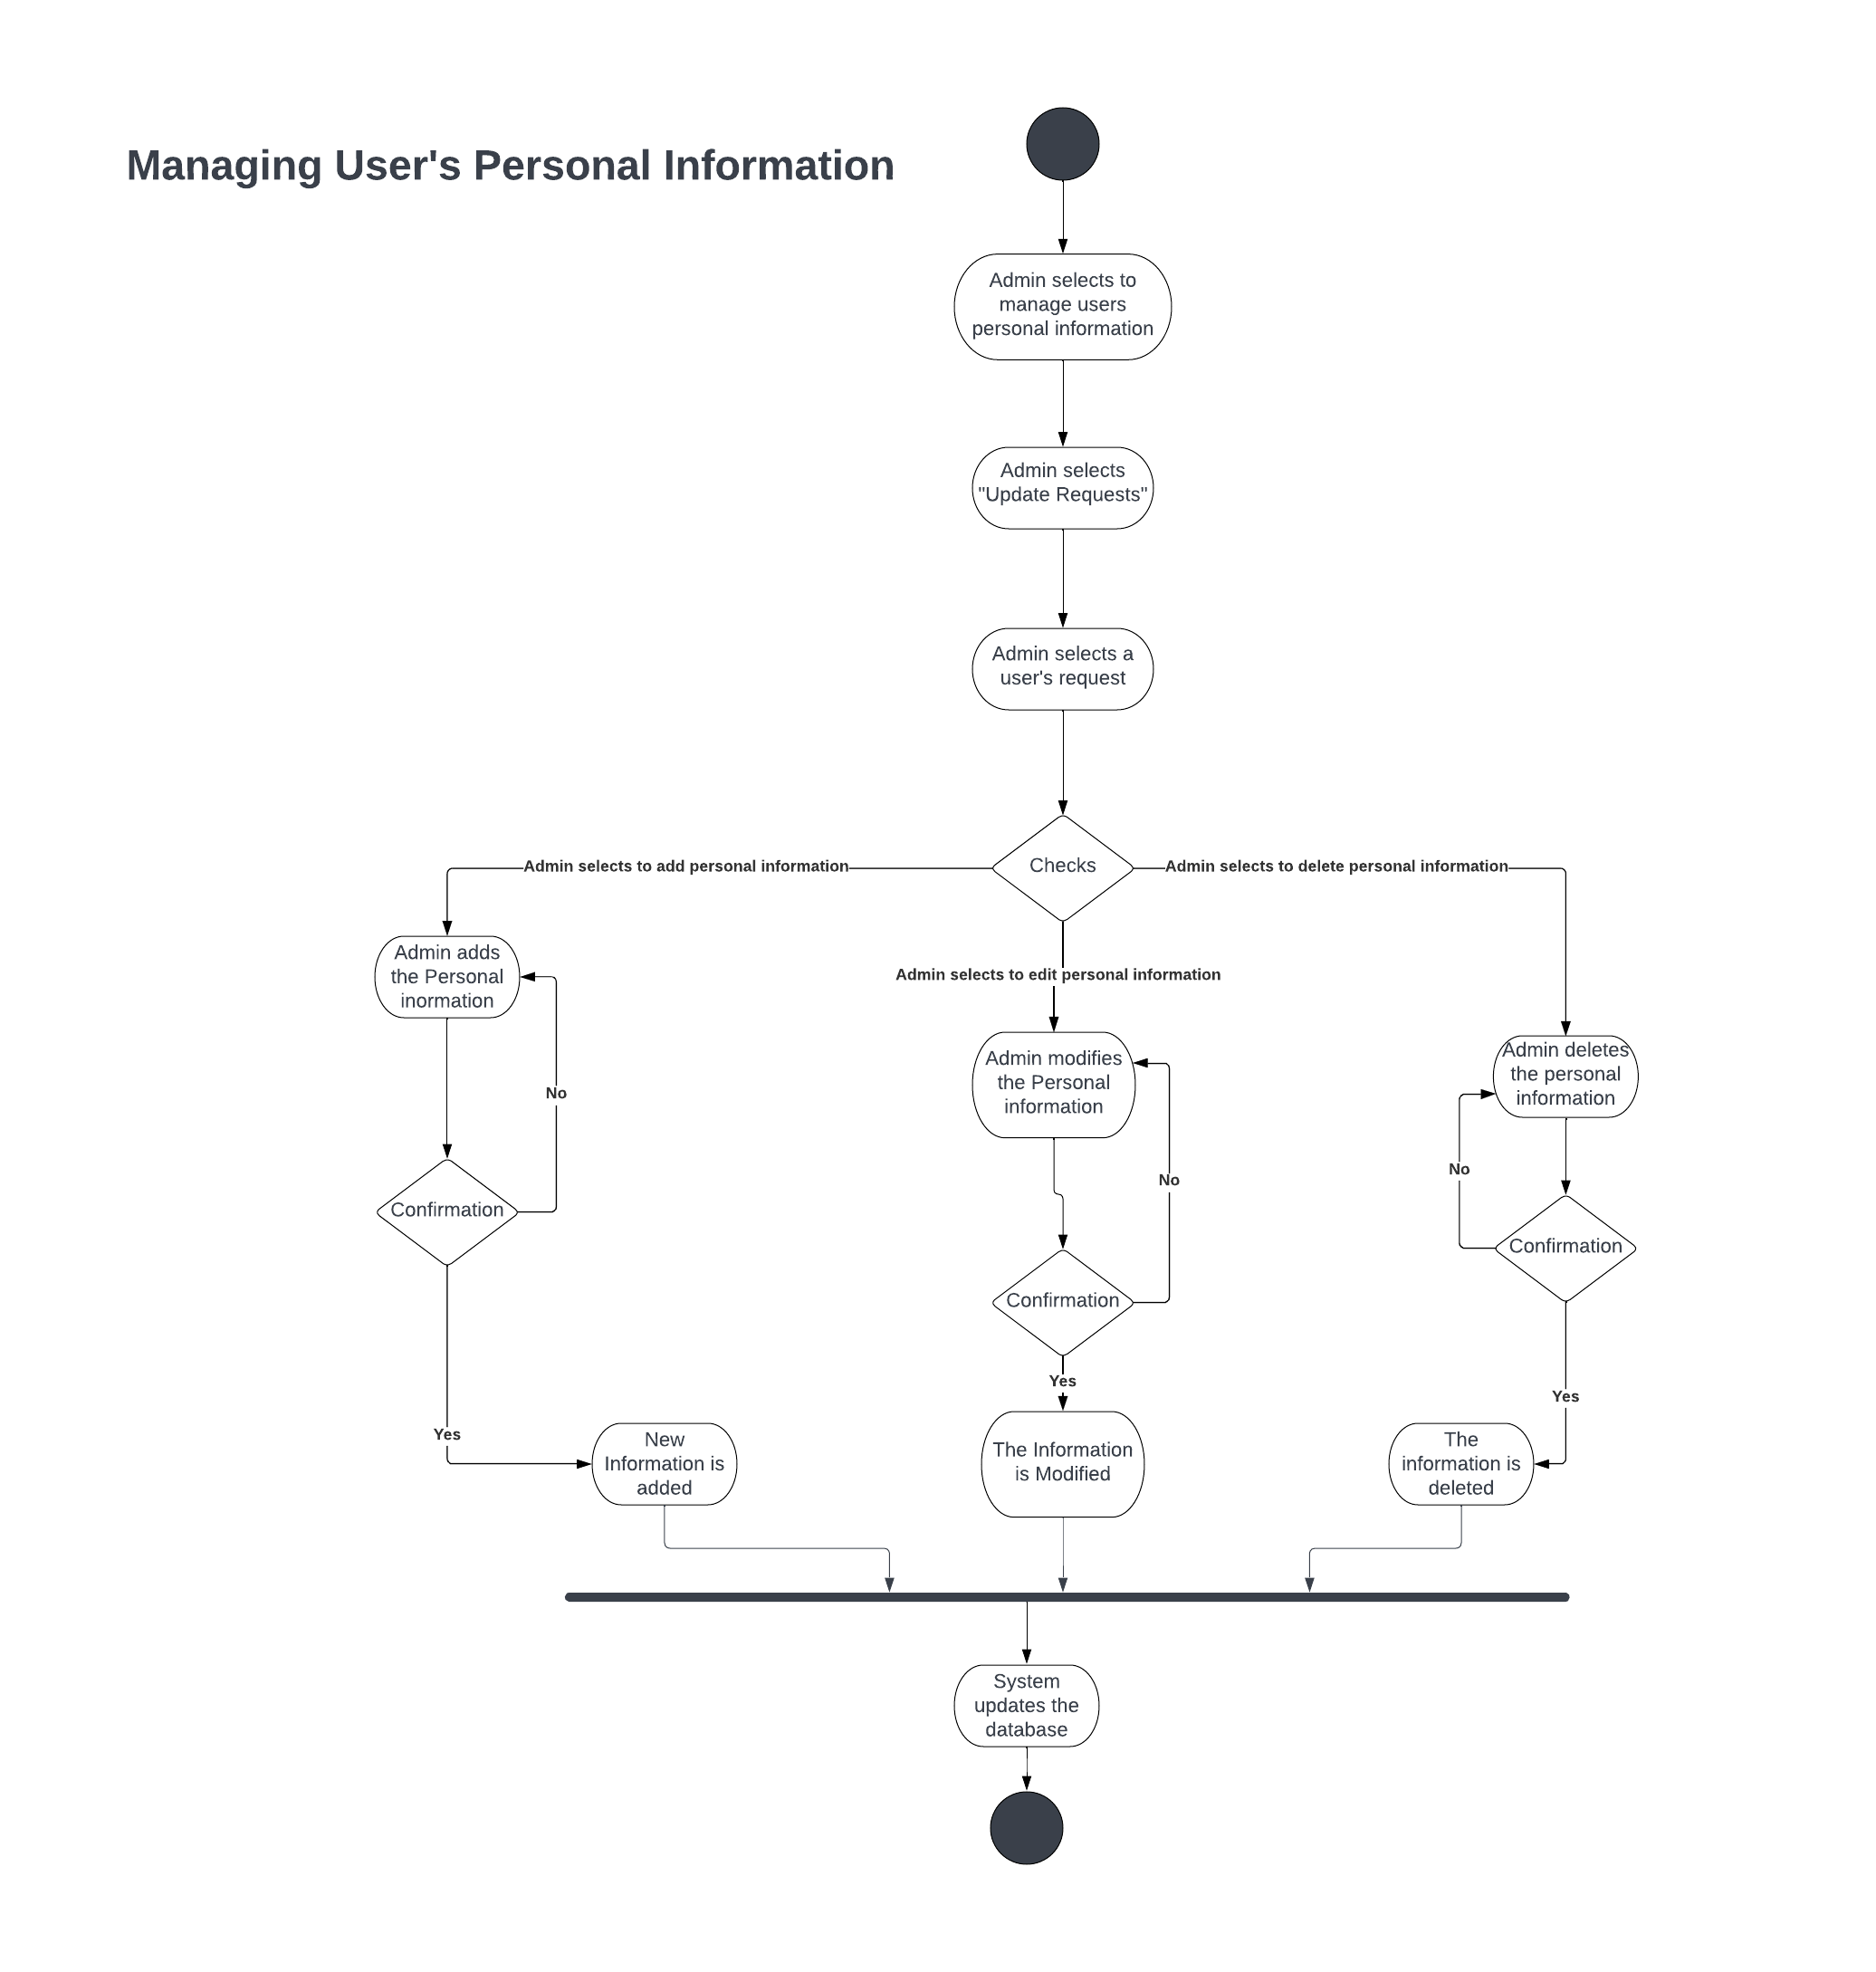

Figure 58 Managing User’s Personal Information

3.2.26 Manage Sponsors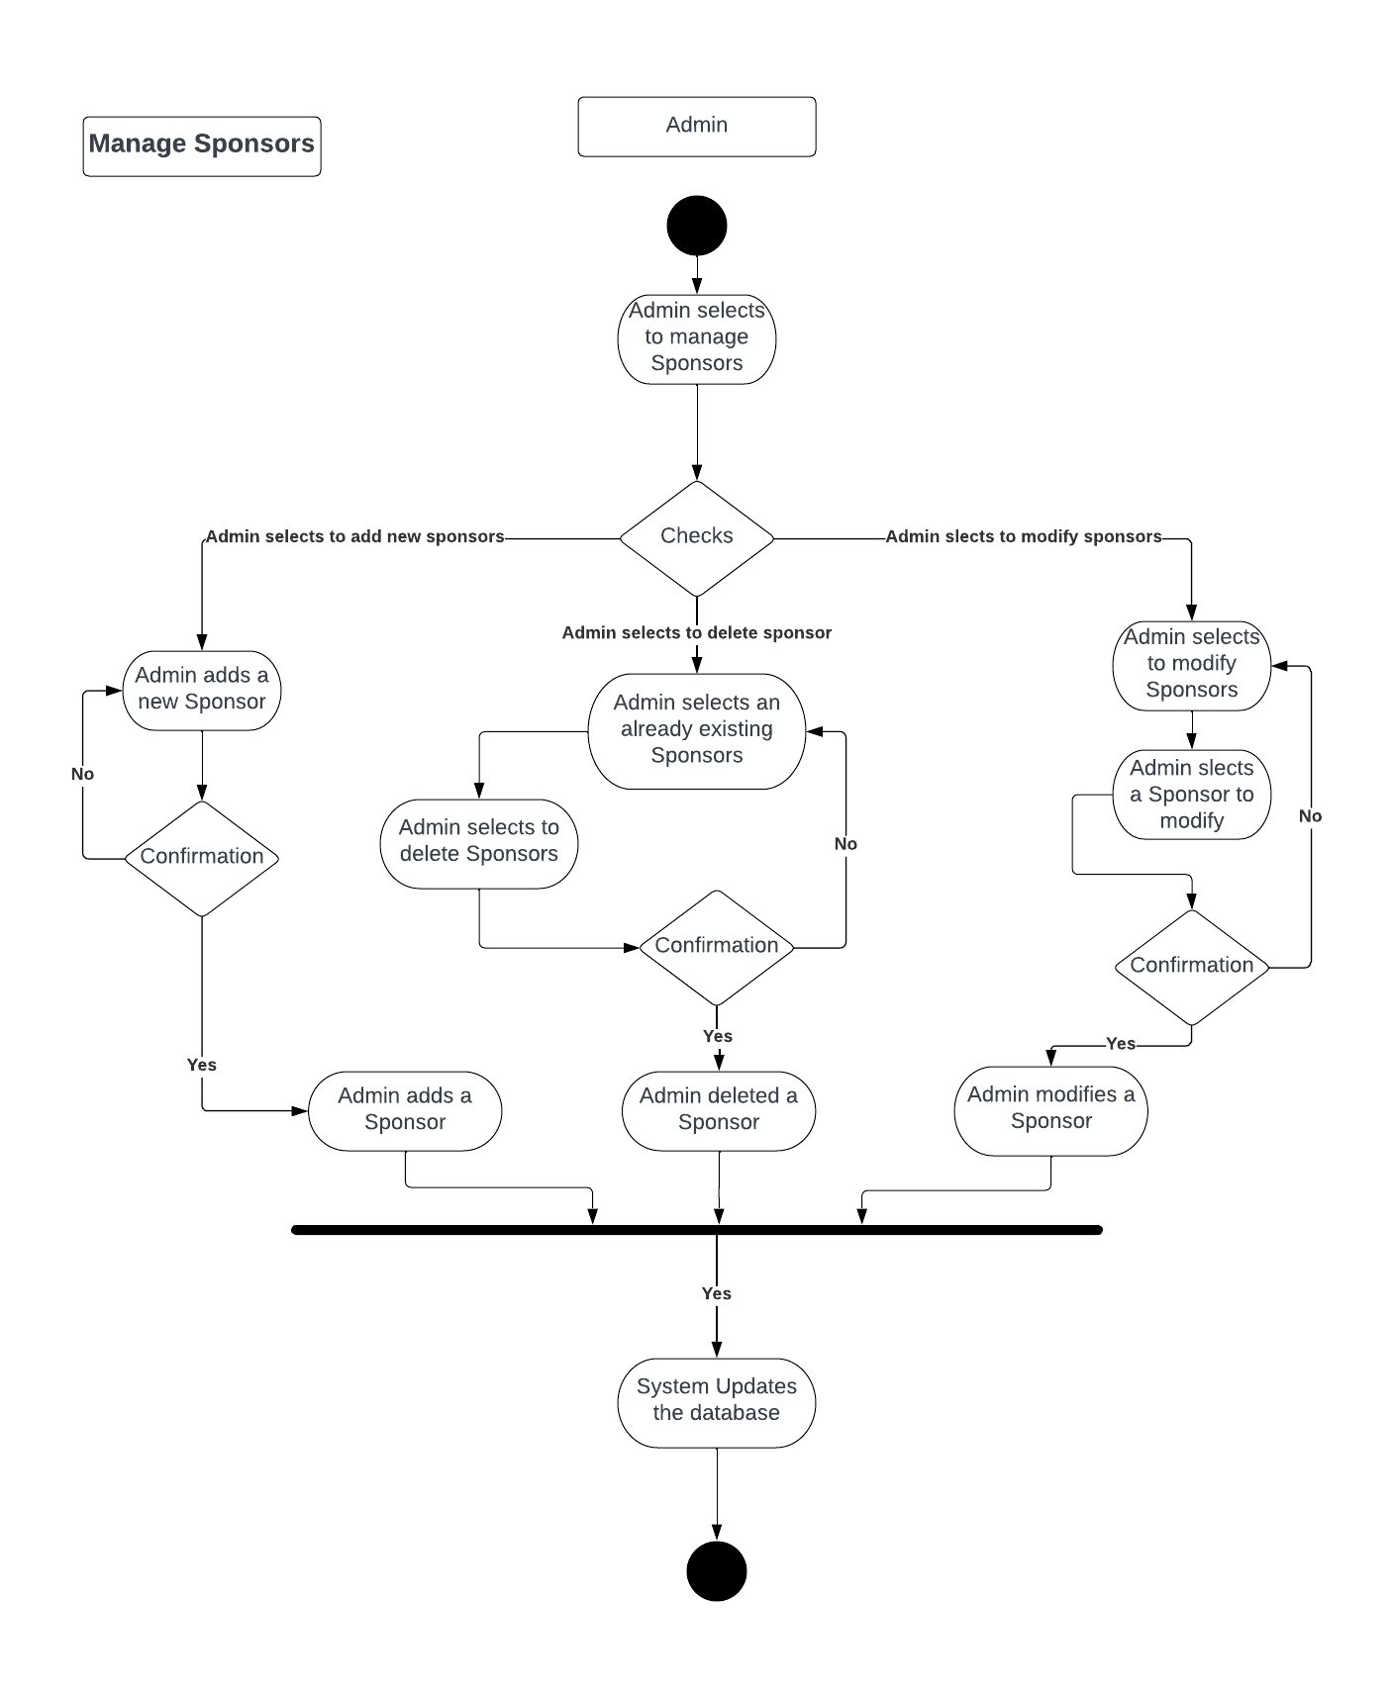

Figure 59 Manage Sponsors

3.2.27 Manage Frequently Asked Questions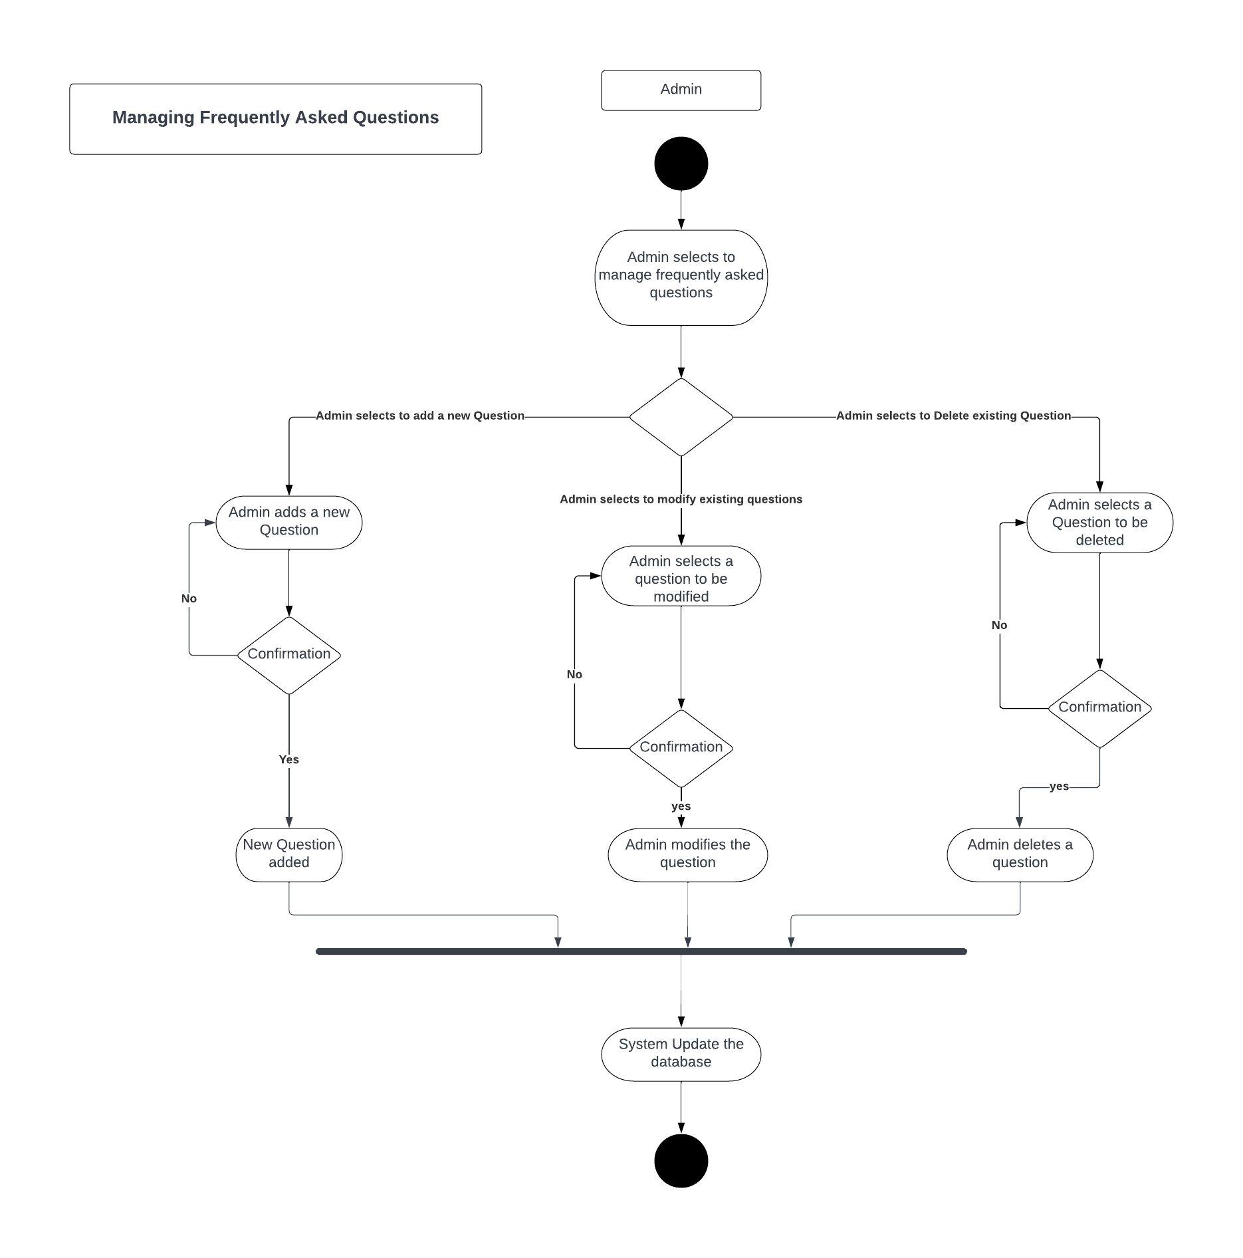

Figure 60 Manage Frequently Asked Questions

## Sequence Diagram

### Login



Figure 62 Manage Advertisement Activity Diagram

### Registration



Figure 63 Registration Sequence Diagram

### Make the Request for Blood



Figure 64 Make the Request for Blood Sequence Diagram

### Donate Blood



Figure 65 Donate Blood Sequence Diagram

### Check Eligibility of User for Blood Donation



Figure 66 Check Eligibility of User for Blood Donation

### View Blood Donation Center’s



Figure 67 View Blood Donation Center’s Sequence Diagram

### Generate Appointment Report



Figure 68 Generate Appointment Report Sequence Diagram

### Display User Profile



Figure 69 Display User Profile Sequence Diagram

### View Blood Requests



Figure 70 View Blood Request Sequence Diagram

### Update Personal Information



Figure 72 Update Personal Information

### Delete Personal Information



Figure 73 Delete Personal Information

### Get User Feedback



Figure 74 Get User Feedback

### Add User Information



Figure 75 Add Information of blood Donors.

### Generate Report on Blood Stocks



Figure 76 Generate Report on Blood Stock

### Update Blood Stock



Figure 77 Update Blood Stock

### Download Weekly/Monthly Appointment Report



Figure 78 Download Appointment Reports

### Manage NGOs or Blood Donation Center’s



Figure 80 Manage NGO or Blood Donation Center

### Manage News



Figure 81 Manage News

### Manage Advertisement



Figure 82 Manage Advertisement

### Handling Blood Request



Figure 83 Handling Blood Request

### Managing User’s Personal Information



Figure 85 Managing User’s Personal Information

### Managing Campaigns



Figure 86 Managing Campaigns

### Manage Donor List



Figure 87 Manage Donor List

### Manage Sponsors



Figure 88 Manage Sponsors

### Manage Financial Donations



Figure 89 Manage Financial Donations

### 3.3.26 Manage Job Posts



Figure 90 Manage Job Posts

### 3.3.27 Manage Frequently Asked Questions



Figure 91 Manage Frequently Asked Questions

## Software Architecture

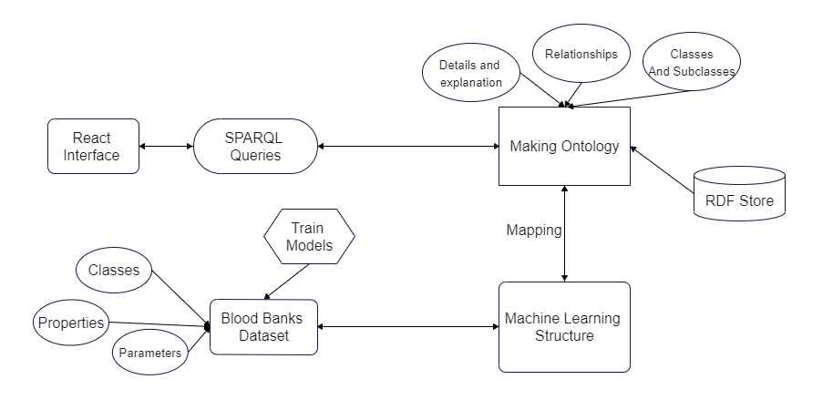

Figure 92 Software Architecture Diagram

## Class Diagram



Figure 93 Class Diagram

## Database Diagram



Figure 94 Database Diagram

## Collaboration Diagram

### Login



Figure 95 Login Collaboration Diagram

### Registration



Figure 96 Registration Collaboration Diagram

### Make the Request for Blood



Figure 97 Make the request for blood Collaboration Diagram

### Donate Blood



Figure 98 Donate Blood Collaboration Diagram

### Check Eligibility of User for Blood Donation



Figure 99 Check Eligibility of User for Blood Donation Collaboration Diagram

### View Blood Donation Center’s



Figure 100 View Blood Donation Center Collaboration Diagram

### Generate Appointment Report



Figure 101 Generate Appointment Report Collaboration Diagram

### Display User Profile



Figure 102 Display User Profile Collaboration Diagram

### View Blood Requests



Figure 103 View Blood Request Collaboration Diagram

### Update Personal Information



Figure 105 Update Personal Information Collaboration Diagram

### Delete Personal Information



Figure 106 Delete Persona Information Collaboration Diagram

### Get User Feedback



Figure 107 Get User Feedback Collaboration Diagram

### Add User Information



Figure 108 Add User Information Collaboration Diagram

### Generate Report on Blood Stocks



Figure 109 Generate Report on Blood Stock Collaboration Diagram

### Update Blood Stock



Figure 110 Update Blood Stock Collaboration Diagram

### Download Weekly/Monthly Appointment Report



Figure 111 Download Appointment Reports Collaboration Diagram

### Manage NGOs or Blood Donation Center’s



Figure 113 Manage NGO’s/Blood Donation Center Collaboration Diagram

### Add News



Figure 114 Manage News Collaboration Diagram

### Manage Advertisement



Figure 115 Manage Advertisement Collaboration Diagram

### Handling Blood Requests



Figure 116 Handling Blood Requests Collaboration Diagram

### Managing User’s Personal Information



Figure 118 Manage Users Personal Information Collaboration Diagram

### Managing Campaigns



Figure 119 Manage Campaigns Collaboration Diagram

### Managing Donors List



Figure 120 Manage Donor List Collaboration Diagram

### Manage Sponsors



Figure 121 Manage Sponsors Collaboration Diagram

### Manage Financial Donation



Figure 122 Manage Financial Donation Collaboration Diagram

### Manage Job Posts



Figure 123 Managing Job Posts Collaboration Diagram

### Managing Frequently Asked Questions



Figure 124 manage Frequently Asked Questions Collaboration Diagram

1. Chapter 4: System Testing
   1. Test Cases

Test Case 4.1.1 - Login

|  |  |  |  |  |  |  |
| --- | --- | --- | --- | --- | --- | --- |
| **Test Case ID** | **Test Case Scenario** | **Test Case** | **Preconditions** | **Test Steps** | **Post Conditions** | **Pass/Fail** |
| **TC-01** | User/Admin Login | Verify whether user is Able to login into the system or not. | The User or Blood Donation Center or Admin be registered in the system in order to login the system. | 1. This test case starts when the user enters the required fields in the sign-in form.  2. This User hits the login button  3. This test case ends. | The User (only in Online Blood Donation System) or Blood Donation Center or Admin has successfully gained access to his/her user account/system profile. | Pass |

*Table 68: Test Case 4.1.1 - Login*

Test Case 4.1.2 - Register

|  |  |  |  |  |  |  |
| --- | --- | --- | --- | --- | --- | --- |
| **Test Case ID** | **Test Case Scenario** | **Test Case** | **Preconditions** | **Test Steps** | **Post Conditions** | **Pass/Fail** |
| **TC-02** | User/ Admin registration | Verify whether the user is able to register into the system or not. | The User or Blood Donation Center must fill and submit their online registration form in order to get registered in the system. | 1. This test case starts when the user fills the form to get access to the system.  2. The form is submitted after correctly filling out the fields.  3. The user hits the register button and Test case Ends | The User (only in Online Blood Donation System) or Blood Donation Center has been registered in the system. | **Pass** |

*Table 69: Test Case 4.1.2 - Register*

Test Case 4.1.3 – Make Request for Blood

|  |  |  |  |  |  |  |
| --- | --- | --- | --- | --- | --- | --- |
| **Test Case ID** | **Test Case Scenario** | **Test Case** | **Preconditions** | **Test Steps** | **Post Conditions** | **Pass/Fail** |
| **TC-03** | Making of Blood Request | Verify whether the user can make the blood request or not | The User or Blood Donation Center must be logged in into the system and the User or Blood Donation Center must select the “Blood Request” option from the navigation bar. | **1.**This Test case starts when the user wants to make Blood Request.  2. The user gives his/her complete and valid details and the request of the particular group that he wants to get.  3. The user submits the request.  4. This test case ends | The User (only in Online Blood Donation System) has been moved to the “my requests” page. | **Pass** |

*Table 70: Test Case 4.1.3 – Make Request for Blood*

Test Case 4.1.4 – Donate Blood

|  |  |  |  |  |  |  |
| --- | --- | --- | --- | --- | --- | --- |
| **Test Case ID** | **Test Case Scenario** | **Test Case** | **Preconditions** | **Test Steps** | **Post Conditions** | **Pass/Fail** |
| **TC-04** | Blood Donation Request | Verify whether the user can make request for blood donation or not. | The User must be logged in into the system and the User must select the “Donate Blood” option from the navigation bar. | 1.This test case starts when the user wants to donate the blood.  2. The Users provides his complete and valid Information related to his physical health.  3. The User selects submit donation request and the test case Ends. | The User (only in Online Blood Donation System) has been moved to the check blood eligibility page in the system. | **Pass** |

*Table 71: Test Case 4.1.4 – Donate Blood*

Test Case 4.1.5 – Check Eligibility of user for Blood Donation

|  |  |  |  |  |  |  |
| --- | --- | --- | --- | --- | --- | --- |
| **Test Case ID** | **Test Case Scenario** | **Test Case** | **Preconditions** | **Test Steps** | **Post Conditions** | **Pass/Fail** |
| **TC-05** | Checking Eligibility for donation | Verify the User to check eligibility for blood donation by filling the blood analysis form. | The User must be logged in into the system and the User must fill the initial form of blood donation for checking the eligibility of blood donation. | 1.This test case starts when the user wants to check whether he is eligible for blood donation or not.  2. The user gives information about his physical health.  3.The User confirms and submits the analysis form.  4.This test case Ends. | The User (only in Online Blood Donation System) has received confirmation messages about blood analysis and moved to the check blood donation list page in the system. | **Pass** |

*Table 72: Test Case 4.1.5 – Check Eligibility of user for Blood Donation*

Test Case 4.1.6 – View Blood Donation Center’s

|  |  |  |  |  |  |  |
| --- | --- | --- | --- | --- | --- | --- |
| **Test Case ID** | **Test Case Scenario** | **Test Case** | **Preconditions** | **Test Steps** | **Post Conditions** | **Pass/Fail** |
| **TC-06** | Viewing Blood Donation Center’s | Verify Whether the Online User can view the blood donation Center list and make appointments for blood donation. | The user must be logged in into the system and the user must fill the blood donation form before making appointments. | 1. This test case starts when a registered User wants to view blood donation Center lists and make appointments.  2. The User opens the list and views the Blood Donation Center details.  3.The user accepts or denies the appointment.  4. This test case ends. | The User (only in Online Blood Donation System) or Blood Donation Center or Admin has successfully viewed blood donation requests and made appointments about blood donation. | **Pass** |

*Table 73 :Test Case 4.1.6 – View Blood Donation Center’s*

Test Case 4.1.7 – Generate Appointment Report

|  |  |  |  |  |  |  |
| --- | --- | --- | --- | --- | --- | --- |
| **Test Case ID** | **Test Case Scenario** | **Test Case** | **Preconditions** | **Test Steps** | **Post Conditions** | **Pass/Fail** |
| **TC-07** | Generate Appointment Report | Verify that whether the User can generate the appointment receipt. | The user must be logged in into the system and the user must book the appointment. | 1. This test case starts when a registered User wants to generate an appointment receipt.  2. Users opens the appointment page and gets the appointment report.  3. The User downloads the appointment report.  4.This Test case Ends. | The User (only in Online Blood Donation System) or Blood Donation Center or Admin has successfully generated and downloaded appointments. | **Pass** |

*Table 74: Test Case 4.1.7 – Generate Appointment Report*

Test Case 4.1.8 – Display User Profile

|  |  |  |  |  |  |  |
| --- | --- | --- | --- | --- | --- | --- |
| **Test Case ID** | **Test Case Scenario** | **Test Case** | **Preconditions** | **Test Steps** | **Post Conditions** | **Pass/Fail** |
| **TC-08** | Displaying User/Admin Profile | Verify that the Online User or blood donation Center or admin to view the personal details by clicking on the view profile tab. | The user, admin or blood donation Center must be logged in into the system. | 1. This test case starts when a registered User or Blood Donation Center or Admin wants to view personal details.  **2.**The user or blood donation Center or admin opens the profile page.  The admin views his personal Information.  3.The User views his personal information and this test case ends. | The User (only in Online Blood Donation System) or Blood Donation Center or Admin has successfully viewed his/her user account/system profile | **Pass** |

*Table 75: Test Case 4.1.8 – Display User Profile*

Test Case 4.1.9 – View Blood Requests

|  |  |  |  |  |  |  |
| --- | --- | --- | --- | --- | --- | --- |
| **Test Case ID** | **Test Case Scenario** | **Test Case** | **Preconditions** | **Test Steps** | **Post Conditions** | **Pass/Fail** |
| **TC-09** | Viewing Blood Requests | Verify that the Online User or blood donation Center to view the blood requests posted by the request maker and make decisions about acceptance or rejection. | The user or blood donation Center must be logged in into the system | 1. This test case starts when a registered User or Blood Donation Center or Admin wants to view blood requests and make decisions about them.  **2.** The user or blood donation Center views the request makers request post with complete details provided by the request maker.  3. The user confirms to accept or deny request.  4. This Test case ends. | The User (only in Online Blood Donation System) or Blood Donation Center or Admin has successfully viewed blood donation requests and made decisions (Accept or Deny). | **Pass** |

*Table 76: Test Case 4.1.9 – View Blood Requests*

Test Case 4.1.10 – Update Personal Information

|  |  |  |  |  |  |  |
| --- | --- | --- | --- | --- | --- | --- |
| **Test Case ID** | **Test Case Scenario** | **Test Case** | **Preconditions** | **Test Steps** | **Post Conditions** | **Pass/Fail** |
| **TC-10** | Updating Personal Information | Verify that the Online User or Blood Donation Center to update himself/herself personal information in the system. | The user and blood donation Center must be logged in into the system and the User or Blood Donation Center must fill and submit their online updating form in order to get updated in the system. | 1. This test case starts when a User (only in Online Blood Donation System) or Blood Donation Center wants to update personal information in the system.  **2.** The user updates his profile information by providing with some newer details.  3. The user confirms to add new information.  4.This test case ends. | The User (only in Online Blood Donation System) or Blood Donation Center or Admin has updated personal information in the system. | **Pass** |

*Table 78: Test Case 4.1.10 – Update Personal Information*

Test Case 4.1.11 – Delete Personal Information

|  |  |  |  |  |  |  |
| --- | --- | --- | --- | --- | --- | --- |
| **Test Case ID** | **Test Case Scenario** | **Test Case** | **Preconditions** | **Test Steps** | **Post Conditions** | **Pass/Fail** |
| **TC-11** | Deletion of Personal Information | Verify that the Online User or blood donation Center or admin to delete his/herself account. | The User and Blood Donation Center must be logged in the system | 1. This test case starts when a registered User or Blood Donation Center or Admin wants to delete his/her user account/system profile.  2.The user opens the personal Information details page.  3.The user confirms to select to delete his personal Information.  4.This test case ends. | The User (only in Online Blood Donation System) or Blood Donation Center has successfully deleted his/her user account/system profile. | **Pass** |

*Table 79: Test Case 4.1.11 – Delete Personal Information*

Test Case 4.1.12 – Get User Feedback

|  |  |  |  |  |  |  |
| --- | --- | --- | --- | --- | --- | --- |
| **Test Case ID** | **Test Case Scenario** | **Test Case** | **Preconditions** | **Test Steps** | **Post Conditions** | **Pass/Fail** |
| **TC-12** | Get User Feedback | Verify That the Online User can give the feedback about blood donation website or system. | The User must be logged in into the system. | 1. This test case starts when a User or Blood Donation Center wants to give feedback about the system.  **2.**The user fills the online feedback form by filling all the required information.  3.The user confirms and submits the feedback Form.  4.This test case ends. | The User (only in Online Blood Donation System) or Blood Donation Center or Admin has been given feedback about the system. | **Pass** |

*Table 80: Test Case 4.1.12 – Get User Feedback*

Test Case 4.1.13 – Add Blood donor’s Information.

|  |  |  |  |  |  |  |
| --- | --- | --- | --- | --- | --- | --- |
| **Test Case ID** | **Test Case Scenario** | **Test Case** | **Preconditions** | **Test Steps** | **Post Conditions** | **Pass/Fail** |
| **TC-13** | Add Blood Donor’s Information | Verify that whether the Blood Donation Centers can add Blood Donors Information or not. | The blood donation centers have assessed the system by entering their valid credentials and entering the information of the blood donors. | 1.This test case starts when the Blood donation Centers click on the button for adding the blood donor’s information. | The blood donation center has successfully added the information of the blood donors. | **Pass** |

*Table 81: Test Case 4.1.13 – Add Blood donor’s Information.*

Test Case 4.1.1 – Generate Report of Blood Stocks

|  |  |  |  |  |  |  |
| --- | --- | --- | --- | --- | --- | --- |
| **Test Case ID** | **Test Case Scenario** | **Test Case** | **Preconditions** | **Test Steps** | **Post Conditions** | **Pass/Fail** |
| **TC-14** | Generating Report of Blood Stocks | Verify that whether the system allows the Blood Donation Center to generate Report of Blood Stocks. | The blood donation centers have assess the blood donation center’s interface by entering their credentials. | 1.This test case starts when the Blood donation Centers click on the button for the report of blood stock. | The blood donation center has successfully generated the report of available bloodstocks of the blood donors. | **Pass** |

*Table 82: Test Case 4.1.14 – Generate Report of Blood Stocks*

Test Case 4.1.15 – Update Blood Stocks

|  |  |  |  |  |  |  |
| --- | --- | --- | --- | --- | --- | --- |
| **Test Case ID** | **Test Case Scenario** | **Test Case** | **Preconditions** | **Test Steps** | **Post Conditions** | **Pass/Fail** |
| **TC-15** | Updating Blood Stocks | Verify whether the blood donation centers can update the bloodstock by entering new blood information or change the previous information. | The blood donation centers have assessed the system by entering their credentials for making the changes to the system database. | 1.This test case starts when the Blood donation Center wants to update the Blood Stock.  2.The Blood donation Center updates the blood stock.  3.The system prompt and the blood donation Center confirms to update blood stocks.  4.This test case ends. | The blood donation center has successfully update bloodstocks. | **Pass** |

*Table 83: Test Case 4.1.15 – Update blood Stocks*

Test Case 4.1.16 – Download Appointment Reports

|  |  |  |  |  |  |  |
| --- | --- | --- | --- | --- | --- | --- |
| **Test Case ID** | **Test Case Scenario** | **Test Case** | **Preconditions** | **Test Steps** | **Post Conditions** | **Pass/Fail** |
| **TC-16** | Download Appointment Reports | Verify Whether the Blood Donation Centers can download Weekly/Monthly Appointment Reports. | The blood donation centers have assessed the system by entering their valid credentials | **1.**This test case starts when the Blood donation center wants to generate appointment reports.  2.The Blood donation center views and downloads the appointment report.  3.This test case ends. | The blood donation center has successfully downloaded the appointment reports of individual blood donor or weekly and Monthly reports. | **Pass** |

*Table 84: Test Case 4.1.16 – Download Appointment Reports*

Test Case 4.1.17 – Manage NGO’s or Blood donation centers.

|  |  |  |  |  |  |  |
| --- | --- | --- | --- | --- | --- | --- |
| **Test Case ID** | **Test Case Scenario** | **Test Case** | **Preconditions** | **Test Steps** | **Post Conditions** | **Pass/Fail** |
| **TC-17** | Manage NGO’s or Blood Donation Centers | Verify that whether admin is able to manage NGO’s or Blood Donation Centers by modifying their Information. | The user must register as an admin to the blood donation system. For deleting or modifying the blood donation center, there must be at least one record in the database. | 1.This test case starts when the admin of blood donation Center wants to manage the NGO’s or Blood donation Centers.  2.The admin modifies or adds the Information in the NGO’s.  3.The admin confirms to save and update the changes.  4.This test case ends. | The admin of the system has successfully deleted, modifying, add the new record to the system database. | **Pass** |

*Table 86: Test Case 4.1.17 – Manage NGO’s or Blood donation centers.*

Test Case 4.1.18 – Manage News

|  |  |  |  |  |  |  |
| --- | --- | --- | --- | --- | --- | --- |
| **Test Case ID** | **Test Case Scenario** | **Test Case** | **Preconditions** | **Test Steps** | **Post Conditions** | **Pass/Fail** |
| **TC-18** | Manage News | Verify that whether admin is able to manage news. | The admin has assessed the system by providing the valid information. | 1.This test case starts when the admin of blood donation Center wants to manage the announcements and news feed of the system.  2.The admin modifies or adds the Information in the news.  3.The admin confirms to save and update the changes.  4.This test case ends. | The blood donation center has successfully manage the news in the system database. | **Pass** |

*Table 87: Test Case 4.1.18 – Manage News*

Test Case 4.1.19 – Manage Advertisement

|  |  |  |  |  |  |  |
| --- | --- | --- | --- | --- | --- | --- |
| **Test Case ID** | **Test Case Scenario** | **Test Case** | **Preconditions** | **Test Steps** | **Post Conditions** | **Pass/Fail** |
| **TC-19** | Manage Advertisement |  | The admin has assessed the system by entering their credentials | 1.This test case starts when the admin of blood donation Center wants to manage the advertisement.  2.The admin modifies or adds the Information in the advertisement.  3.The admin confirms to save and update the changes.  4.This test case ends. | The blood donation center has successfully managed the advertisement such as adding, modifying, or deleting. | **Pass** |

*Table 88: Test Case 4.1.19 – Manage Advertisement*

Test Case 4.1.20 – Handling Blood Requests

|  |  |  |  |  |  |  |
| --- | --- | --- | --- | --- | --- | --- |
| **Test Case ID** | **Test Case Scenario** | **Test Case** | **Preconditions** | **Test Steps** | **Post Conditions** | **Pass/Fail** |
| **TC-20** | Handling Blood Requests | Verify that whether admin can manage advertisement | The admin must be logged in to the system. | 1.This test case starts when the admin of blood donation Center wants to manage requests related to blood donation or blood acceptance.  2.The admin views the request and acts regarding the analysis report.  3.The admin confirms to save and update the changes.  4.This test case ends. | The user has successfully received the notification of approval or rejection of the request. | **Pass** |

*Table 89: Test Case 4.1.20 – Handling Blood Requests*

Test Case 4.1.21 – Managing Users Personal Information

|  |  |  |  |  |  |  |
| --- | --- | --- | --- | --- | --- | --- |
| **Test Case ID** | **Test Case Scenario** | **Test Case** | **Preconditions** | **Test Steps** | **Post Conditions** | **Pass/Fail** |
| **TC-22** | Managing Users Personal Information | Verify that whether admin can manage users personal Information. | The admin must be logged in into the system and the user must have sent request to update his/her personal information | **1.**This test case starts when the admin wants to view user information.  2. The admin can view the user personal information. | A small alert is sent to the admin “Your changes are done successfully”. And the User information is saved | **Pass** |

*Table 91: Test Case 4.1.21– Managing Users Personal Information*

Test Case 4.1.22 – Managing Campaigns

|  |  |  |  |  |  |  |
| --- | --- | --- | --- | --- | --- | --- |
| **Test Case ID** | **Test Case Scenario** | **Test Case** | **Preconditions** | **Test Steps** | **Post Conditions** | **Pass/Fail** |
| **TC-23** | Managing Campaigns | Verify that whether admin can manage Campaigns. | The admin must be logged in into the system. | 1. 1. This test case starts when the admin of blood donation Center wants to manage the campaigns.  2.The admin modifies or adds the Information in the campaigns.  3.The admin confirms to save and update the changes.  4.This test case ends. | An alert is sent to the admin “The action is performed successfully”. | **Pass** |

*Table 92: Test Case 4.1.22 – Managing Campaigns*

Test Case 4.1.23- Manage Donor List

|  |  |  |  |  |  |  |
| --- | --- | --- | --- | --- | --- | --- |
| **Test Case ID** | **Test Case Scenario** | **Test Case** | **Preconditions** | **Test Steps** | **Post Conditions** | **Pass/Fail** |
| **TC-24** | Manage Donor List | Verify that whether admin is able to manage Donor List. | The Donor and the admin must be logged in into the system. | 1.This test case starts when the admin of blood donation Center wants to manage the donor list.  2.The admin views the available donor and downloads the donor list. The admin removes a donor from the list.  3.The admin confirms to save and update the changes.  4.This test case ends. | The admin is provided with an alert message “User successfully removed”. And the admin is provided with a message if the download is completed. | **Pass** |

*Table 93: Test Case 4.1.23- Manage Donor List*

Test Case 4.1.24 – Manage Sponsors

|  |  |  |  |  |  |  |
| --- | --- | --- | --- | --- | --- | --- |
| **Test Case ID** | **Test Case Scenario** | **Test Case** | **Preconditions** | **Test Steps** | **Post Conditions** | **Pass/Fail** |
| **TC-25** | Manage Sponsors | Verify that whether admin is able to manage Sponsors. | The admin must be logged into the system and the sponsors must be logged in into the system. | 1.This test case starts when the admin of blood donation Center wants to manage the Sponsors.  2.The admin edit the sponsor info and updates it by update and saving the information.  3.The admin confirms to save and update the changes.  4.This test case ends. | The Alert is generated for the admins in case of success and failures of the action performed | **Pass** |

*Table 94: Test Case 4.1.24– Manage Sponsors*

Test Case 4.1.25 – Manage Financial Donations

|  |  |  |  |  |  |  |
| --- | --- | --- | --- | --- | --- | --- |
| **Test Case ID** | **Test Case Scenario** | **Test Case** | **Preconditions** | **Test Steps** | **Post Conditions** | **Pass/Fail** |
| **TC-26** | Manage Financial Donations | Verify that whether admin is able to manage Financial Donations. | The admin must be logged in into the system and the donor must be logged in into the system | 1.This test case starts when the admin of blood donation Center wants to manage the Financial Donations.  2.The admin Downloads the list of financial donation and this test case ends. | An alert is generated when the list is successfully downloaded. | **Pass** |

*Table 95: Test Case 4.1.25 – Manage Financial Donations*

Test Case 4.1.26 – Manage Job Posts

|  |  |  |  |  |  |  |
| --- | --- | --- | --- | --- | --- | --- |
| **Test Case ID** | **Test Case Scenario** | **Test Case** | **Preconditions** | **Test Steps** | **Post Conditions** | **Pass/Fail** |
| **TC-27** | Manage Job Posts | Verify that whether admin is able to manage Job Posts. | The organizations must be affiliated with the system and the admin must be logged in into the system | 1.This test case starts when the admin of blood donation Center wants to manage the Job posts.  2.The admin modifies or adds the Information in the Job Posts.  3.The admin confirms to save and update the changes.  4.This test case ends. | The admin is notified by alerts on the success of his actions. | **Pass** |

*Table 96: Test Case 4.1.26 – Manage Job Posts*

Test Case 4.1.27- Managing Frequently Asked Questions

|  |  |  |  |  |  |  |
| --- | --- | --- | --- | --- | --- | --- |
| **Test Case ID** | **Test Case Scenario** | **Test Case** | **Preconditions** | **Test Steps** | **Post Conditions** | **Pass/Fail** |
| **TC-28** | Managing Frequently asked Questions | Verify that whether admin is able to manage FAQ’s. | The admin must be logged in into the system | 1.This test case starts when the admin of blood donation Center wants to manage the Frequently Asked Questions.  2.The admin modifies or adds the Information in the Frequently asked Questions.  3.The admin confirms to save and update the changes.  4.This test | Alert message is send to the admin according to the actions he performed | **Pass** |

*Table 97: Test Case 4.1.27- Managing Frequently Asked Questions*

* 1. Unit / Integration / Acceptance Testing

4.2.1. Unit Testing

In Unit testing we test all the modules independently. This kind of testing includes Black box and white box testing.

* **Black Box Testing:**

In this phase testing the inputs and outputs are generated for the purpose of testing.

* **White Box Testing:**

In this phase we are testing the design and the code of the system.

4.2.2 Integration Testing

In integration testing, we will combine all the dependent modules and we start to test them.

* **Bottom-up testing:**

In this we firstly test the base Modules and then at the end we go for testing the last modules of the system

* **Top Down testing:**

In this phase we test the complete system as a whole and then we go for testing the modules within the system.

4.2.3. Acceptance Testing:

In acceptance testing we check whether our project has conformed to the requirements or not. Acceptance testing is a type of testing used to verify whether a software system meets the requirements specifications. The primary goal of this test is to assess the system's compliance with business requirements and to confirm that it meets the criteria for delivery to end users.

* **Alpha Testing:**

Software testing known as "Alpha Testing" is done to find issues before a product is made available to the general public or real users. For the user acceptability the alpha test will be performed. Only because it is completed early on, before the closing of project development, is this referred to as alpha testing, before the software is made available in the actual world, this is the last testing phase.

* **Beta Testing:**

Beta testing is sometimes referred to as "pre-release testing." Beta testing is also known as user acceptance testing (UAT) or end user testing. During this stage of software development, applications are submitted to real-world testing by the software's target audience.

* **Unit Testing:**

Unit testing is a software development process that examines the smallest testable components of an application, known as units, individually and independently for appropriate operation.

* **Integration Testing:**

Integration testing, often known as integration and testing (I&T), is a sort of software testing that involves testing the many units, modules, or components of a software program as a whole.

1. Chapter 5: Conclusion

# Problem Faced and Lesson Learned

## 5.1.1 Problem Faced

During our project we encountered a few problems related to the development of the prototypes and the gathering of modules of our system. There were fewer more problems that were related to the making and creation of diagrams. During diagrams creations there were issue in working with the new tools and new software’s. In the development phase we faced problems in the following listed areas.

* Making of ontologies
* Ontologies integration
* API Creation.
* Difficulties in handling middleware
* Difficulties in performing the authentication through API’s.
* Difficulties regarding integrating the Blood Centers into the system.
* Difficulties in implementing the new emerging concepts.
* Difficulties in learning new tools
* Difficulties in diving into new technologies.

## 5.1.2 Lesson Learned

While working on this project we gained knowledge about multiple aspects, some of them are listed below:

* Learnt about how to meet deadlines.
* Team Work.
* Learnt about how to work under short deadlines and managing the scope changes.
* Learnt the new tools and technologies
* Learnt how to cooperate and coordinate with the team members and distribution of the task among the team members.
* Learnt the concepts and made a clear understanding about the project domain.

## Project Summary

People of Pakistan face lot problems due to unavailability of donors in emergencies and find the blood donors in their nearby places. Although multiple websites developed to handle these type of situations and help the people through these applications but there is still need to upgrade these systems. Our project is a website for blood donations. In this project, we suggest an automated blood donation system to facilitate blood donation and relieve emergencies. We employ machine learning and ontology learning methodologies because they enable the system to learn on its own. Blood donation is essentially a process where a person can willingly donate his or her blood for subsequent transfusions. The procedure of giving blood is extremely important, and it can made simple by employing machine learning. Through machine learning, we can identify which user can donate the blood through analysis of their blood values such as Red blood cells, white blood cells, Platelets etc. Through this system, users can book the appointment for the transfusion to their nearby blood donation Center or hospital. To donate the blood through this website, blood report is compulsory for the people who are willing to donate. This process can facilitate the receptor that they can require blood after the analysis of blood report of donor and there is no need to retest the blood of donor.

The main goal of creating this system or web application was to allow users to look for blood in blood banks and obtain blood in any situation. By contacting the donor online or at a personal phone number, patients can obtain the blood. We are adding the blood donation Centers to our website and users see the available stock of blood of any blood donation Center and can request to them for the blood. The technology for use for implementing of this system is python that will use for cleaning and training of dataset. We are using different classification algorithms for the training of dataset such as Logistic regression, gradient boosting, decision tree and KNN. Protégé will use for making the Ontology, react for the frontend development, mongo DB as a Database and node for backend. This system will help the blood donation Centers to keep the record of the blood and can download the reports of bloodstocks and appointment at any time. People can find all the donors (new or old) according to their blood group and can contact them. Donors can easily check that they are viable for donate the blood or not after entering their blood report values. Laboratories will integrate in our system that can confirm the blood report of the users.

## Future Work

Currently we are focusing on development of the website and in future, we will try to create a Mobile application that will further help the people to use the system conveniently. Also, implement the Machine learning algorithm so that user can check their blood test after providing the blood samples. Implementation the Chat system will help the user to connect directly through the website.

## References

[1] S. T. C. R. B. A. Sinha S, “Haemoglobinopathies in India: estimates of blood requirements and treatment costs for the decade 2017-2026,” Journal of community genetics, vol. 11, no. June,11, pp. 39-45, 2020.

[2] M. M. Mostafa, “ Profiling blood donors in Egypt:A neural network anaylsis, Expert system with Applications,” vol. 36, no. 2009, pp. 5031-5038, 2009.

[3] D. K. Srivastava, Utkarsh Tanwar, M.G.Krishna Rao and Priya Manohar, “A Research Paper on Blood Donation Management,” International Journal of creative research thoughts, vol. 9, no. 5 May 2021, p. 8, 2021.

[4] Dr Usman Waheed, “Knowledge, Attitude and Practices towards Blood Donation in Pakistan: A Nationwide Survey”.

[5] Dr. Muneeba Azmat, “National Blood Donor Policy (2011) Safe Blood Transfusion Programme, Ministry of National Health Services, Government of Pakistan.”

[6] Hassan Abbass Zaheer, “ Inventory of Blood Donor Organizations (2012) Safe Blood Transfusion Programme, Ministry of National Health Services, Government of Pakistan.”

[7] Zhou L. (2007) Ontology learning: state of the art and open issues. *Inf. Technol. Manag.*, 8, 241–252. [[Google Scholar](https://scholar.google.com/scholar_lookup?journal=Inf.+Technol.+Manag.&title=Ontology+learning:+state+of+the+art+and+open+issues&author=L.+Zhou&volume=8&publication_year=2007&pages=241-252&)] [[Ref list](https://www.ncbi.nlm.nih.gov/pmc/articles/PMC6173224/#ref16)]

[8] Raj, 1., Anurag Gupta, & S. Poornima . (2018). PREDICTING DONOR'S LIKELIHOOD OF DONATING BLOOD GIVEN VARIOUS Factors. International Journal of Pure and Applied Mathematics, 491-495.

[9] Boonyanusith, W., & Jittamai, P. (2012). Blood Donor Classification Using Neural Network and Decision Tree Techniques. Proceedings of the World Congress on Engineering and Computer Science, 1--5.

